Technical Beginner-Implementation Specialist Course:

**Learning Outcomes:**

* Build,Develop,Test,Deploy, maintain recipes in accordance with best practices
* Manage workspaces and recipe development lifecycle

**What is workato?**

Workato is an IPAAS Enterprise Automation Platform that can be used for providing integration n automation of business process.

**What is Enterprise Automation?**

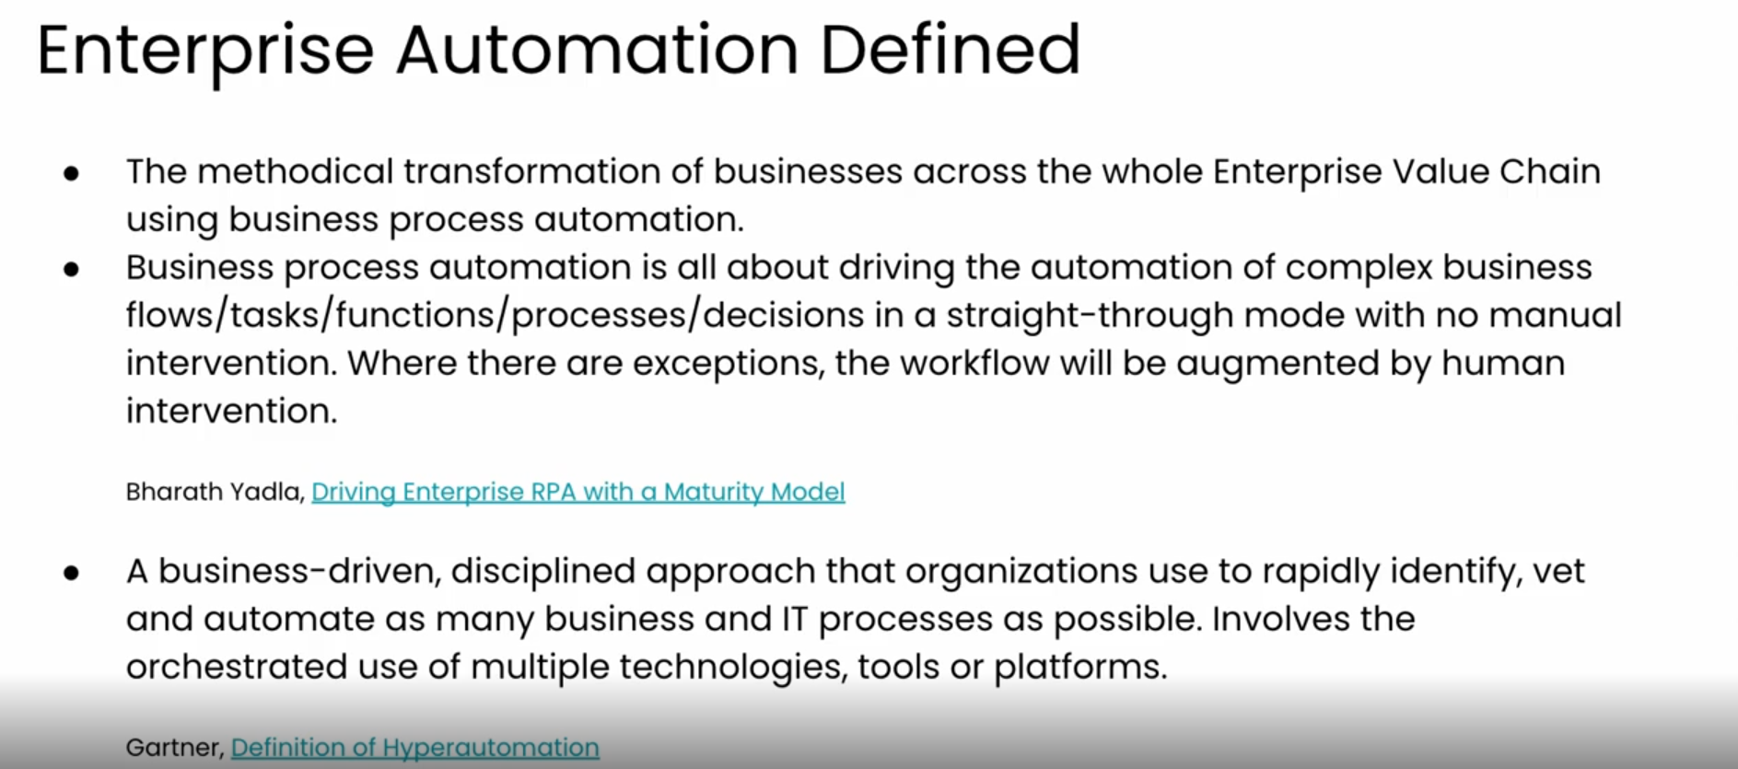

**Why?Workato**

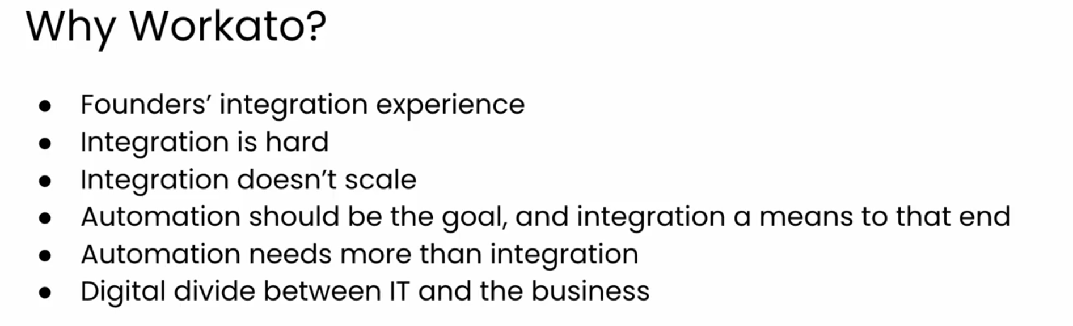

**Product Vision:**

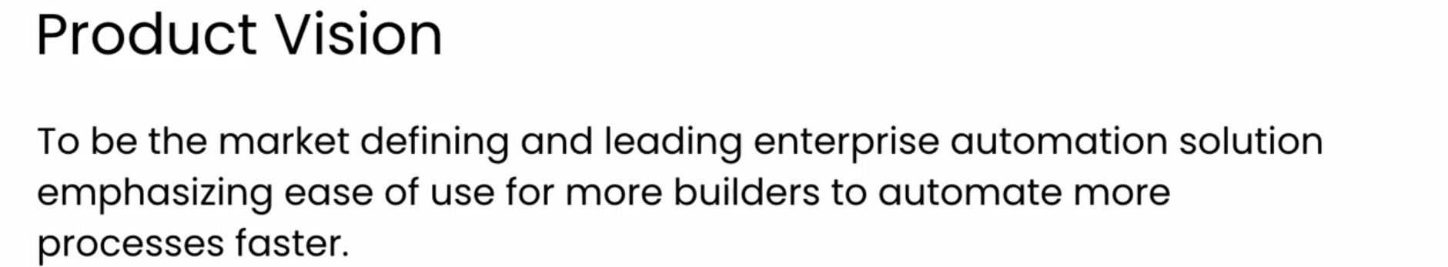

**Features Of Workato?**

* Low Code/No Code
* Enterprise Grade
* Event driven automation of business process
* With or without human engagement
* By both technical it users n less technical business users

**Module 1: Partner Onboarding**

**Introduction to Workato**

* Workato is an IPAAS platform for integration and Workflow automation.
* Workato is fastest growing integration and Automation Platform that serves 11000+ customers, can connect 1000+ on-prem n cloud based apps and 5lakh+ Automation recipes.

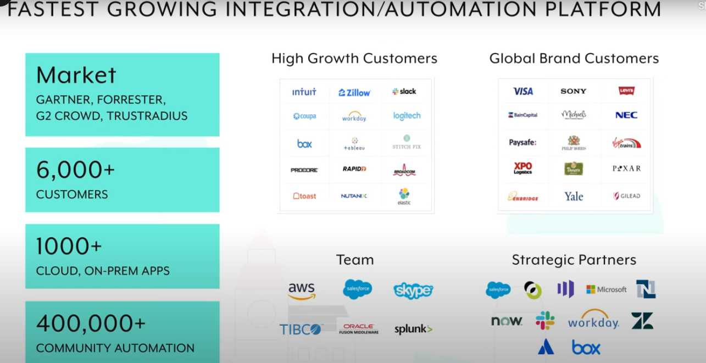

* Workato is used to create Intelligent Process Automation Workflows which provides below benefits:
* Removes Need for Labor in Manual tasks
* Increases the predictability of the services
* Increases Reliability with Less Errors
* Reduces Cost thru Automations.
* Basic Building Blocks Of Workato’s Process Automation Workflows are:

1. Trigger Event
2. Actions

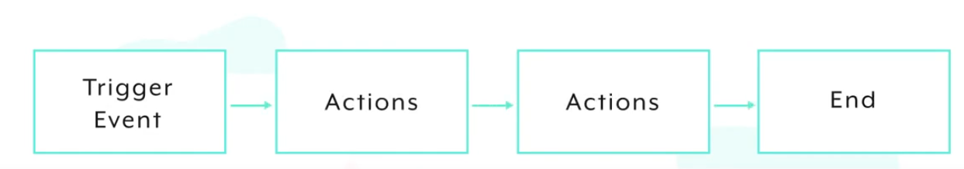

**For Example:-**

Let assume that you are Hungry N you need to find food n eat it then only ur stomach will get full.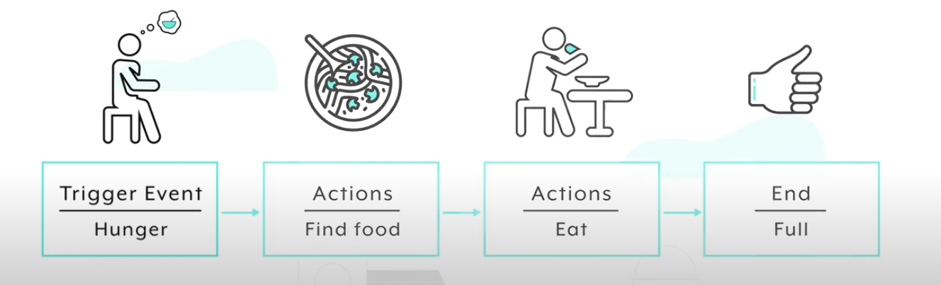

Trigger Event can have multiple datapoints which are used in decision-making like

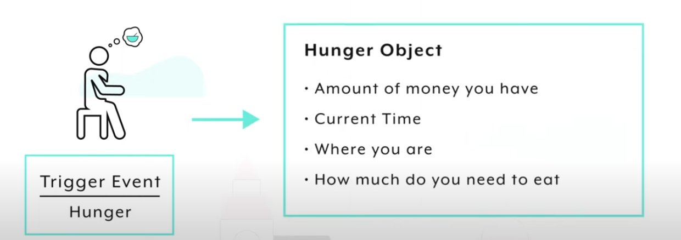

Based on the datapoints we can have conditional logic such as let say we are at home n feeling hungry so conditional logic will be

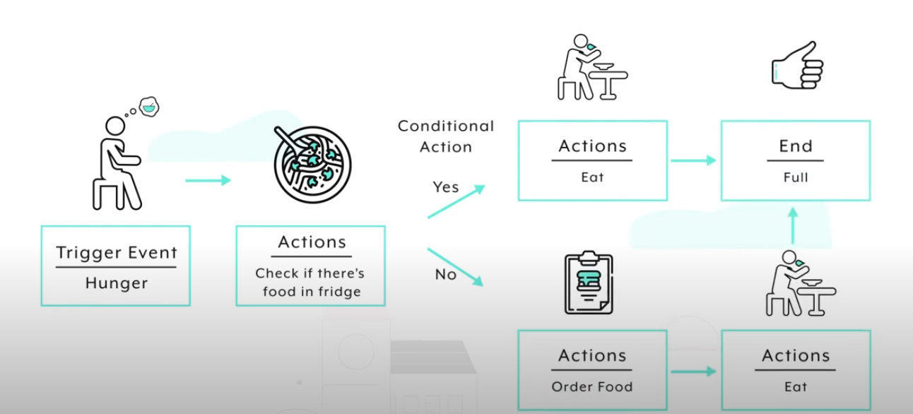

Let say we are at home and we have multiple/List of food options(Array Of Options) to eat but we need to eat tht much only which is required to get our stomach full(Calorie) like

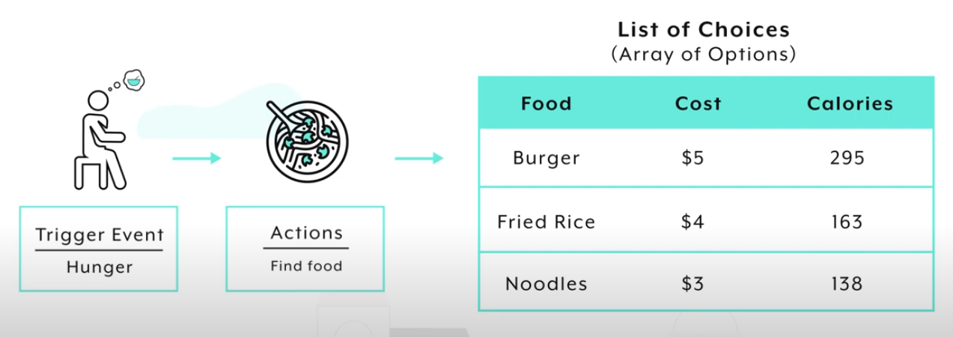

In this case we find the food that is available are burger,fried rice, noodles now we need to decide how much calorie content we want to consume so for that we can use

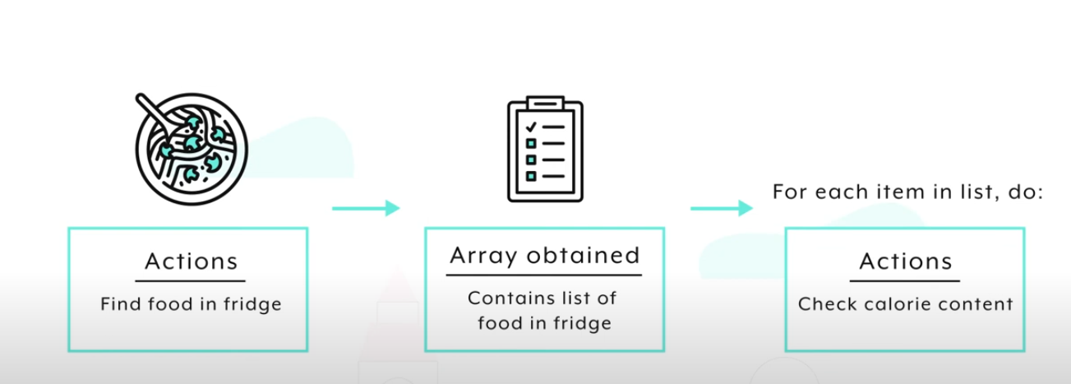

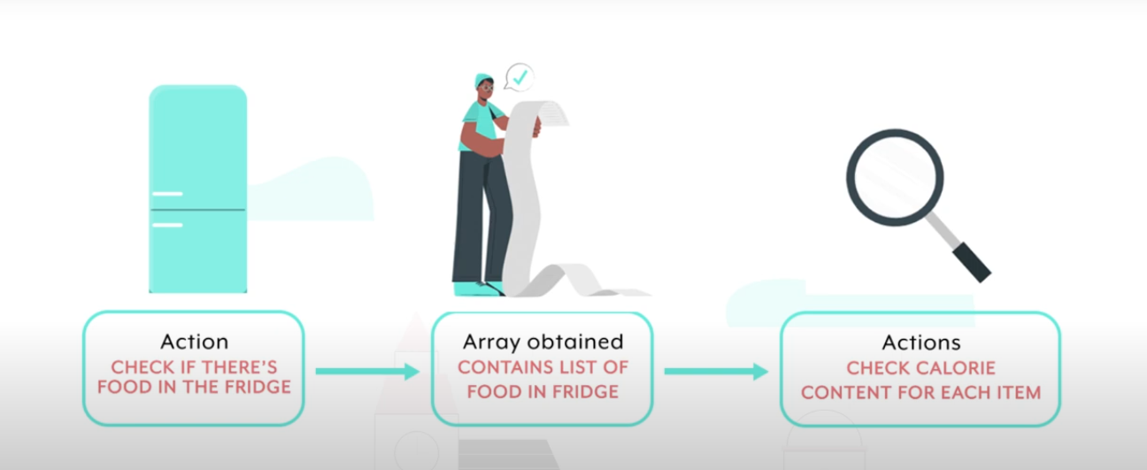

* Server less architecture,every recipe runs on its own container so it scales without running out of capacity n not responding or slowing down.It has 1000+ on-prem, cloud based connectors which we can connect with.It supports integrating with teams,slack,salesforce,workday,okta etc.
* Recipe is nothing but set of instructions that the automation workflow should do i.e trigger event, n actions associated with it
* **Workspace** is nothing but a place in workato where we can work on our own or collaborate with team to create automation workflow recipes for your business processes like onboarding new hire,creating data pipeline,escalating the support ticket etc.
* **Projects** is a way of organizing the automations either by use cases(Order To Cash,Lead Mgmt) or by Dept like (Finance,Marketting,HR).when you click on any of the project you can have multiple recipes attached to one project n you can grant/revoke the access to project.
* **Dashboard** is a place where you can monitor the real time- runs of all automations n take action on.
* **Tools** is a place which provides unique tools for managing recipe lifecycle,connecting on-prem apps,publish apis,Creating chatbots using workboats in slack n teams.Access to these tools depend upon ur role n what u purchased.
* **Team Management** is a place where we can see the collaborators on project,can add roles,invite members n assign them to specific project to work upon etc etc.
* **Environments** we have 3 environments Dev,Test,Production to build,test n ship the automation to production effectively.
* **How to use Projects?**
* Project is flexible way of organizing n bring your teams n automations recipes so that they can be shippable automation products.
* To create a project, go to Projects->click on Create project->name the project eg: “Ticket Escalations” n add emoji n description->Click create project
* To Invite Team members,Go to Team->Pending invitations->Invite Collaborators->add Fullname,email address,assign roles for each Environment->click on send invitation
* Once we create Project, we will have assets,deployment, settings section under our project n create recipe button .under assets we will have recipes created by us n the connections which will have the app connections configured or used in this project. One project can have multiple recipes .

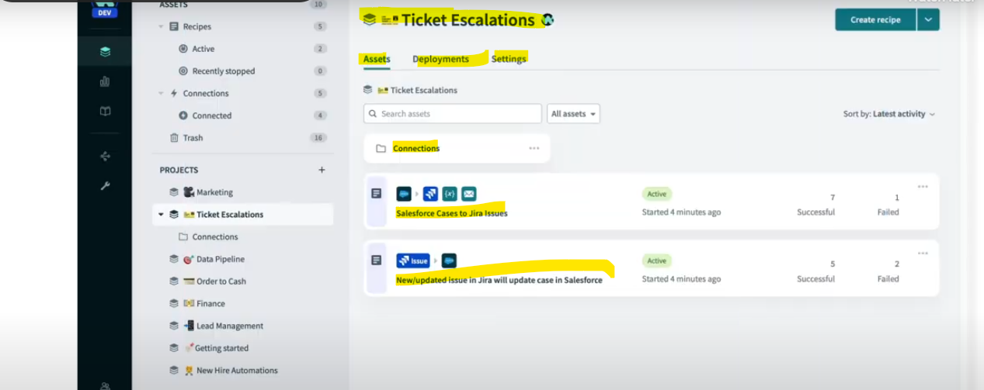

* Deploying Changes to deploy the changes made in a project we can go to that project n select deployments option->select deploy project->select target env(dev,test,production) a give description->click next->then if we want to deploy the complete project or particular recipe then we can select Deploy entire project or Customize deployment -> Click next-> then it will deploy the project.
* Connection Overview?
* Connection are needed to connect/access data within the apps, tools to create automation workflow
* Connection is a secure way to give workato access to your business apps like saleforce,jira,okta etc.
* To Create a connection, open project->select the dropdown beside create recipe button n select create folder to create folder n give the name as connections n then again select the dropdown beside create recipe button n select create connection button->new connection page opens select the app/tools name(eg. Salesforce,jira) for which you want to create connection n give connection name, location,auth type,host name n then click on connect button

Note: Choose correct value for location field as it may be project specific only. We can switch the connections from an existing recipes where it was using old connections by going to that recipe n clicking on it n selecting connection

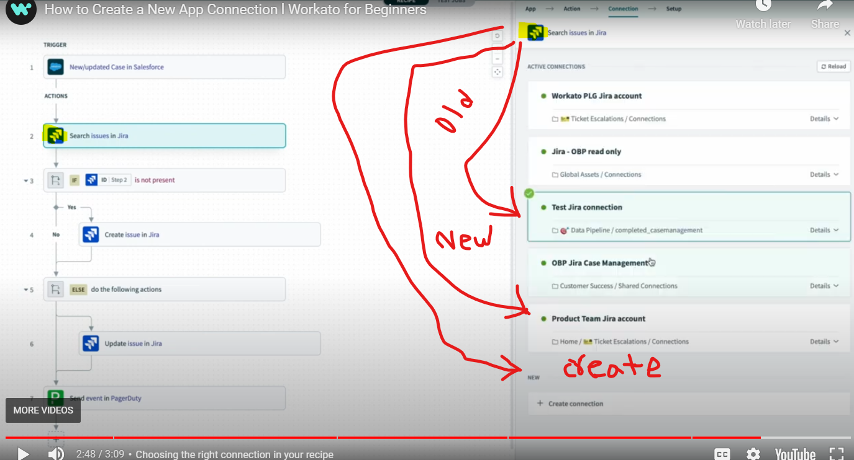

* Recipe Overview?
* Recipe is an set of instruction that an automation workflow can have n also recipes are automations for business processes.
* A recipe is made up of Trigger event,Actions n connection
* To create a Recipe, go to the projects->select a project under which you want to create a recipe->click on create recipe button->Give name,Create in folder,pick starting point like trigger from n click on start building-> new page opens with option to select an app or trigger an event
* Trigger are events that kick off the recipe they can be Time based,event-based
* Actions are set of tasks that you want to automate

**Introduction to Enterprise Automation**

* Common Terminologies:-
* API: Application Programming Interface. This is the software layer between two applications that allows them to talk to one another
* APIM: API Management is the practice of managing and documenting APIs and making them available for use within a company and by it's suppliers and/or customers. This also involves governance and security considerations.
* ATS: Applicant Tracking System, (Examples: Greenhouse, Oracle Taleo).
* BA or BSA: Business Analyst or Business Systems Analyst.
* CIO: Chief Information Officer. The CIO is the inward-looking technology leader. They manage relationships with internal customers (users) and oversee the organization's IT infrastructure.
* CPQ: Configure, Price, Quote, Software that manages quoting and configuration for complex purchases. (Example: Salesforce CPQ)
* CRM: Customer Relationship Management software (Example: Salesforce, HubSpot, Insightly). We use Salesforce internally at Workato.
* CTO: Chief Technology Officer. The CTO is more outwardly focused than the CIO. They help to grow the business by developing the tools and technology that external customers will buy.
* EDI: Electronic Data Interchange. This is the concept of businesses electronically communicating information that was traditionally communicated on paper, such as purchase orders and invoices.
* ERP: Enterprise Resource Planning - Software used to organize business information, build financial models, and help large companies operate efficiently. More information here. (Examples: SAP S/4HANA, Oracle NetSuite, Sage Intacct).
* ETL: Extract, Transform, Load. Many ETL functions can be done in Workato. When moving data from one location (database or file) to another, there are three steps in the process: 1. Extract it from the source database or file 2. Transform it (remove duplicates, check for data correctness, change format), and 3. Load it to the target database. (Examples of dedicated ETL solutions: Informatica Power Center, Talend, Pentaho)
* ELT: Extract, Load, Transform. Same thing as ETL, but the order is different. With the modern cloud databases like Snowflake, which could do transformations in-database, the preferred order of operations is: 1. Extract 2. Load 3. Transform in database, then usually writing the data to a View (table of data formatted differently from the source, that maintains its connection to the source table(s), so it gets updated when they do).
* HRIS: Human Resources Information System - Software used to manage HR processes and store employee data. (Examples: Workday, BambooHR, Namely)
* ITSM: IT Service Management. A set of policies, processes and procedures for managing the implementation, improvement and support of customer-oriented IT services.
* Low Code/No Code: The ability to develop software without having to code as a developer, in the traditional sense.
* MDM: Master Data Management, a system of ensuring a company's master copy of their business data is consistent, clean, and correct.
* ODBC: Open Database Connectivity. A standard for connections to move data between databases, BI tools, and ETL/ELT tools
* SaaS: Software as a Service
* Shadow IT: The situation that develops when business teams take IT into their own hands because of the perception that the IT team cannot fulfill their requests. For example they use Zapier to build their own integrations.
* TTL: Time To Live The amount of time to allow responses (data) to be cached. After TTL is reached, the data is no longer available. Workato has TTL as a configurable setting for API caching to improve response time and reduce load on business applications
* Integration /Automation Use cases?
* **Data Consistency:** Organizations can have many business apps n within those multiple apps some apps might be containing same type of data .So if there is change in data of one app for particular entity then all other app data also needs to updated.let say business app salesforce had some changes in data of one entity(eg: user data like name,address,phone no) then the same data need to be consistent/in-sync across all apps that are used in business apps.let say we have CRM,ERP N Billing system so all three system should have data in sync.**To make data consistent across all business apps all apps should be integrated eg tools like informatica,SSIS,DDF etc.**
* **Multistep Process:** Organization can have many business apps so one app can be used for storing some sort of data (eg. Customer data like name,address) that data needs to be used in other system to generate the bill on customer name let say in billing system so we can do that by automating this business process.**So here we need automation of business process for two or more independent systems eg: tools like RPA**
* **Composite Service:** Organization can have many business apps, sometimes business needs to aggregate/combine the data from dif. systems to do its business effectively for this business can create one more layered app to aggregate/combine data from multiple sources and use that app as input for the calling system.For example: we have total 3 systems ,two db system which have customer data n order data respectively and one saleforce app which needs this customer data n order data for further processing so business can create one API which can collect the customer n order data from both the dbs n give response to salesforce app for further processing. **in this process we need integration of apps and api mgmt. capability. Eg tools like Mulesoft,Apigee etc.**

If you see eg, so all vendors are currently satisfying only one or two use case but to get more success the vendor needs to support all three use cases so….

To satisfy all 3 use cases in one platform/tool, many vendors like Workato , mulesoft are using IPAAS technology which can fulfil all this requirement

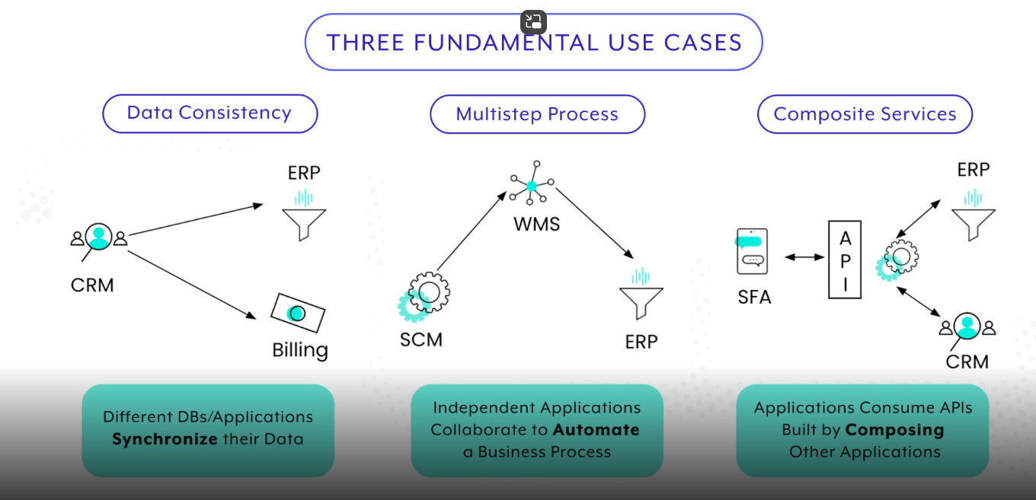

* Types of Automation technology?
* A business can use below technologies to run their businesses effectively like MFT(Managed File Transfer),ETL/ELT,API,RPA(Remote Process Automation),MDM(Master Data Mgmt),Ipaas,BPM(Business Process Mgmt) out of the below technologies some ar there from past 30 years,some are 10 years n some are recently developed. There is always a confusion for abusiness of how to approach a use case to find its best suitable technology , how many technology types we need, can etl n api work together,what are the cost n skills needed to manage these technologies

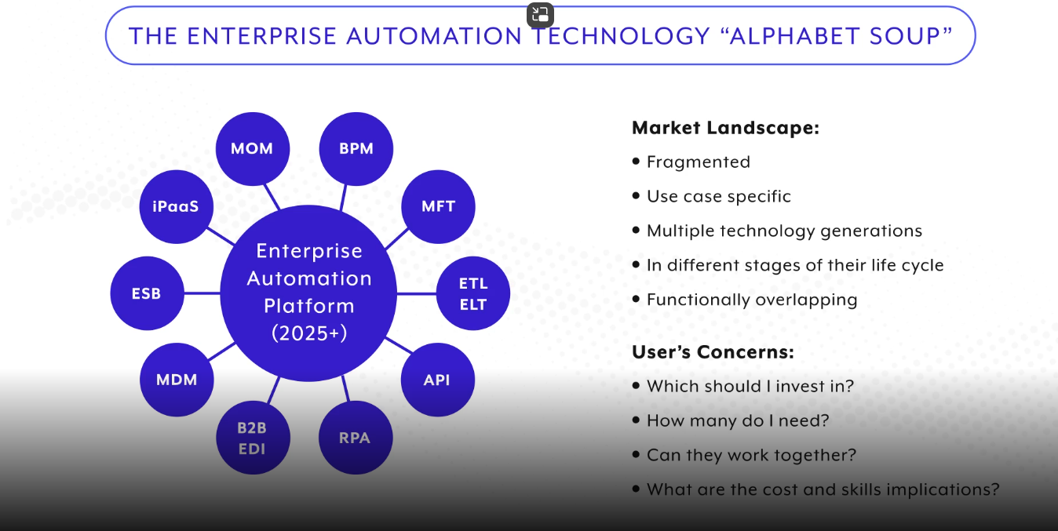

* So there is a need of one platform that can combine all the listed technologies can be used to run the business effectively by managing only one platform so **IPAAS** is one technology which can speed up the process of combining all other or most of the listed types. 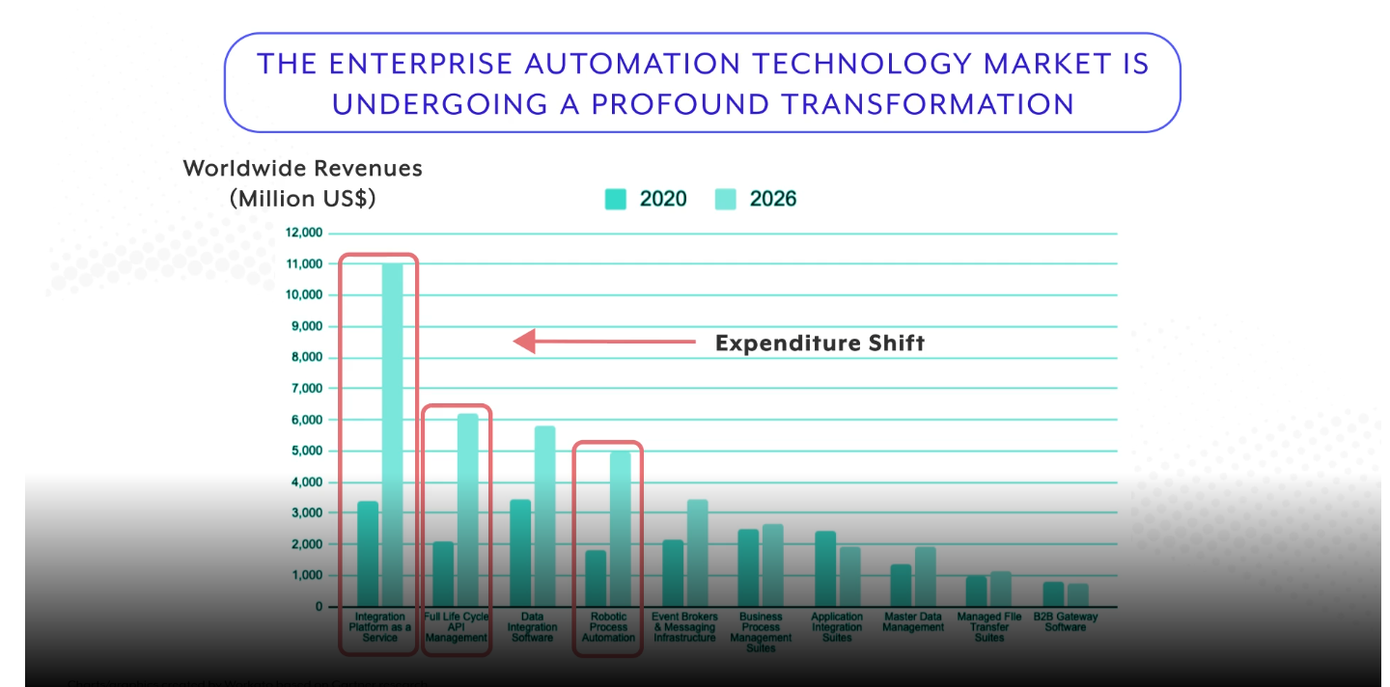
* The 3 most used technology types are RPA,API MGMT,IPAAS ETC.

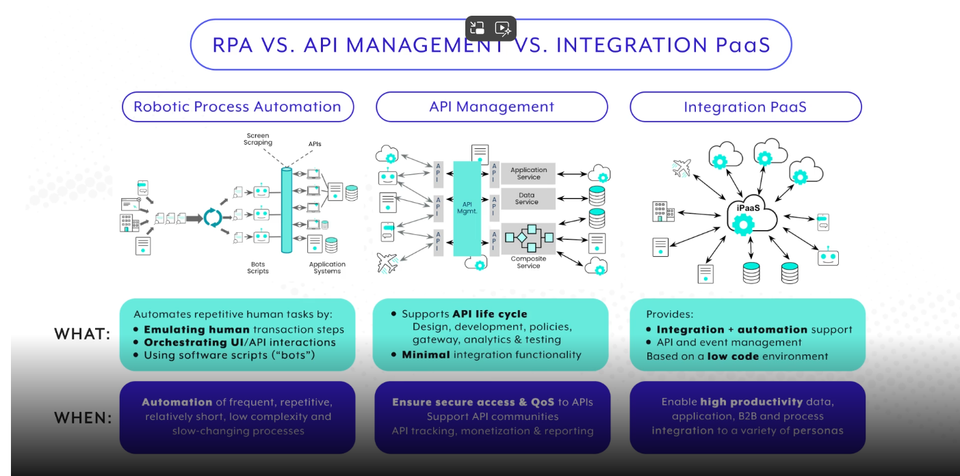

* IPAAS is a technology that can support both RPA as well as API MGMT capabilities.

**Introduction to the Partner Portal**

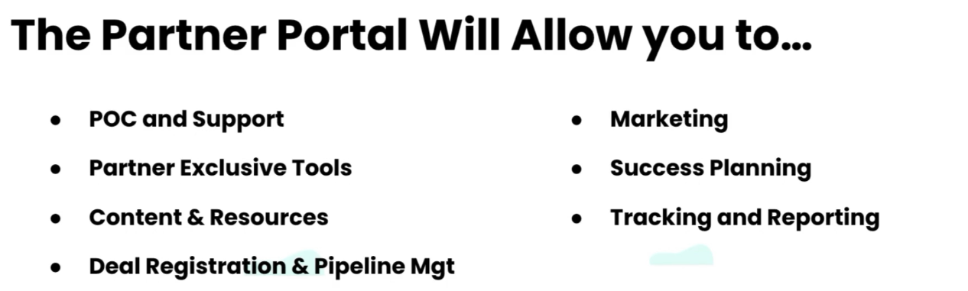

**Module 2: Partner Involved Workflows**

* **Problems faced by SaaS companies in collaborating with partners which results into less business for SaaS Companies like Workato,Mulesoft are:**
* Limited Understanding of Partner impact
* Unclear Role Alignment
* Limited Access to Internal-facing portals
* Lack of shared processes

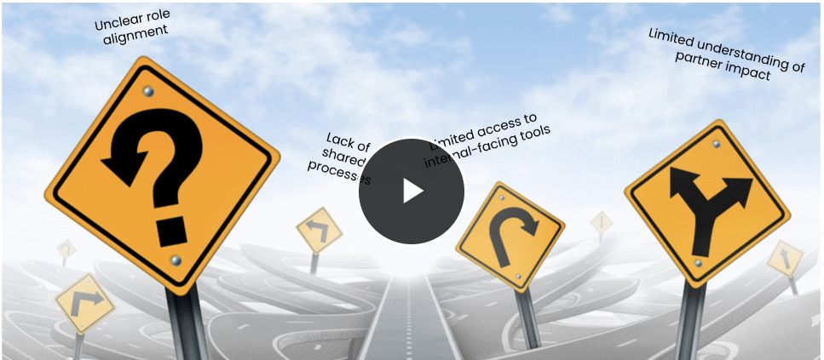

* **Limited Understanding of Partner impact** : In order to maximize the partner impact on business of workato(i.e.more business to Workato), workato has created 4 roles for partners at opportunity level and added field in salesforce to track them for each opportunity

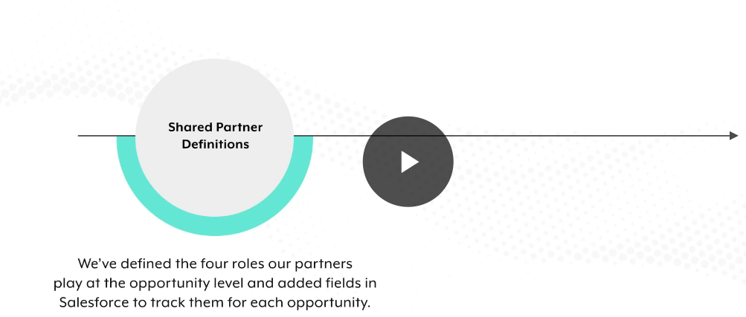

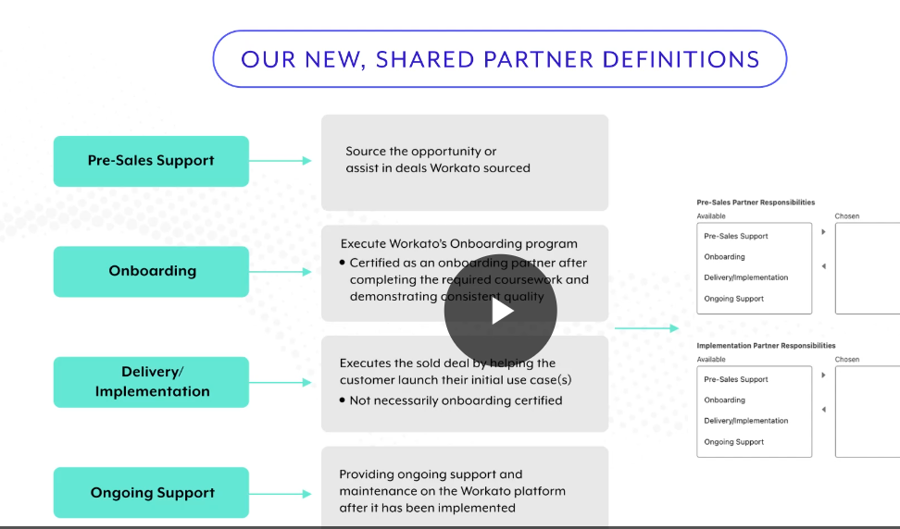

* **Unclear Role Alignment & Lack of shared processes**: In order to clear role alignment and create shared processes workato has developed partner involved workflows . these pre and post sales workflows are nothing but a playbook that can e used by the workato team n the partner to run the opportunity seamlessly.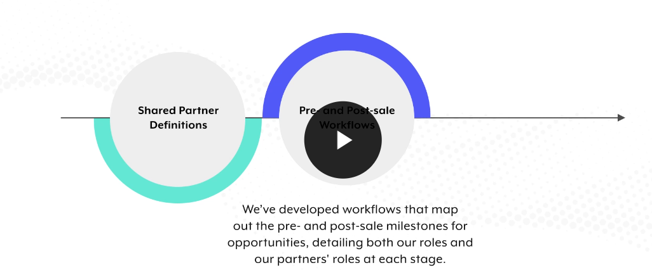

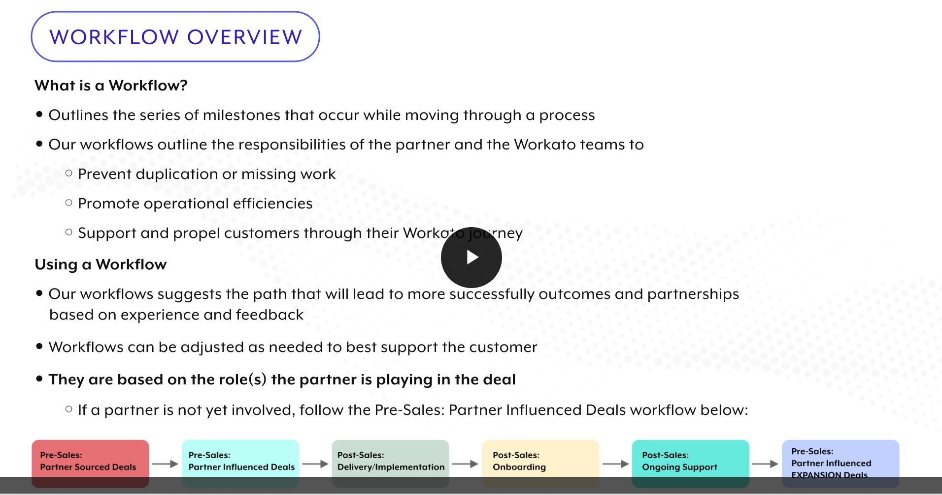

* Limited Access to internal-facing tools: in order to solve limited access to internal-facing tools, workato is creating some new tools that can be used to easily collaborate with partner and the workato team

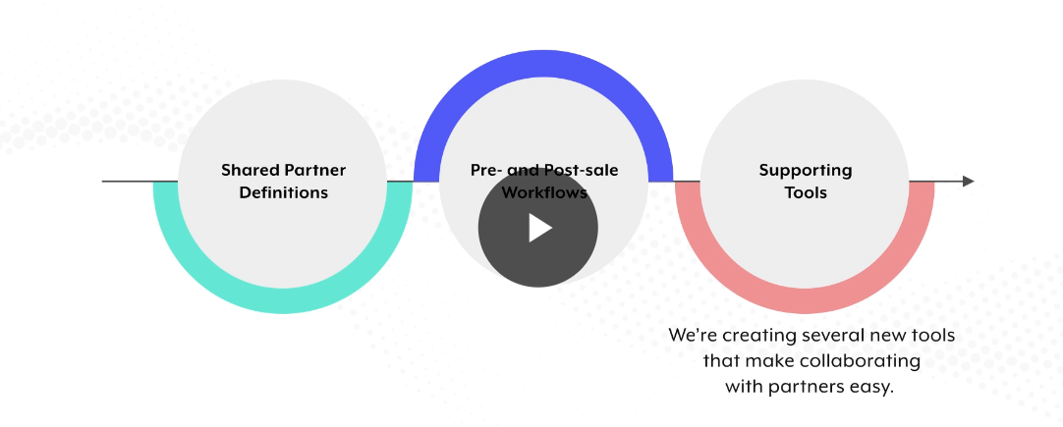

Workato is building below tools

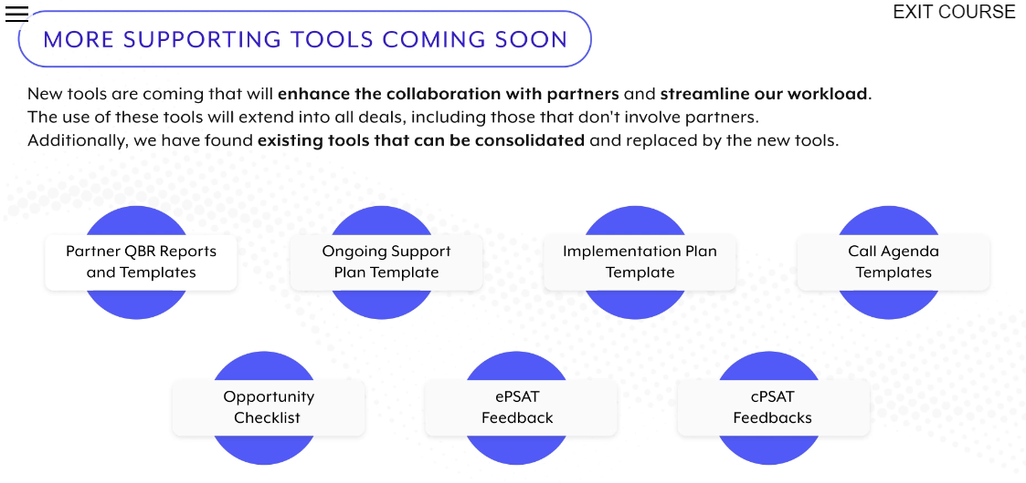

**Module 3: Automation Pro 1 On Demand**

* **What is the New Automation Mindset?**

-It is the combination of three major concepts

* Process Mindset:- Adopt systems thinking and practice a **Process Mindset**
* Growth Mindset:- Embrace challenges to become stronger through a **Growth Mindset**
* Scale Mindset:- Engage your entire community to develop a **Scale Mindset**

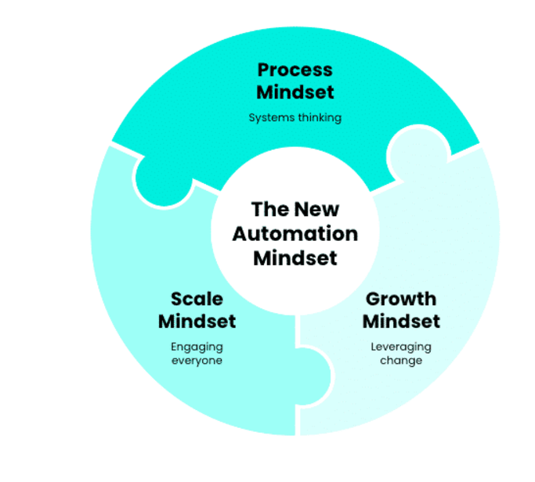**Introduction to Workato**

-Workato is IPAAS platform with low-code integration that is used for building automation workflows to run business effectively.

- Workato’s Core level of functionalities includes :

* Data Integration : First level of Workato functionality is data integration without any manual effort n without data duplication.
* Process Integration: Second level is process integrations such as workflow automation ,which enables u to create efficient business processes across multiple applications.
* Experience Integration : Third level is Experience Integration for eg: chatbots to interact with collaboration platforms like teams,slack etc.experience integrations can talk to ur applicationsor business processes to send notifications or carry out cmnds on ur behalf.

For example: let say that u received an opportunity alert so the next step of urs will be entering the opportunity in tools like salesforce as a case and then you need to post that opportunity case details in collaboration platform like Slack so that ur other team members n support team are aware of the opportunity n once done then you need to create a jira issue in jira to keep track of the opportunity case.

This task has 3 parts salesforce task ,slack task, jira task to complete this task manually it can take time depending on whether u have access to all tools but let say we are automating this process so we just need to perform salesforce task where we need to add the opportunity details manually n then automation will get triggered if set on new /update record as trigger event.

In the use case from the video, we saw we can achieve all three of these functions with one essential feature of Workato: a **recipe**. A recipe is comprised of one **trigger** and one or more **actions**. These triggers and actions typically **connect to external applications**.

With one recipe, we were able to complete all three tasks in a complicated workflow: Salesforce case creation, Slack notification, and Jira issue creation.

* **Workato UI?**
* When you first login, you will likely see Workato from the **Project** view, which includes a navigation bar long the left edge and an **Assets** and **Projects** hierarchy next to the navigation bar.

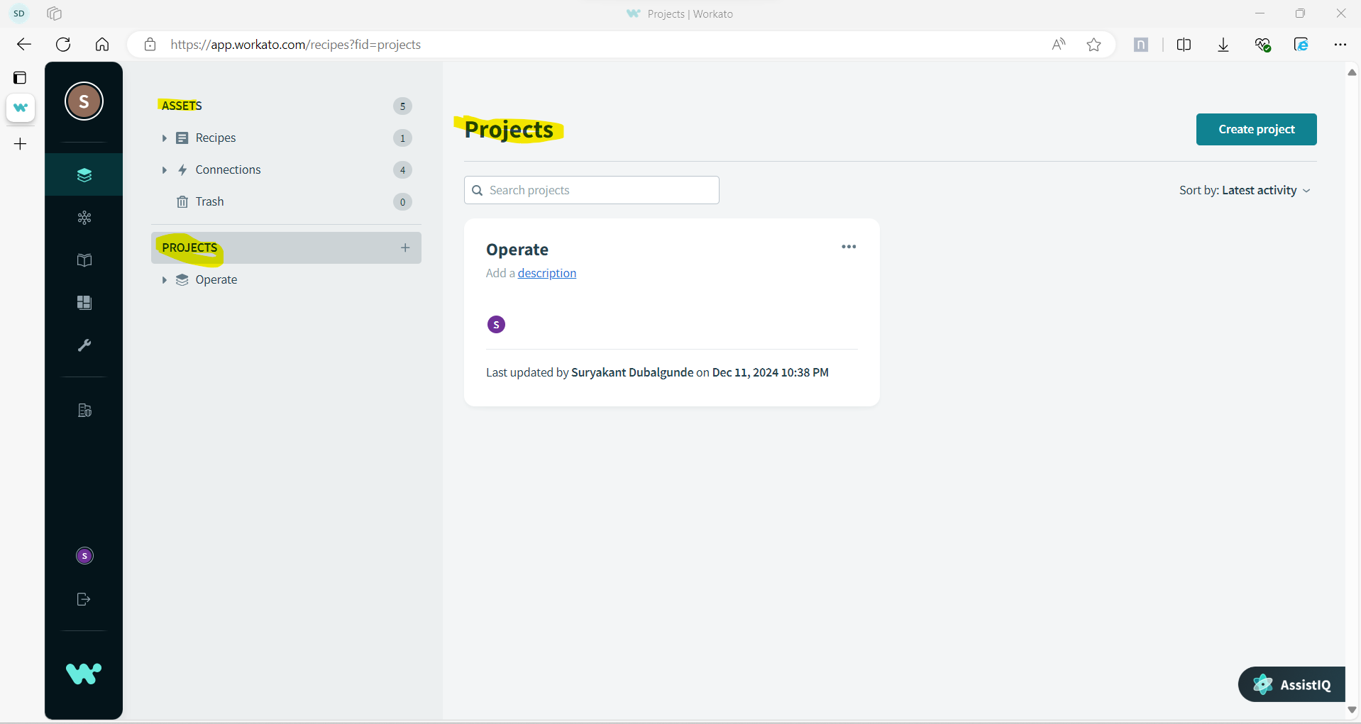

## **Assets**

Assets include smart folders for Recipes and Connections you've created in your account. You can also access your Trash bin from here.

Smart folders show you only the assets you want to see. You can see all the recipes or connections that you have access to, or narrow the list to only active recipes, recently stopped recipes, or connected connections.

## **Projects**

Projects help you create, organize, and manage your automation lifecycle to meet your business goals by grouping people and assets that work together.

A Project is like a repository for your integration assets. It holds the related set of assets for your integrations, including recipes, connections, and subfolders.

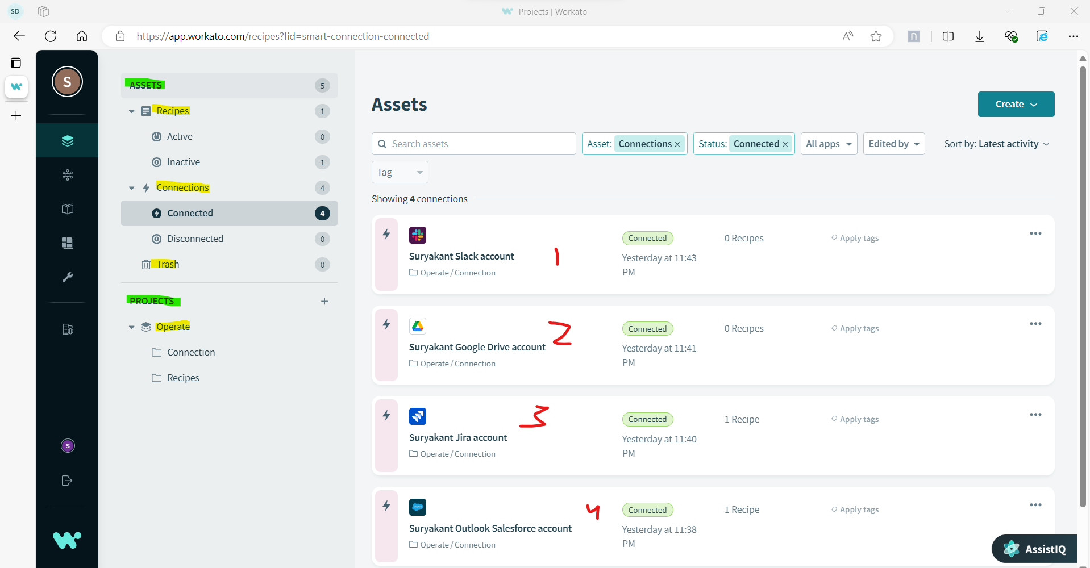

* If you hover over the navigation bar, you will have quick access to **Projects**, your **Operations Hub**, and the **Community Library**. You will also have access to **Settings**, **Tools**, and advanced functionality.

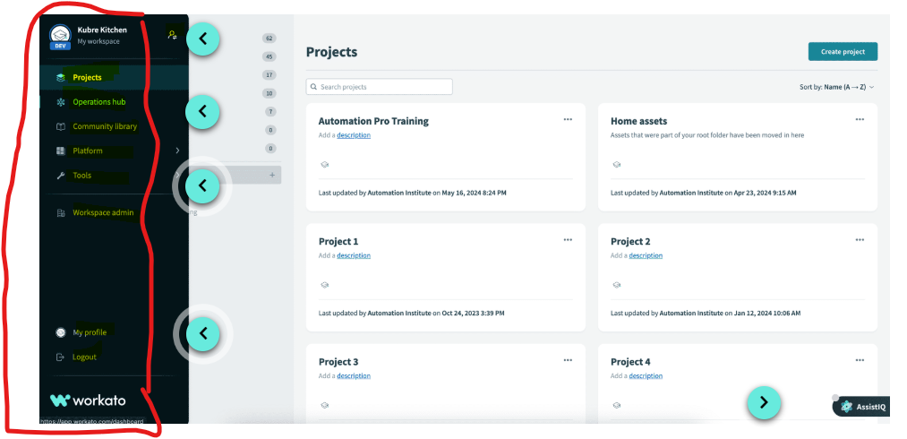

## **Account & Environment switching**

To view the teams you're collaborating with, open the navigation bar and click your profile icon.

If you have access to environments, you will also see a switch environments icon.

## **Operations Hub and Community Library**

The Operations hub dashboard allows users to visualize real-time data pertaining to the recipes and connections in their Workato account at a glance. It provides key insights, analytics, and actions so you can discover and resolve issues faster.

The Workato community is a fast and easy way to get a head-start on your integrations. When you're unable to find a connector out of Workato's library of connectors, head over to the Workato community to search for connectors built by other developers.

## **Tools**

Workato Tools help perform three main functions: Build recipes, connect apps and collaborate and manage recipes.

## **Settings**

In Settings, you can view account and subscription information, change your password and set up two-factor authentication, as well as manage API keys.

* **Projects:**
* Projects are a flexible way for you to bring together your team's recipes and applications in Workato and turn them into shippable automation products.
* With projects, you can organize your integration assets by use case, department, app, or process, and control who has access to them.
* A **project** can contain:
* Recipes
* Connections
* Folders and Subfolders
* **Projects Best Practices**
* Organize projects in your workspace by department, use case, or project.
* Before you import a project into the target workspace, check that **the target workspace has a** **project** into which you can import the exported project.
* Admins can **give users permission** to create/edit/view/delete specific projects by assigning them the admin, analyst, or a custom role.
* Before deleting a project, **verify assets** aren't used in other projects.

**Note :**

1. **Do note that leaving a recipe name blank will result in the creation of a name that is based on the trigger and actions which comprise the recipe.**
2. **You can tell it’s a recipe because it is identified with a purple recipe icon. Connections are identified by a pink lightning bolt icon.**

**Recipe components**

* Recipes are automated workflows built by users that can used for running business process smoothly.
* **Recipes** can contain:
* An application **connection**, for each external application you need it to communicate with: When you start building a recipe, the first step is establishing a connection between Workato and an app.
* A **trigger**, to determine when your recipe will be executed
* Steps, to determine what **actions** your recipe will perform
* Recipe Editor Window is used to create recipes n has 3 parts
* Recipe Workflow 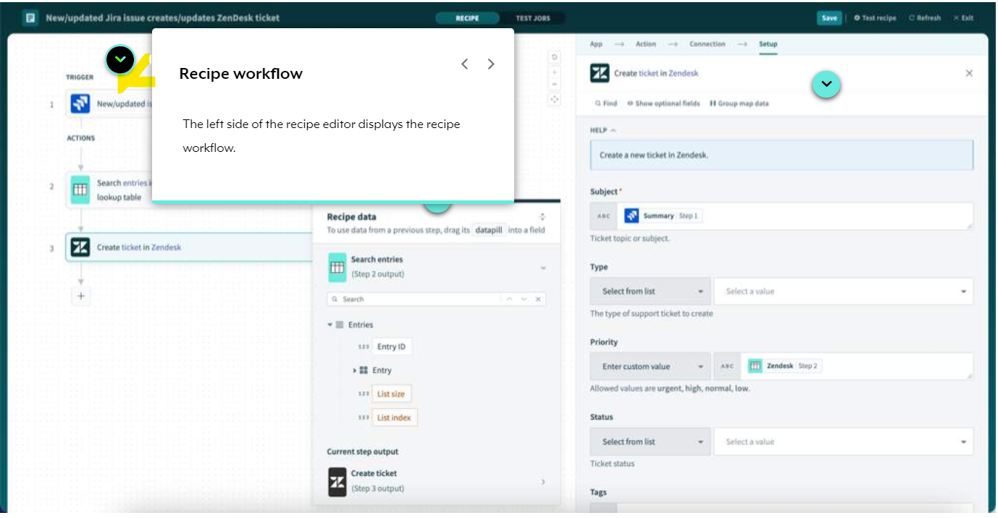
* Recipe Data

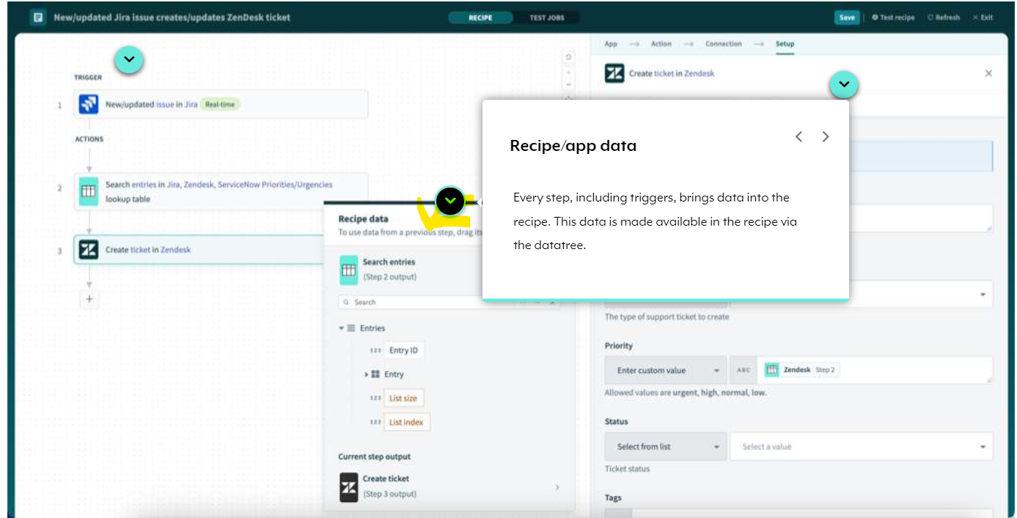

* Step Configuration Data

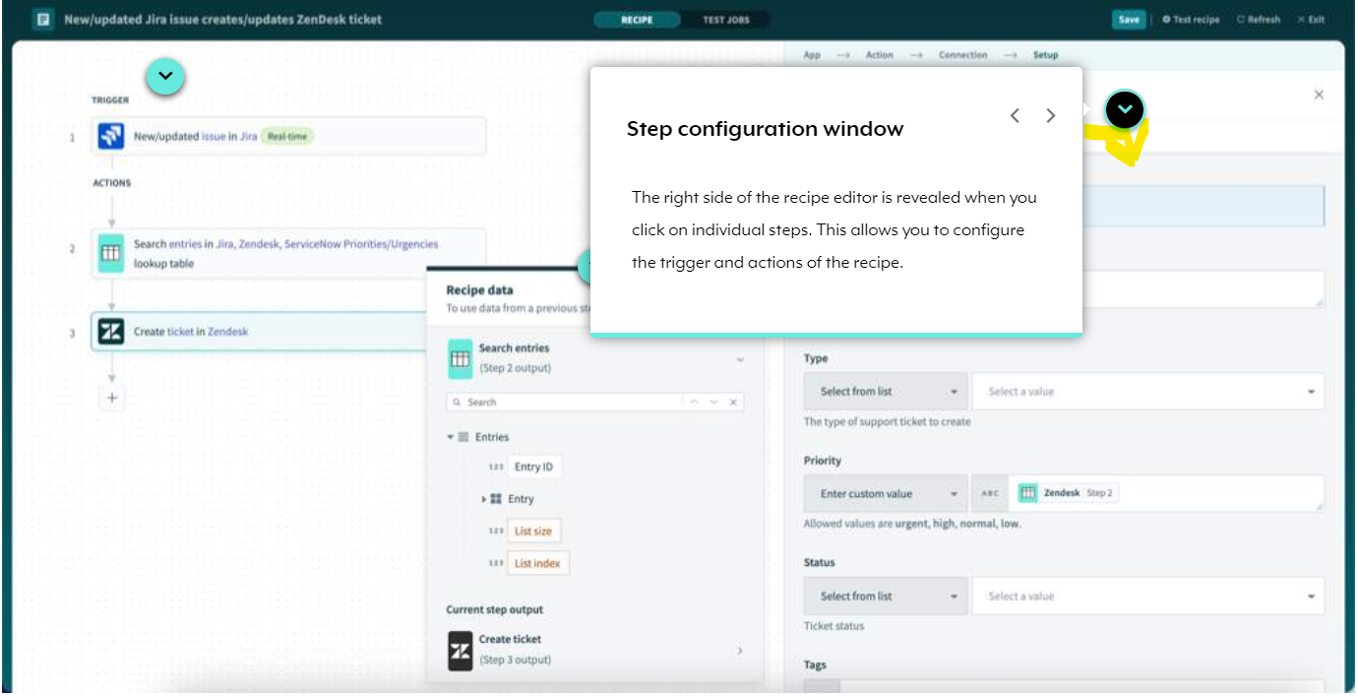

* **Triggers?**
* Triggers are an essential component of recipes as they determine which event or events must be monitored in order to execute the actions described in a recipe.
* Trigger Types: Triggers can be classified into different types based on
* when they check for new events (trigger mechanism)- Polled/Real Time/Scheduled
* how they group new events (trigger dispatch)- Single/Bulk-Batch
* how the recipe will be initiated (trigger event type)- created,updated,deleted

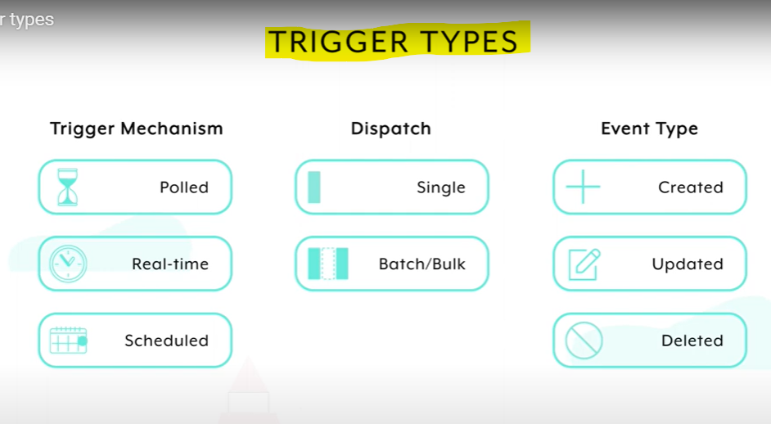

* **Trigger Behaviour?**

- Understanding Workato trigger behavior is essential to effective recipe-building. 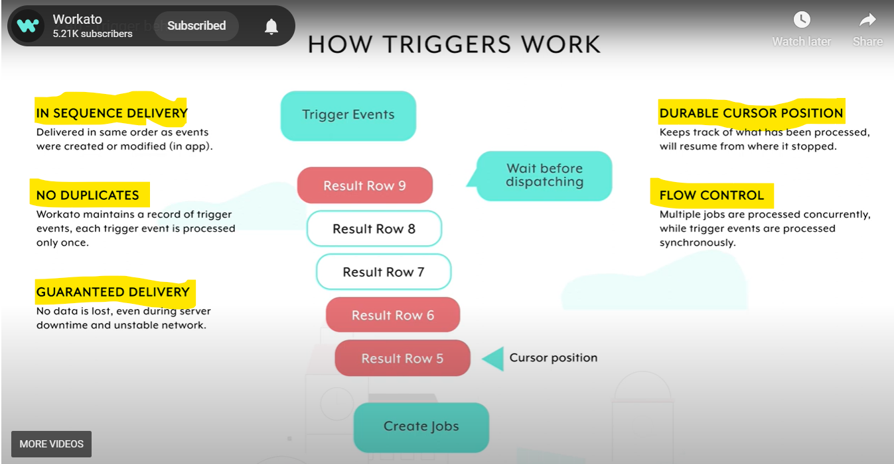

* Trigger Mechanism?
* Trigger mechanisms determine when a trigger will initiate.
* Polling Trigger

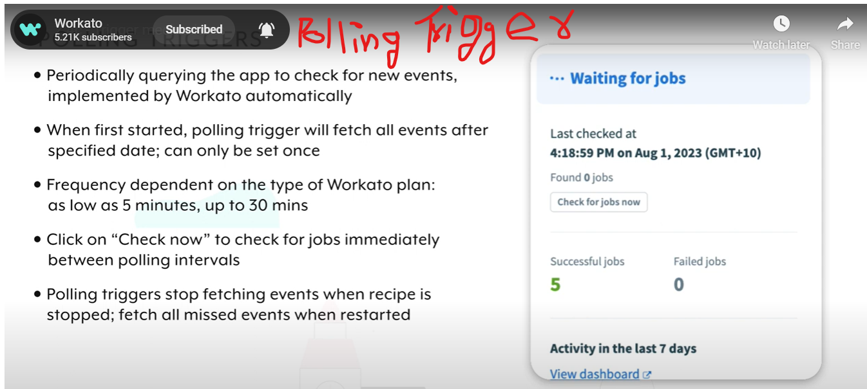

* Real Time Triggers

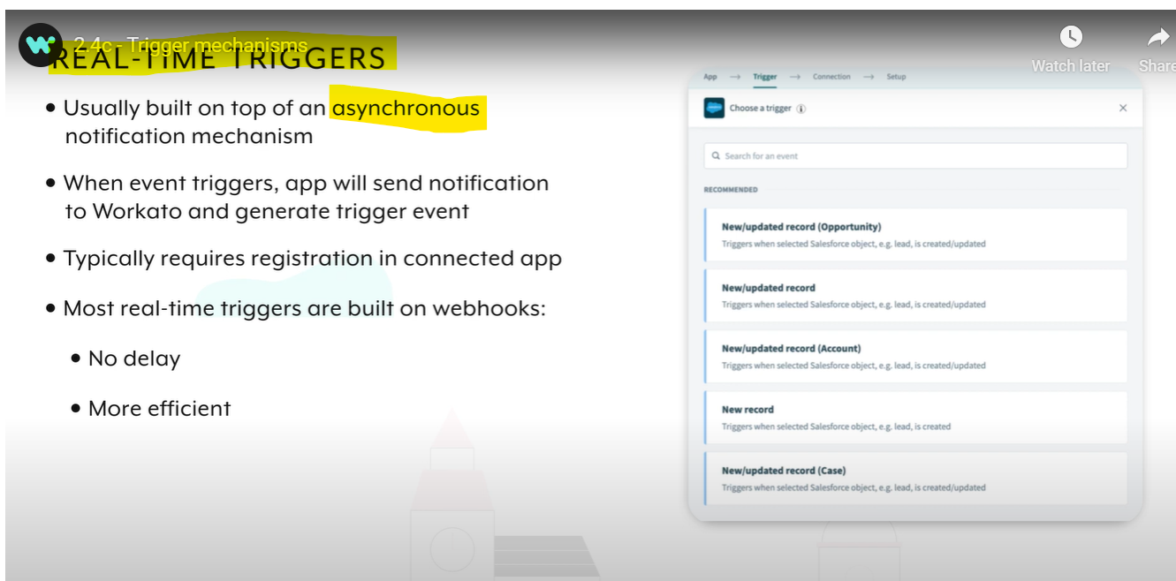

* Scheduled Triggers

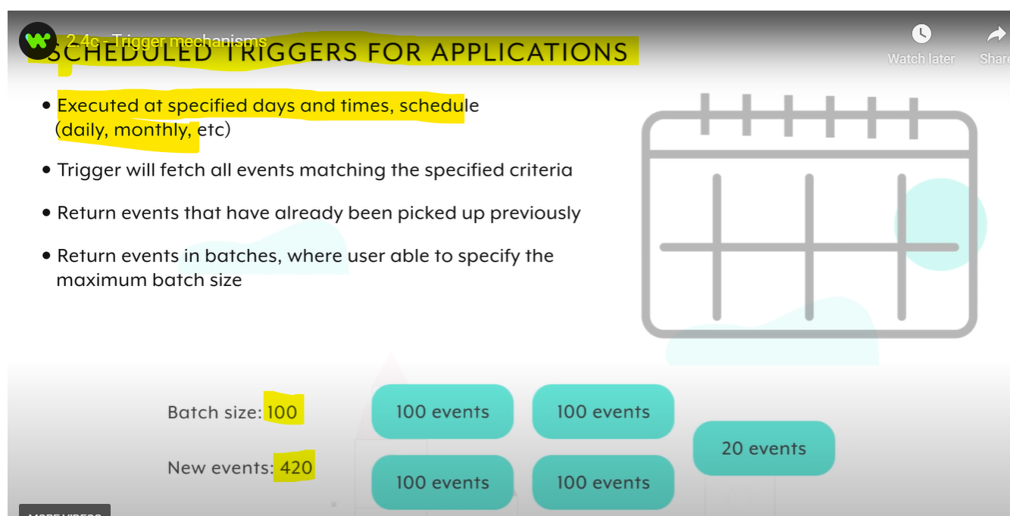

* **Trigger dispatch?**
* It specifies how events are grouped while processing the events.

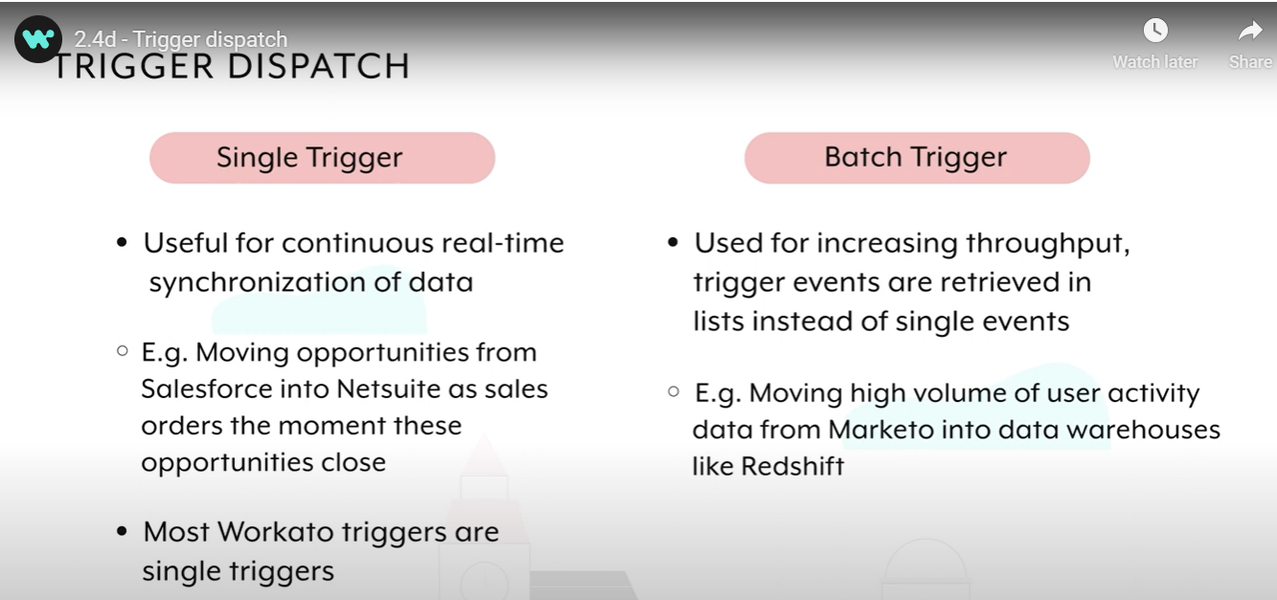

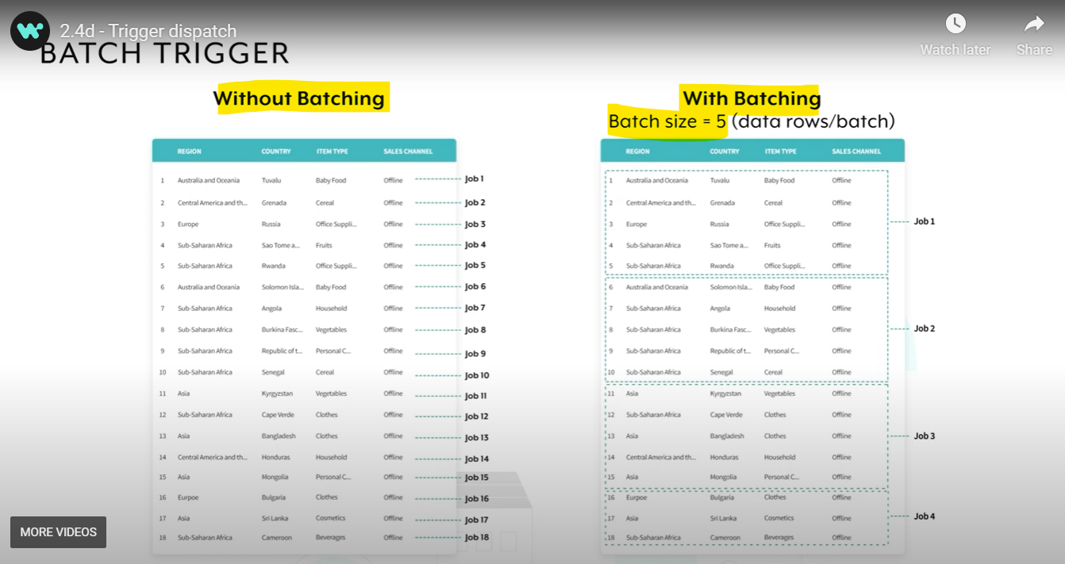

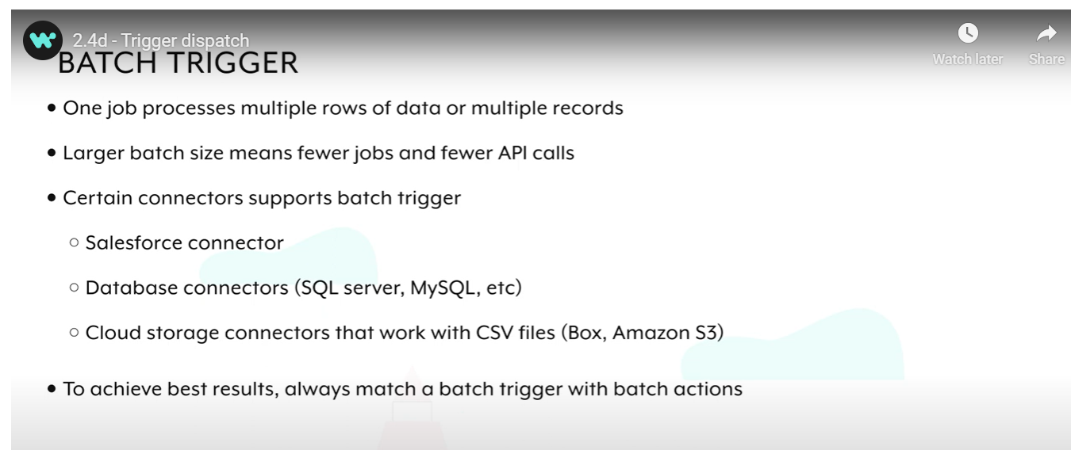

* **Trigger Inputs?**
* Different triggers require specific sets of inputs, based on the application or starting point.
* **Trigger Conditions?**
* Depending on your needs, you may also choose to set up trigger conditions or trigger filters, which will allow you to reduce the records process based on certain criteria.

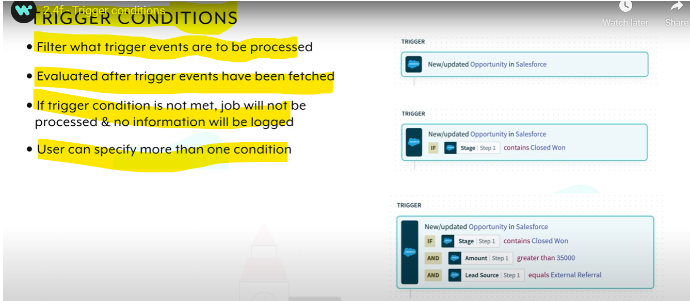

**There are 14 types of trigger conditions** and each condition has different requirements, especially in terms of data type validity. If the condition is used for invalid data types, it might prevent the recipe from starting successfully.

|  |  |  |  |  |  |  |
| --- | --- | --- | --- | --- | --- | --- |
| CONTAINS | STARTS WITH | ENDS WITH | EQUALS | GREATER THAN | IS TRUE | IS PRESENT |
| DOESN'T CONTAIN | DOESN'T START WITH | DOESN'T END WITH | DOES NOT EQUAL | LESS THAN | IS NOT TRUE | IS NOT PRESENT |

Eg: contains High

* **Recipe steps?**
* can be actions or control flow statements that help you describe business logic.
* **Recipe Steps Type:**
* **Actions in an app** - Actions carry out an operation in your target app, such as a create, update, or search operation. Each action requires a set of input fields and typically returns data i.e. output data tree. Every application has an available set of actions which differ across connectors and will generally include create, update, upsert, search, get, delete, etc.
* IF condition
* IF/ELSE condition
* Repeat step
* Call Recipe Functions step
* Stop step
* Handle Errors step
* Adding steps to a recipe is straightforward in Workato. After setting up a trigger, click the plus sign to choose from different action options, including Action in an app, IF and IF/ELSE conditions, Repeat action, Call recipe, Stop job, and Handle Errors.

**Introduction to recipe design**

* When designing a recipe, or a more complex automation project you want to get the most value out of your automations by building them to last. By applying recipe design principles, you can create automations that are organized, readable, and reusable.
* When you’re automating a critical business process, you want it not just to work today. You also want it to be stable over time, able to grow with your needs, and simple to maintain.
* **Understanding the root problem we are trying to solve helps us create an appropriate automation solution.**
* **Map out the workflow automation by considering what happens after certain events, or triggers.**
* **Consider where in our applications we expect to see results**
* **Ensure we have access to the applications we want to integrate.**
* **Data Mapping?**
* Datamapping in Workato is achieved through the use of **datapills**.
* **Datapills** are output data from a trigger or an action step. They **are variables that you can use to map business logic into recipe steps.** For example, to create a Zendesk organization from a Salesforce account, you will assign datapills from the Salesforce account to the Zendesk organization in the recipe actions.
* **Recipe Data contains** Datapills that are contained within the **datatree**, within the App Data section. At any particular recipe step, the App Data section contains the output from the trigger and every action preceding this step.
* **Datapills** are output data from a trigger or an action step. They are variables that you can use to map business logic into recipe steps. Datapills are contained within the datatree, within the App Data section.
* **Steps contain datapills, which contain the data, or value, associated with each field in the source application and object. The value is dynamic in nature, and thus can change with every automation job run.**
* **Datapill Datatypes are**

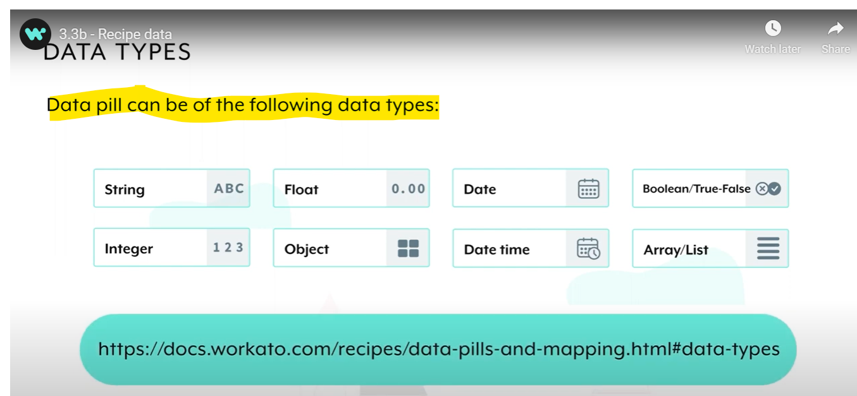

* **Formulas?**
* **With formulas, you can easily work with and format data.**
* Formulas in Workato are included in allowlists of **Ruby methods.**
* Though not all Ruby methods are supported, you can reach out to us to add additional formulas to the allowlist.
* Syntax and functionality for these formulas are generally unchanged from Ruby methods.
* Workato allows you to work with the following standard data types:
* String
* Integer or number
* Date or datetime
* Array/hash (list)

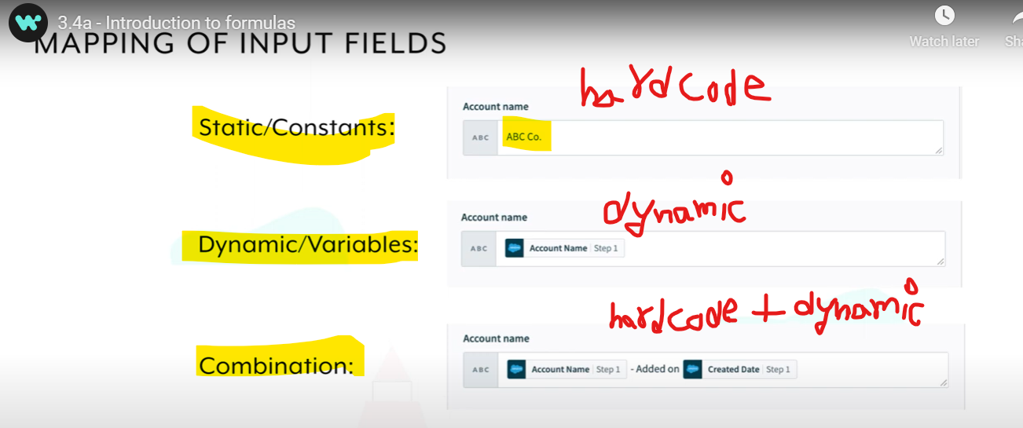

* **Switching To Formula Mode**
* To start using formulas, you need to be in formula mode. Formula mode needs to be switched on at the field level, and most input fields support formula mode.

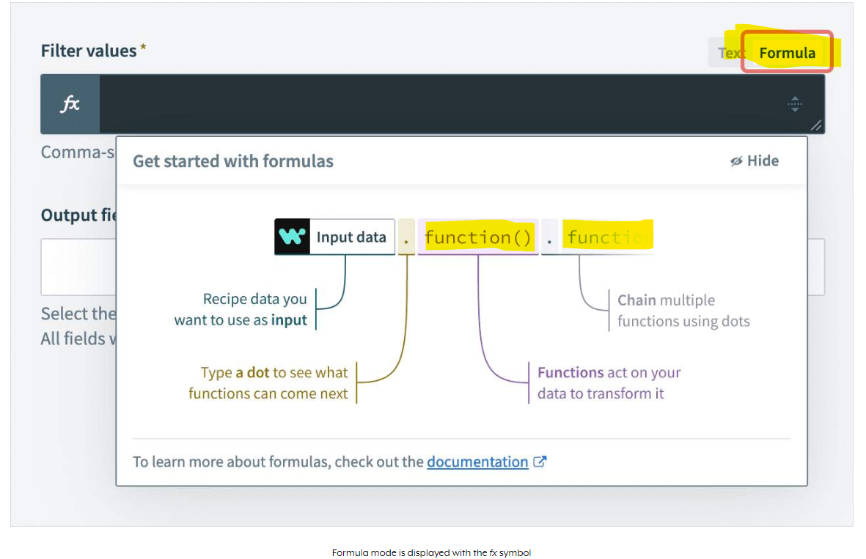

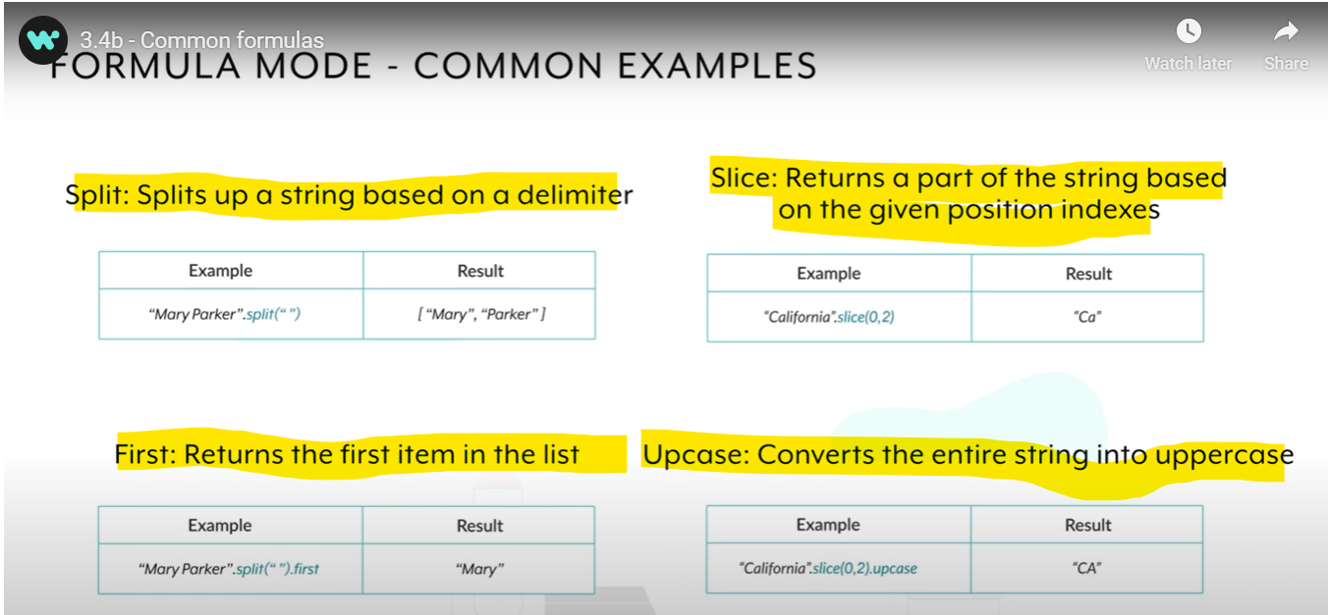

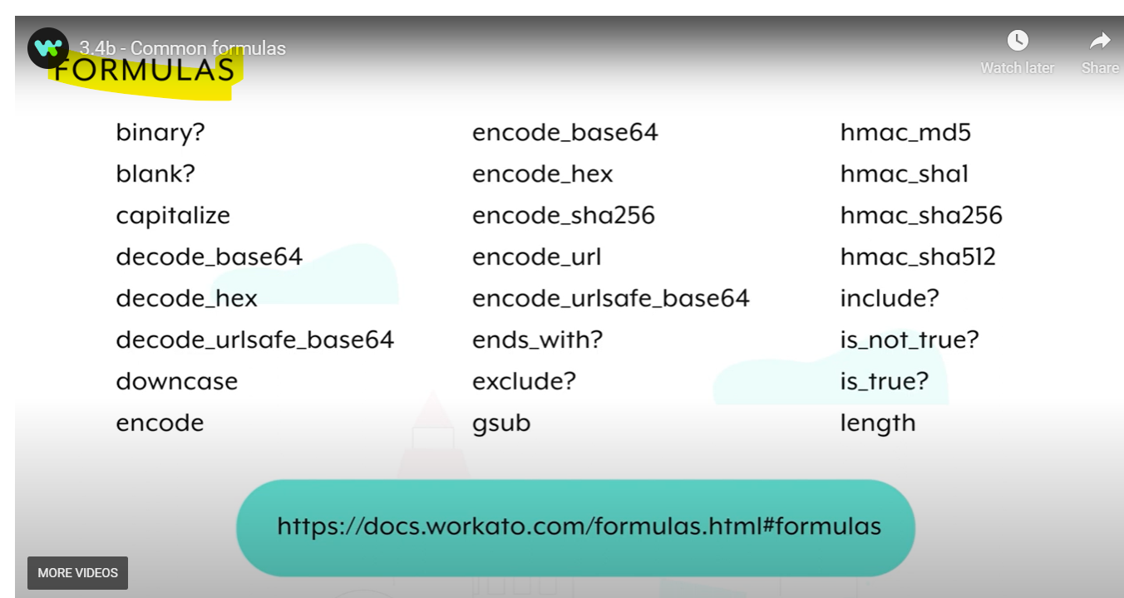

* **To use formulas in Workato, activate formula mode at the field level.**
* **Formula mode provides approved formulas and guidance for data manipulation.**
* **The editor shows type-specific formulas based on the datapill type in an input field.**
* **Text must be explicitly formatted in formula mode, unlike in text mode.**
* **Testing& Running Recipes?**
* Testing ensures your automation's behavior and data processing are correct.
* **Running a test job requires a fully configured trigger, valid data mappings, and valid connections.**
* **Inside the recipe editor, click the Test button to run a single trigger event through the recipe logic.**
* **Successful jobs include the recipe path, input, and output. Failed jobs include the recipe path, input, output, and debugging information**.
* **Operations hub dashboard**
* Used for Real Time monitoring

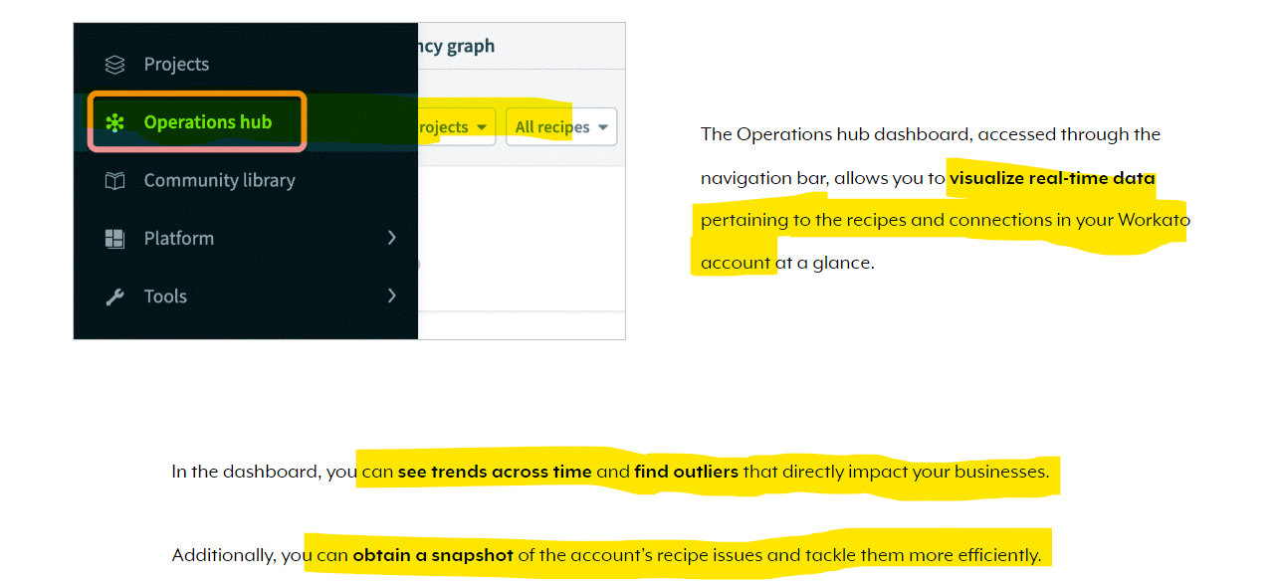

* Operations Hub divided into 3 parts

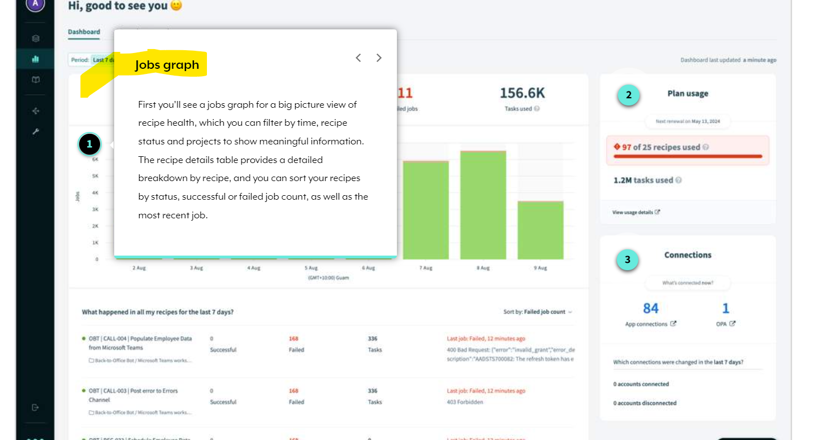

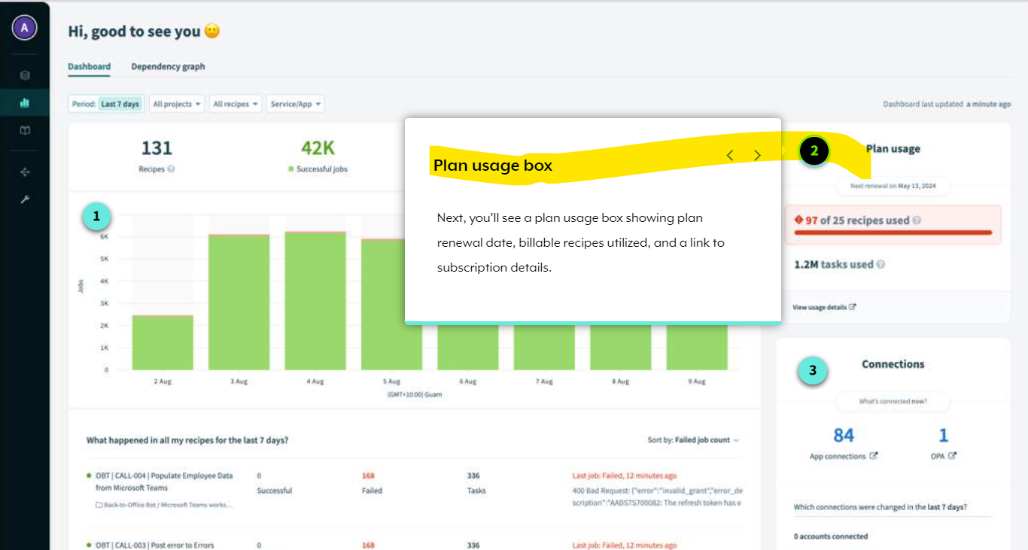

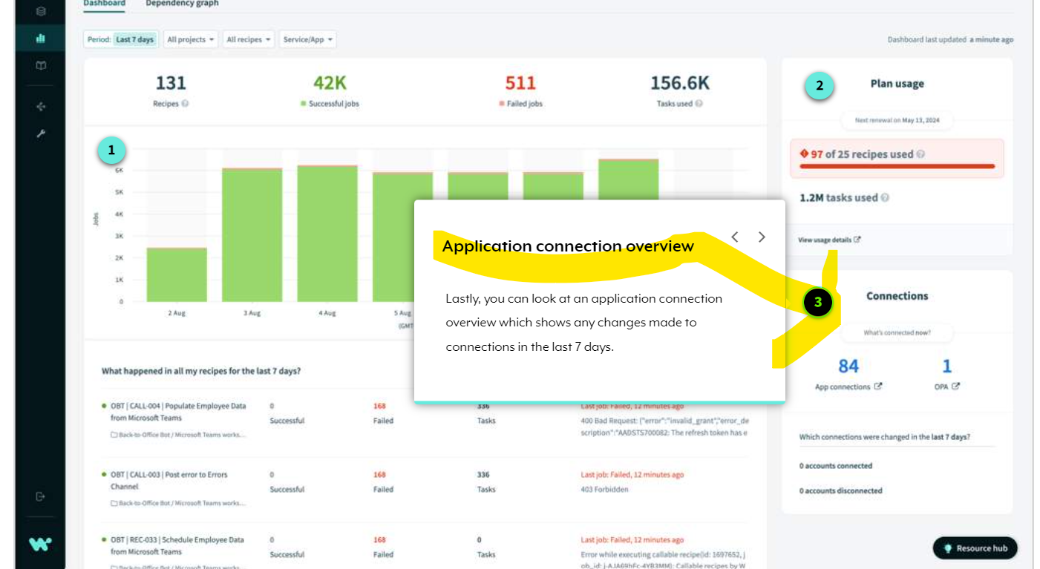

* **Recipe Details & Versions?**
* When viewing a recipe, the main**Recipe tab**gives at-a-glance information and access to **basic recipe information.** Here, you can see **recipe workflow, status, location, and links to dependencies,** such as connections. You can also see**successful and failed jobs.**

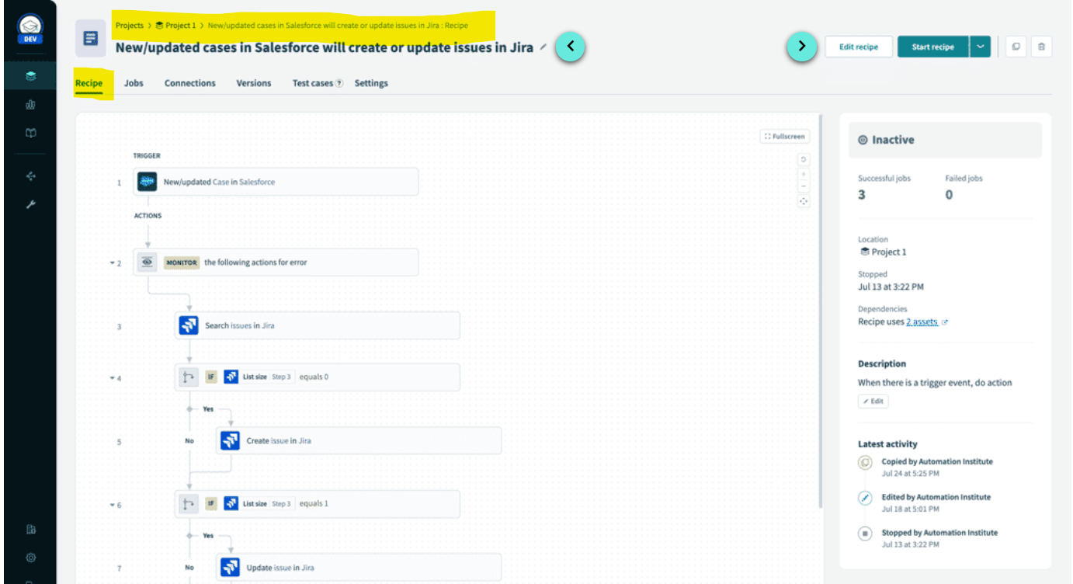

* **Recipe Version Tab?**
* If the **recipe is edited and saved, the recipe will increment to a new version.** These versions are accessible via the recipe versions tab of your recipe details.

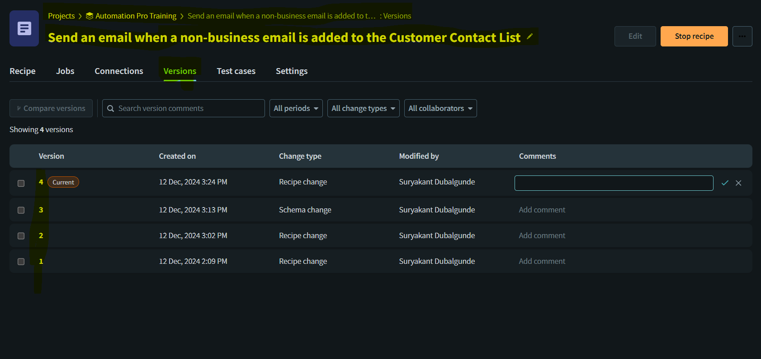

* You can see the **details of all versions**, including the time in which the version was created, the change type as well as the person who modified the recipe. You can also **preview and restore a previous version** of your recipe at any time. We recommend adding a **comment** when you create a new recipe version, for good version control and management.
* **Types of recipe changes**
* There are **two main types** of recipe changes. **Schema changes** are driven by Workato when the schema of objects change while **logic/Recipe changes** are driven by users actively changing the logic of the recipe.
* Recipe Settings?
* The Settings tab is categorized into**three parts**: **General, Data Retention, and Sharing.**
* Under **General settings**, you can choose the **concurrency number depending on the number of jobs the recipe processes simultaneously**. You can also select a higher number for high-volume transactions.

Below, additional resources are available that link to usage metrics and dependencies

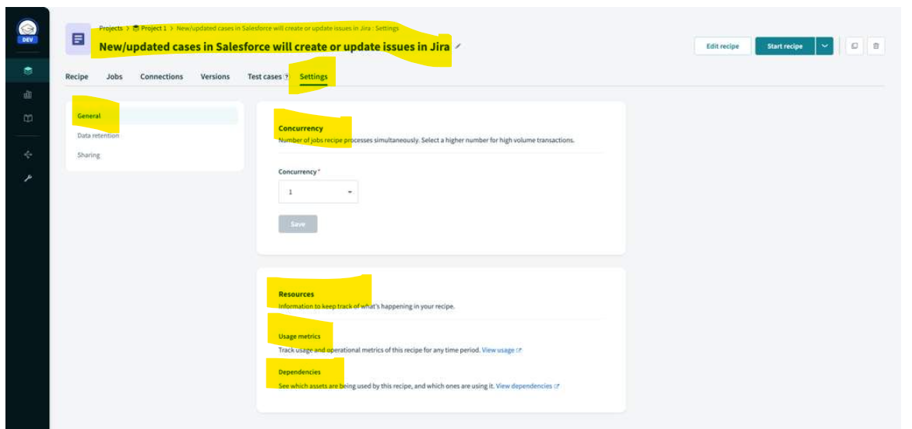

* Under Data Retention, you can set a data retention policy as instructed by your organization or team.

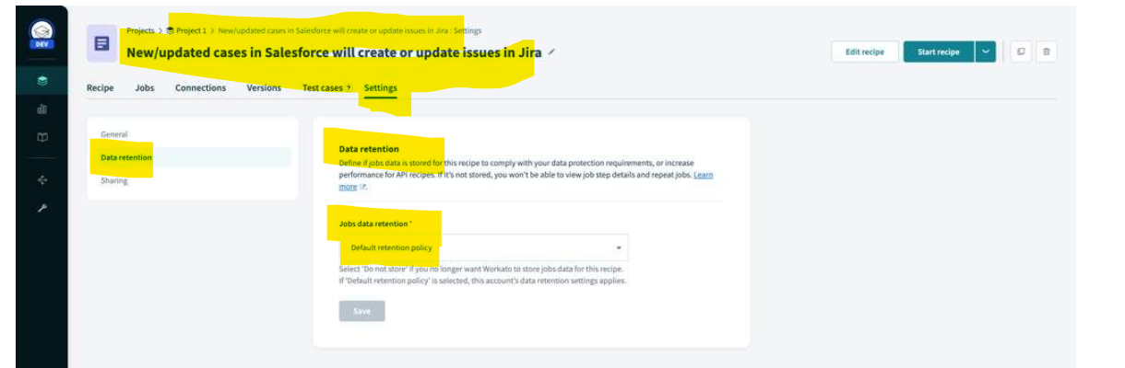

* Under Sharing settings, you can list your recipe in the Workato Community Library. We'll explore the Workato Community Library later in this course.

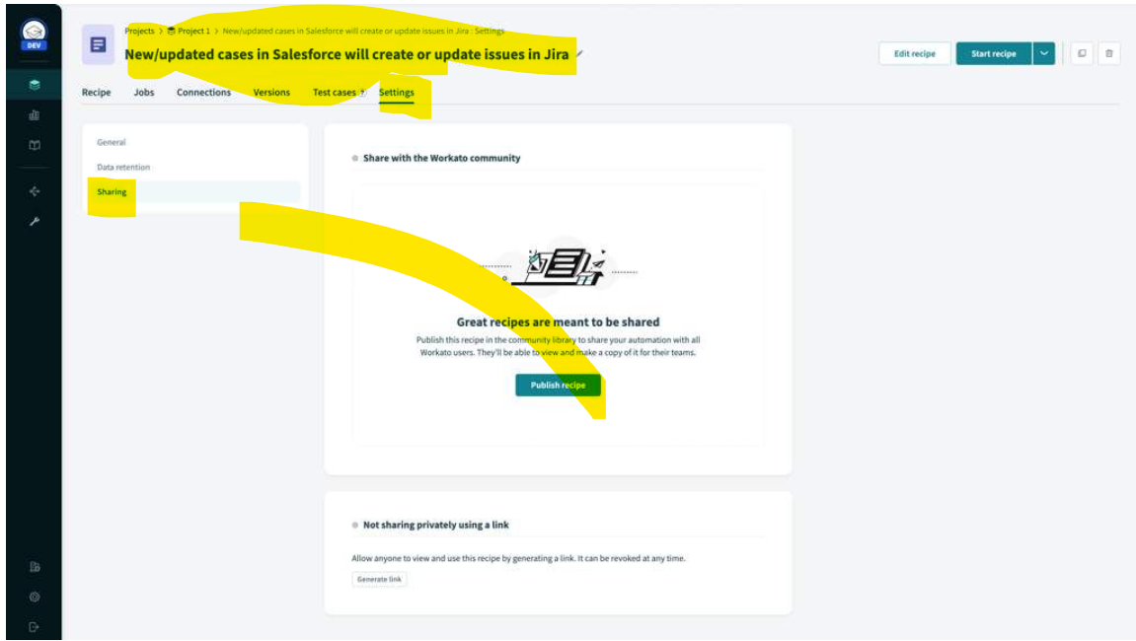

* **Jobs & Jobs Report**
* **When an active recipe processes a trigger event and runs the sequence of actions, as defined in the recipe logic, it creates a job.**
* ach job holds a unique trigger event and executes its recipe logic based on that data.
* Workato provides **details into this execution flow of a job**, such as the steps that were executed and the input and output data from every step.
* **The job report of all processed jobs can be customized to display useful information and will retain data for a duration corresponding with your data retention policy.** 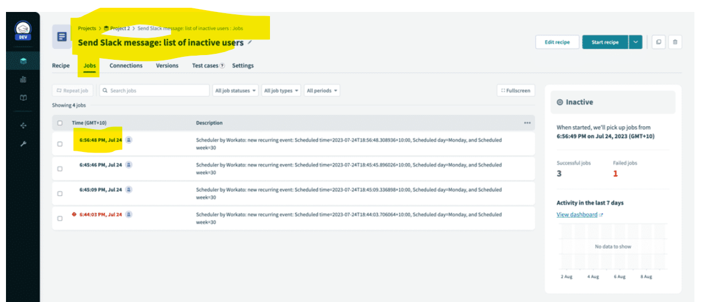
* Select a job to view **complete job details or Report**, such as job ID, recipe version, status, and the date and time the job was processed. You can also see complete details of the execution flow which includes the data input and output from every step.

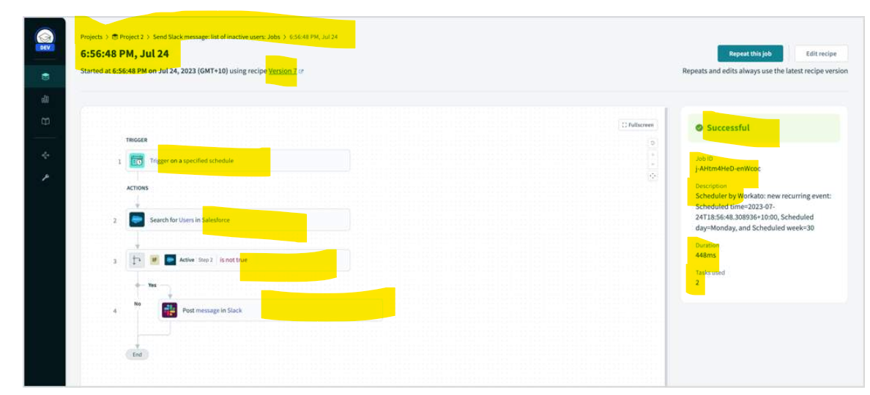

* **Repeating jobs**
* Workato **also supports the repeating of jobs, in cases whereby an error stops a job from full completion. Any job completed or failed can be rerun.**
* Workato stores the data of the trigger event, and repeating the job will run on the latest recipe version. The job history thus only shows the last iteration through a loop. It therefore does not pick up new trigger events.
* **Customizable Job Report?**
* **The job report can be customized to display meaningful data so you can better understand your jobs at a glance.**
* By clicking the More icon on the job report page, you are able to customize the job report to display any app data from your recipe.
* **You may add up to a maximum of 10 columns.**
* **You can only customize the job report when the recipe is not active.**

# **Community library**

* explore the **Workato Community Library** for inspiration and ideas for your solutions.
* The Workato Community **Library contains integrations and workflow automations built by the Workato community. Find, clone, and personalize them to your specific needs.**
* To access publicly-shared recipes on the platform, click Community Library in the navigation bar.
* **You can search for recipes by clicking on the icon of the application or by typing the name of one or more applications.**
* For example, **if you search for Salesforce and Jira, you will see all the community recipes involving Salesforce and Jira that have been created by the Workato community.**

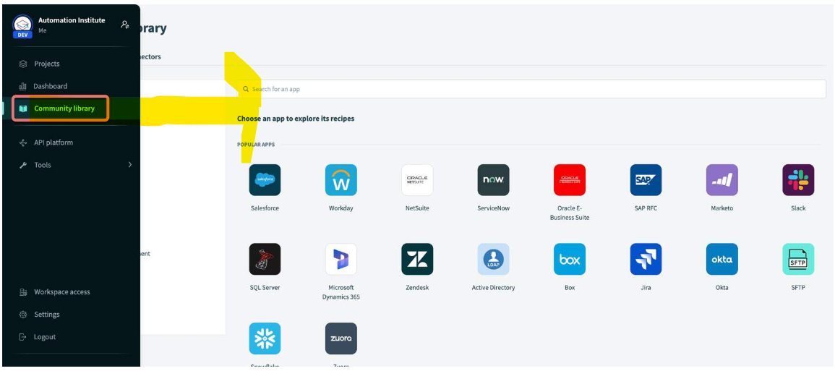

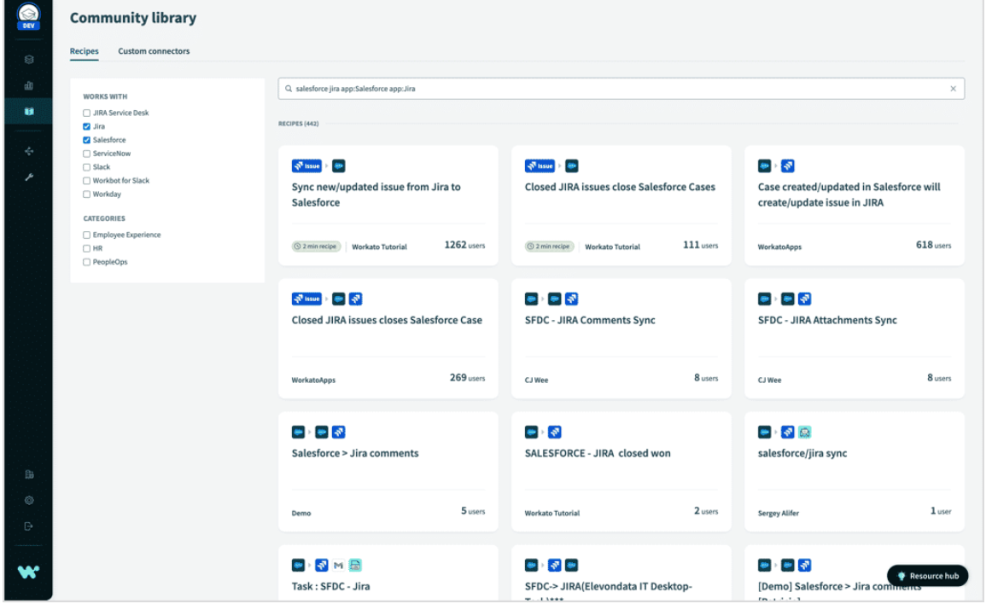

* To use a community recipe in the Community Library, view the recipe and click **Use this recipe** to copy the recipe to your workspace and configure it to your business requirements.

**Module 4: Workato Fit 101**

**Introduction to Business Process, Integration, & Automation**

* **What is Business Process and why it matters?**
* A business process is nothing but set of actions or tasks that different business people

Or diff roles play different parts in doing to ultimately obtain the business goal.

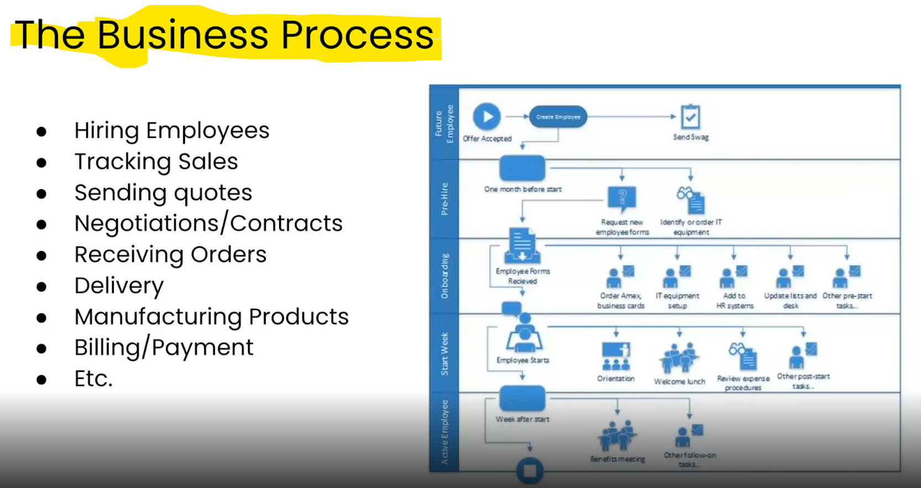

* Business Process Example: Lets consider Hiring Employee is one of the Business process so hiring employee can consist of multiple subtask like interview procee,once offer is accepted business process starts like above picture .
* To maintain data of each and every business process,business needs to use some of the apps tools that can be helpful in maintaining,storing,creating,updating,deleting, business data.let say Hiring Employee is one the business process involved in an organization then the organization/Business should use the apps /tools to store the business data of related business process

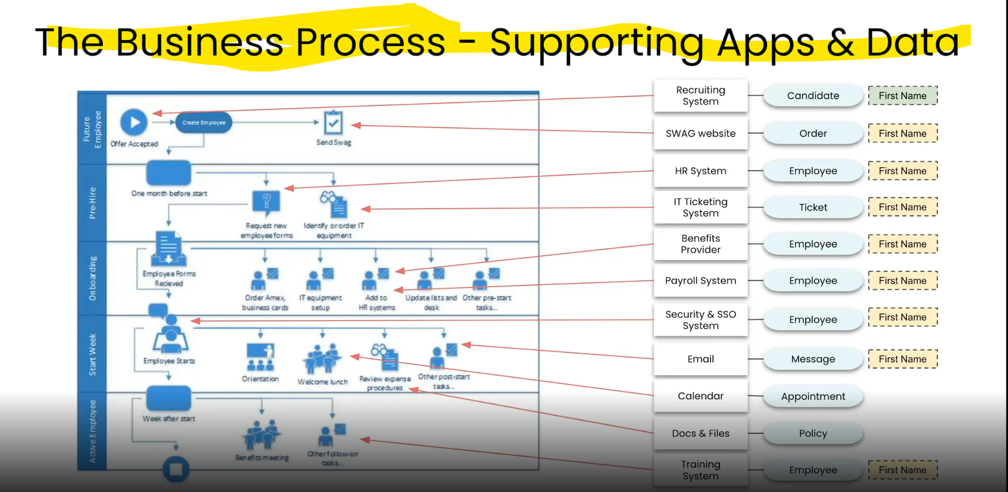

* **What is Integration?**

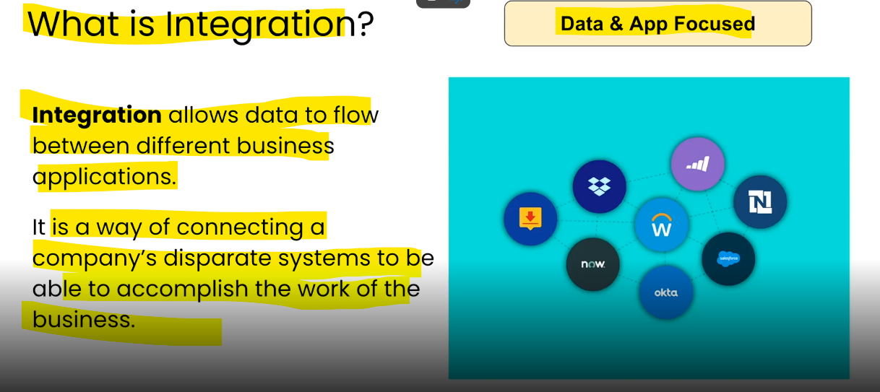

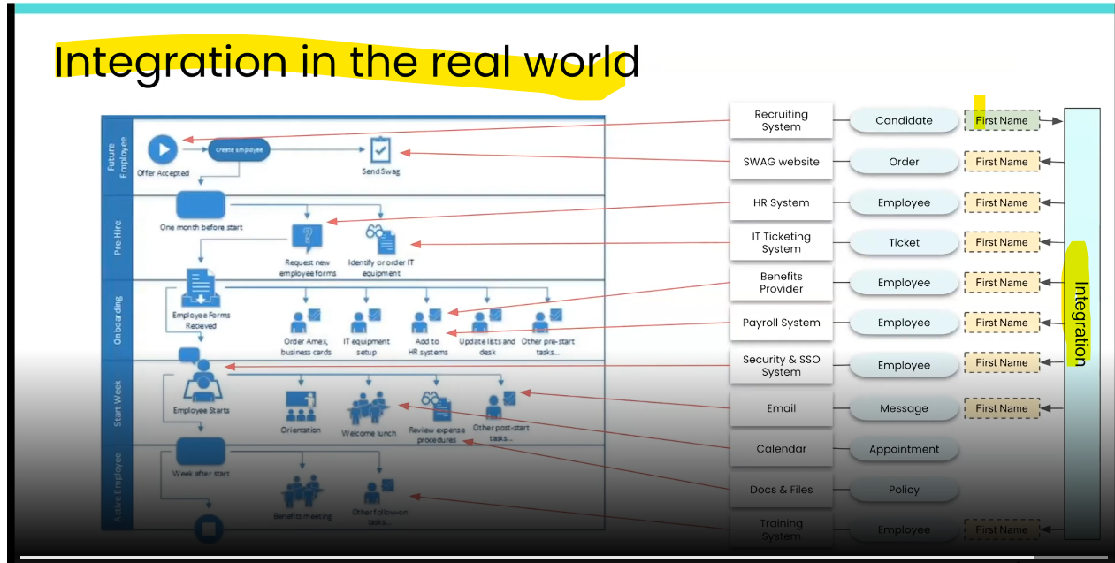

**What is Automation?**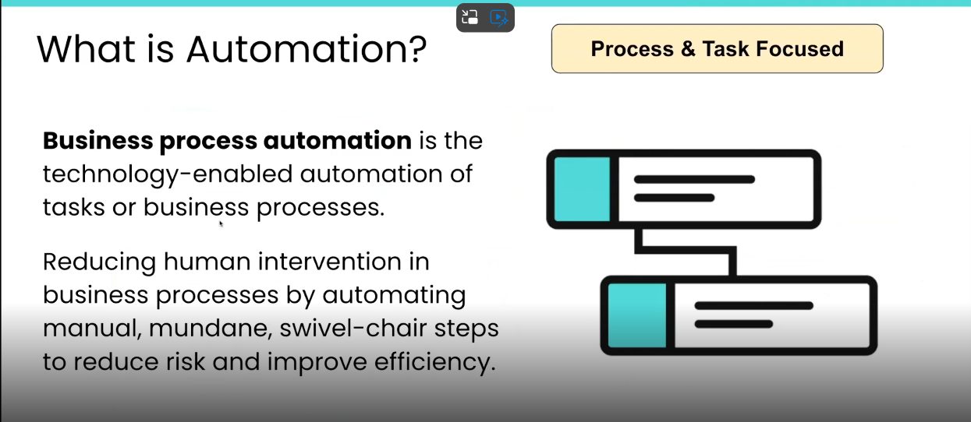 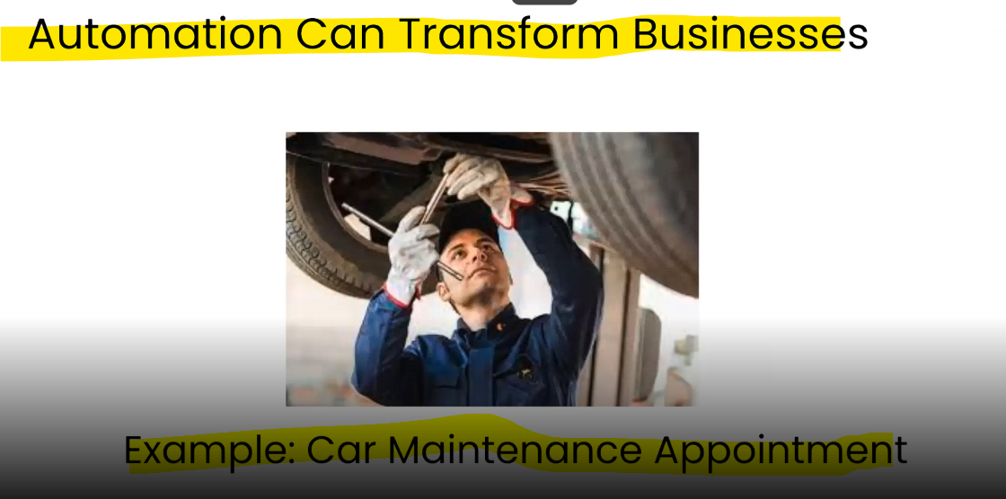

* **How Integration and Automation Work Together?**

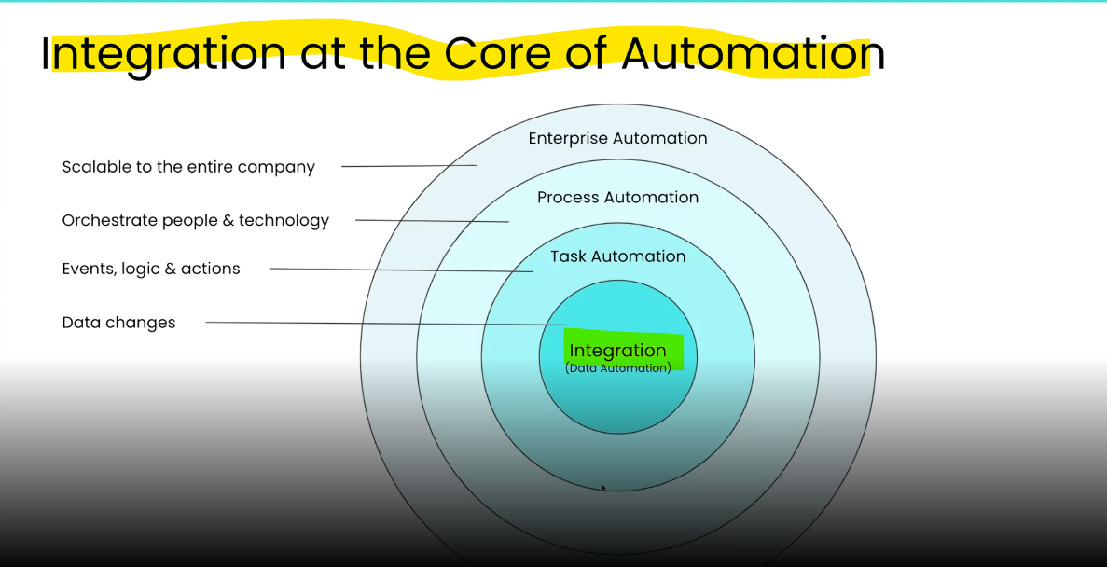

**A Deeper Dive Into Integrations**

* **How Integration Works?**

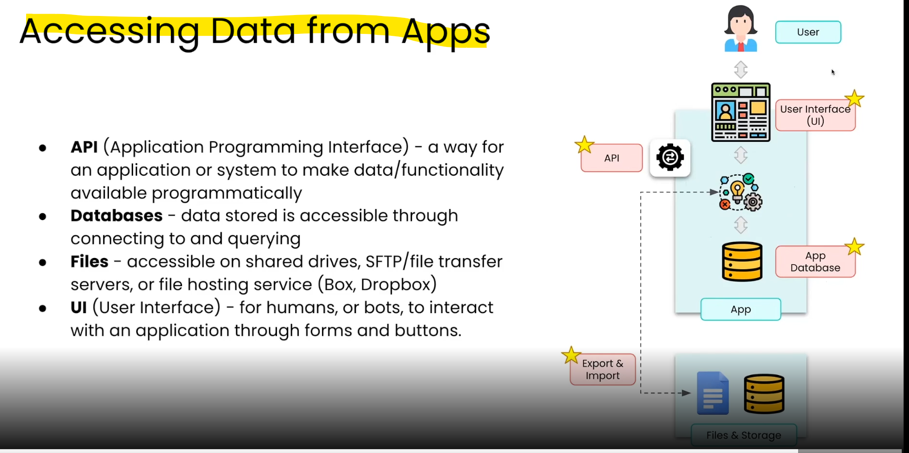

* **Different Types Of Integration?**
* There are few types of Integrations like below?
* **Swivel Chair Integration**
* This is one of the integration type where a user manually enters a data from one system to another

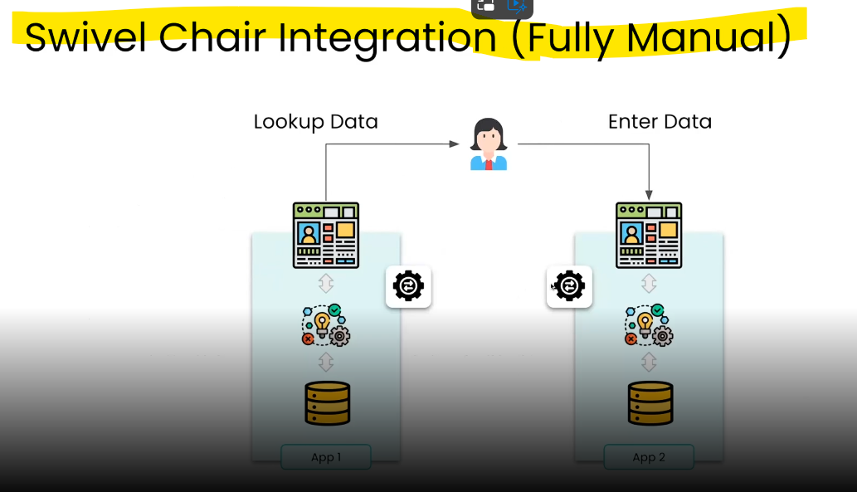

* **File Based Integration**
* This is one of the traditional integration type where we deal with the files where we export the data from one app into file(csv file) n try to transform the data that is accepted by the second system(XML file).

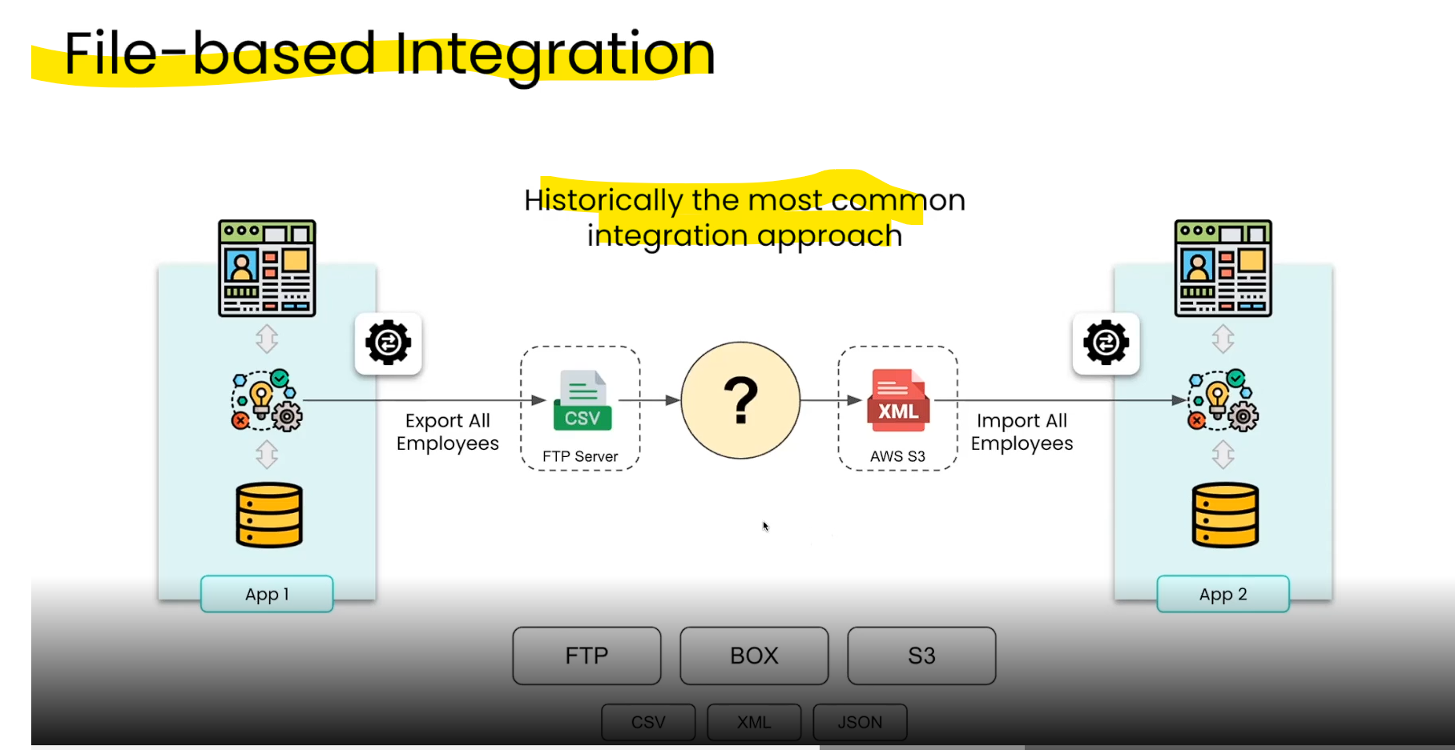

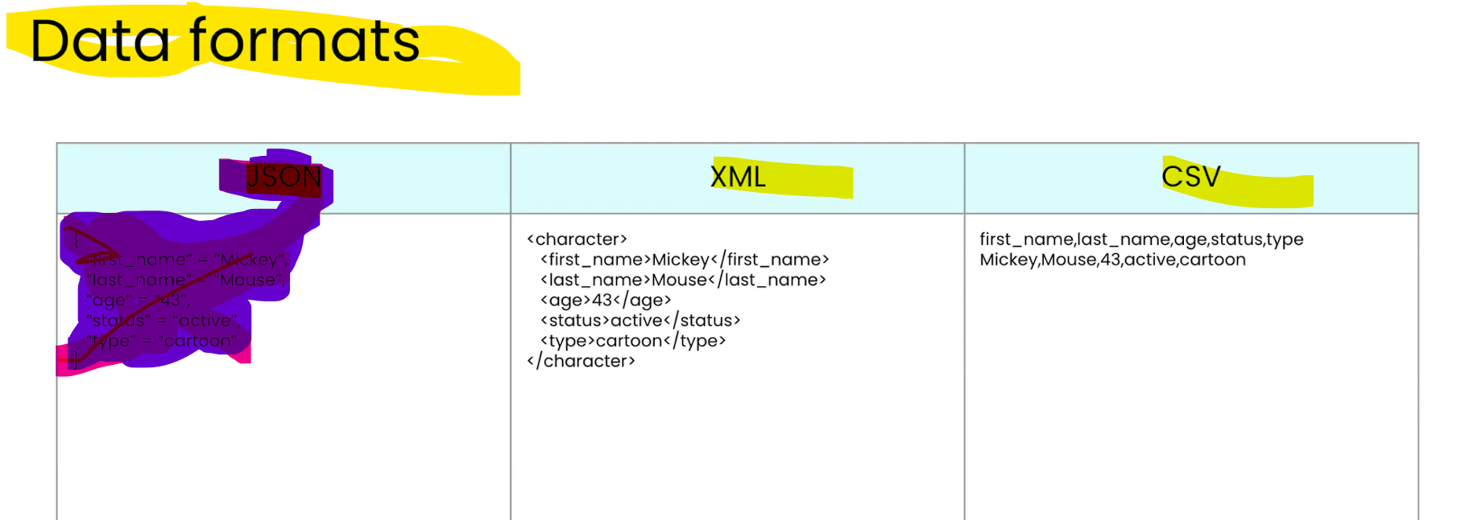

**JSON Format:**

{

"first_name": "Mickey",

"last_name" : "Mouse",

"age": 43,

"status": "active",

"type": "cartoon"

}

* API-Based Integration
* This type of Integration uses API(Application Programming Interface) to establish a communication between multiple systems.

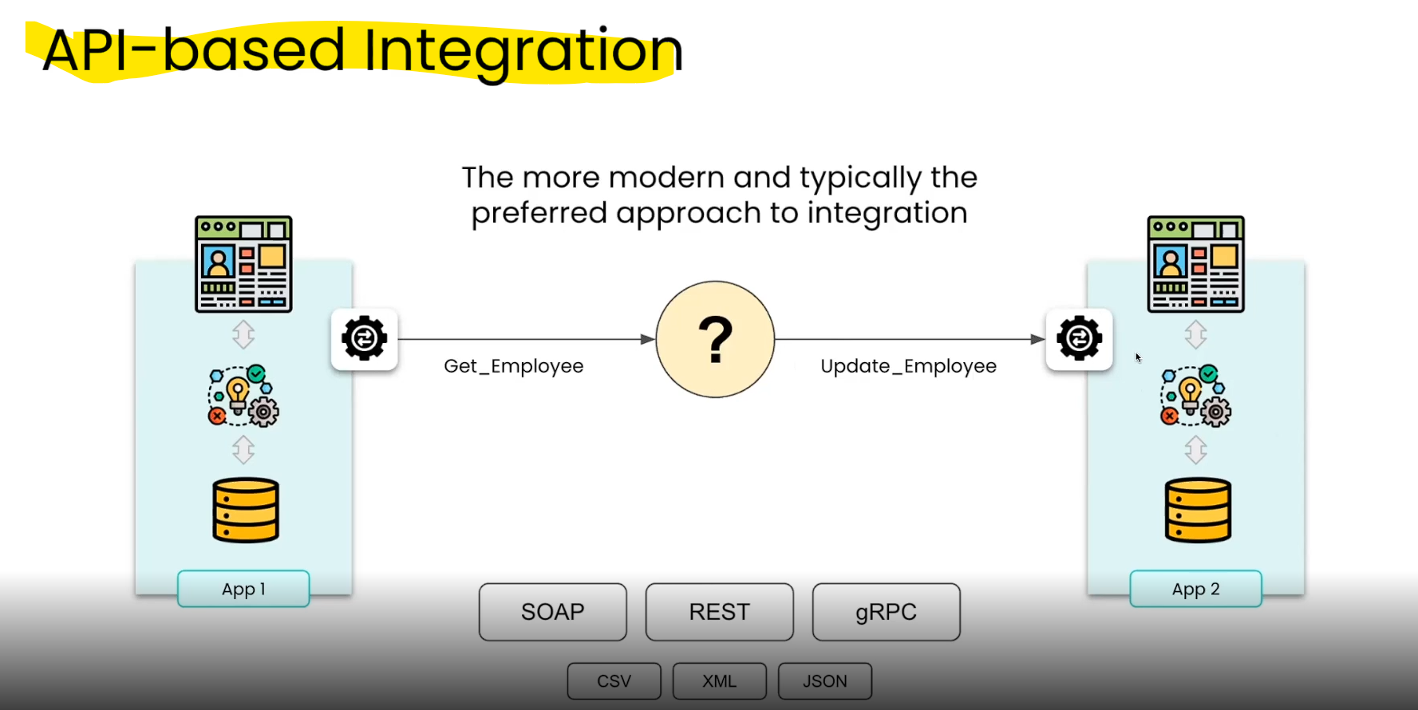

* **UI-Based Integration**
* In this type of integration the Ui of one app sends data to another app UI.

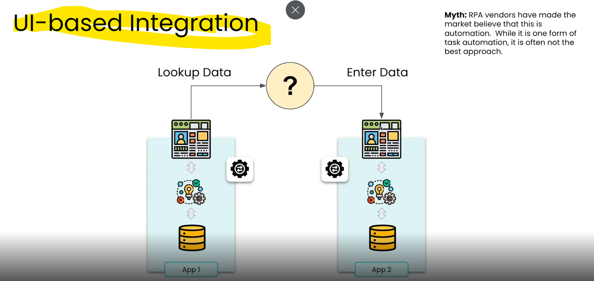

* **Database Integration**
* This type of Integration involves two db systems connecting with each other to exchange the data.This is not recommended one though

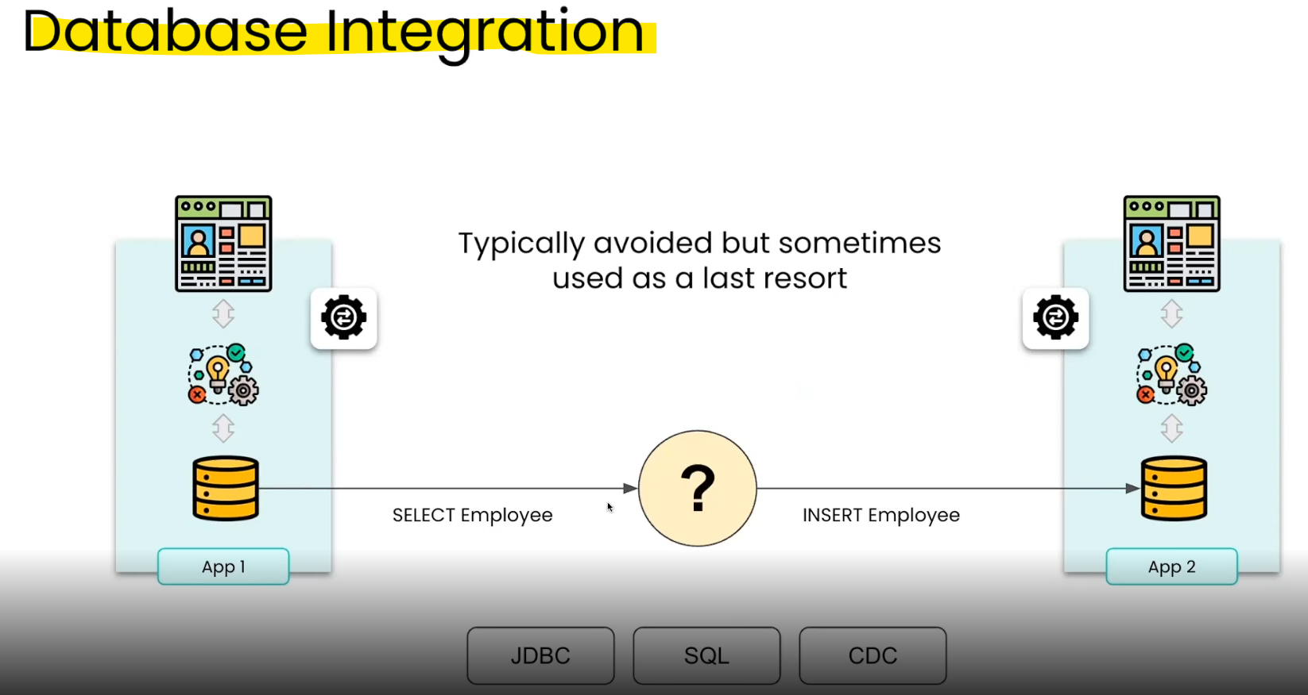

* **Change data capture (CDC)** is a software process that tracks and captures changes to data in a database and delivers them to a downstream system in real-time.
* **Mixed Interface Integration**
* This integration type involves mixed combination of above listed integration types like Database -API,UI-File etc based on requirements and the limitations of systems.

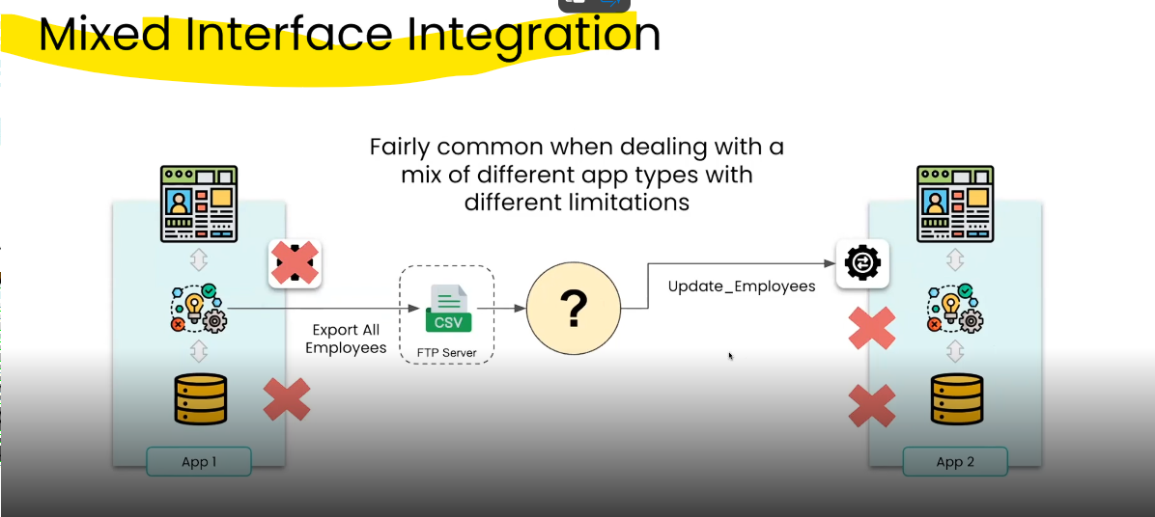

* **How does Integration Happens?**
* **To integrate the systems** either we can use **custome code or scripts** that can be used to integrate or else we can go for **integration & Automation tools available in market** to integrate the systems.

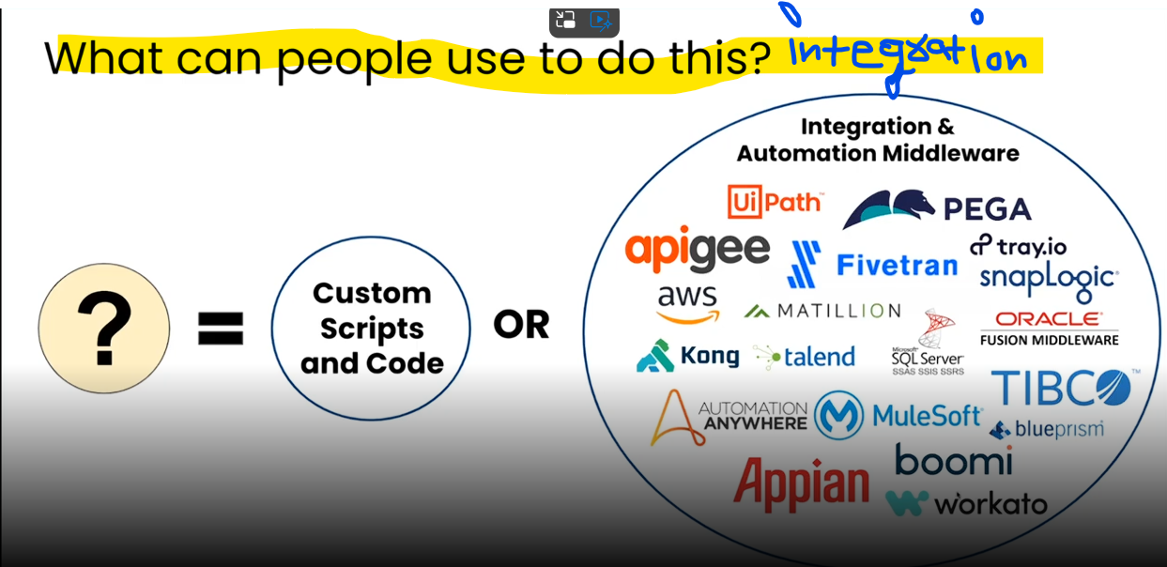

* With Custom Code or scripts we can have point to point integration spaghetti when we create multiple app integrations with each other with below disadvantages

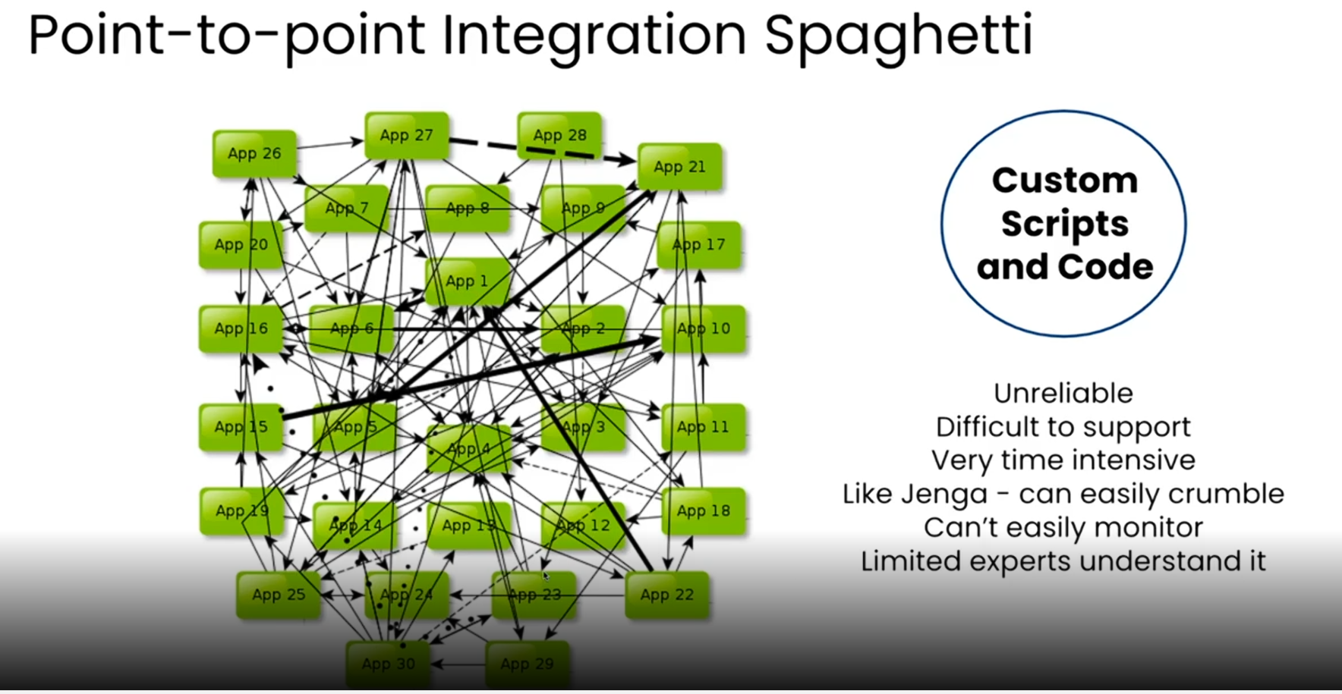

**Industry Overview & Why Workato**

* **Brief History of Integration & Automation?**

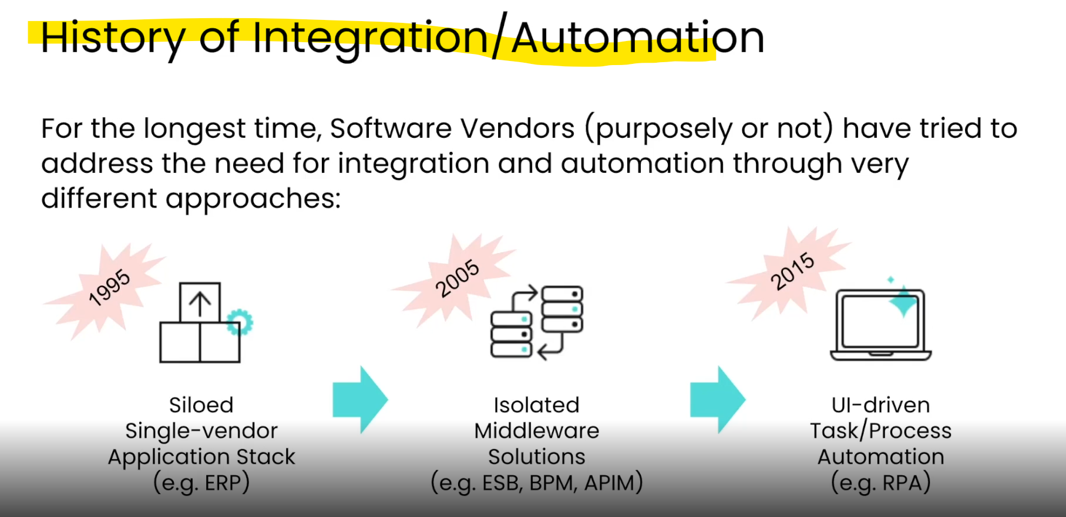

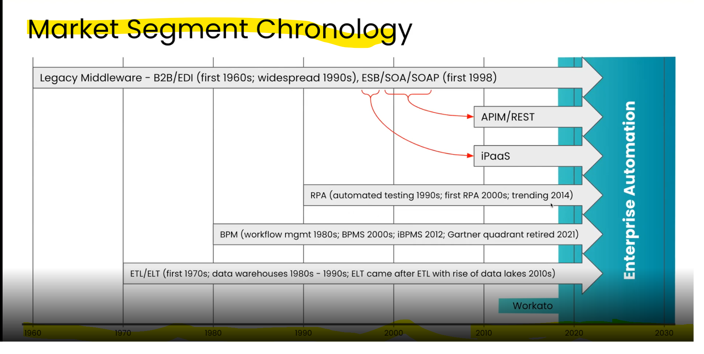

* **Why Workato?**

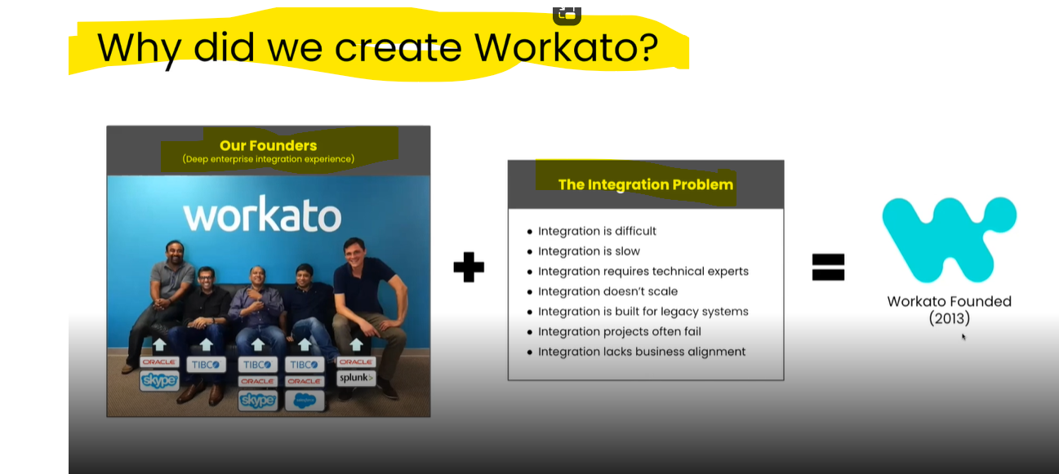

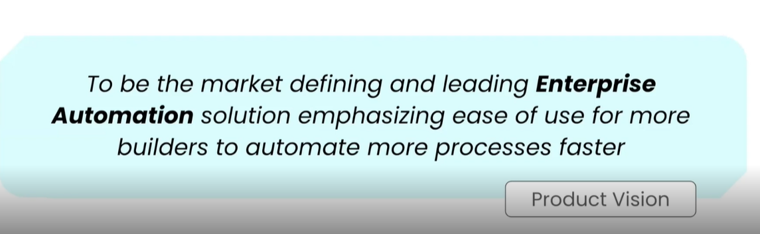

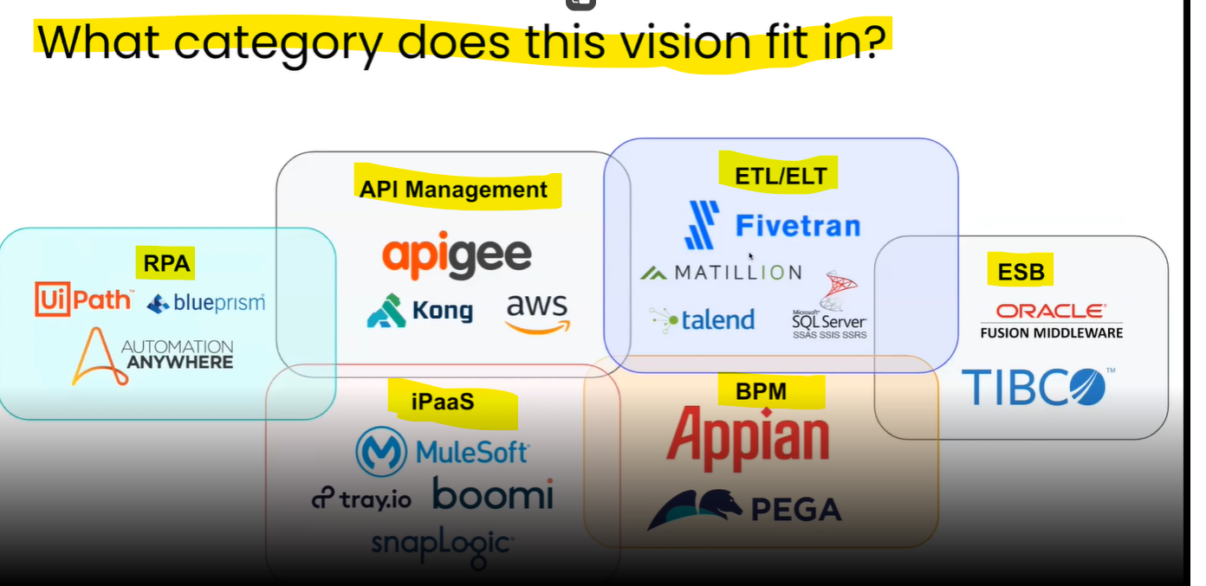

**Note: Workato does not fit into any of the above technology categories mentioned but as the product vision of Workato says that they want to be the market defining, so actually workato wants to create new space called as “Enterprise Automation” where it will be leading the market.**

* **What is Enterprise Automation?**

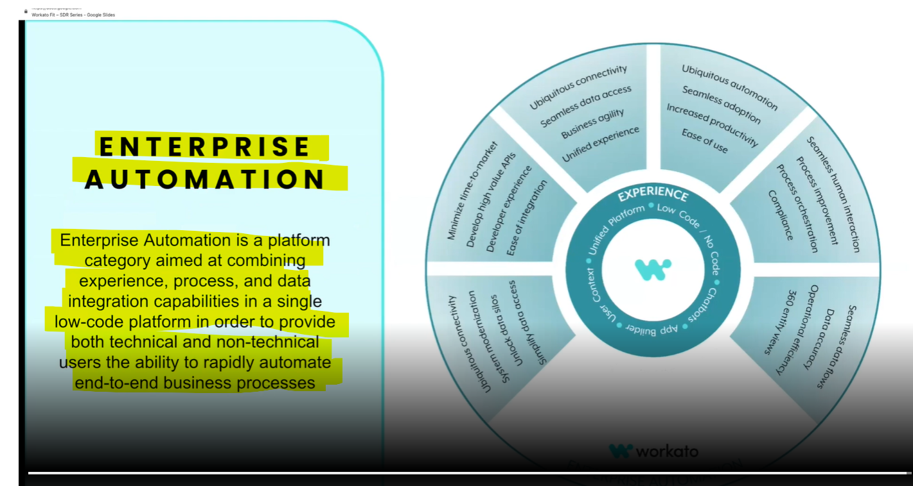

* **Enterprise Automation is a combination of Data Integration,process Integration,Experience Integration where it tries to automate all the business processes by dividing each process into sub processes.**

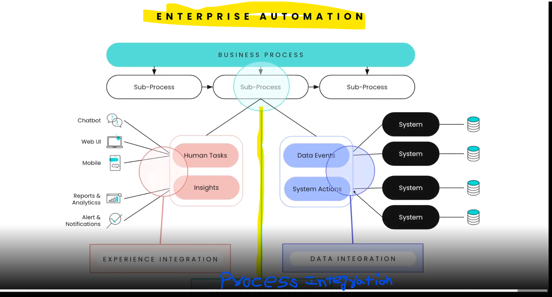

* **Workato Differentiators/Features?**

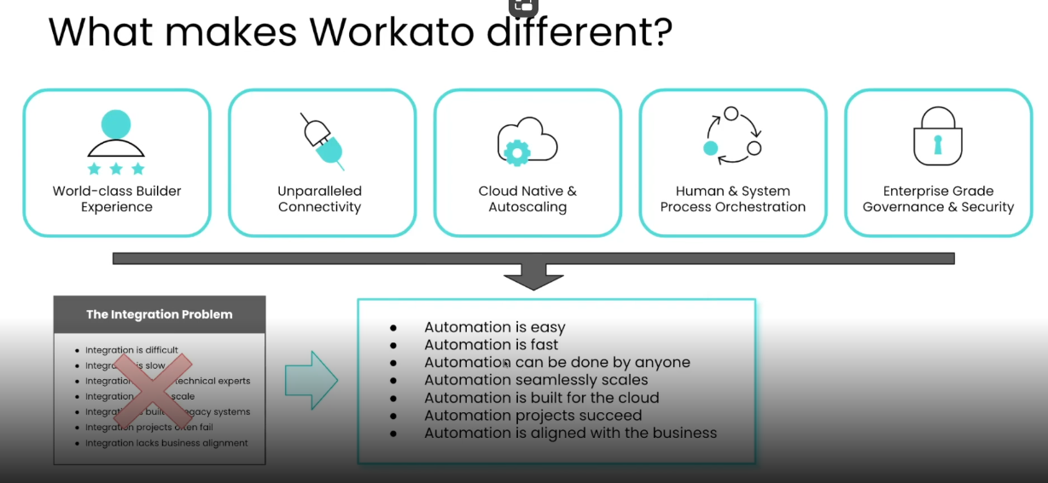

* Where does workato fits in customer environment?

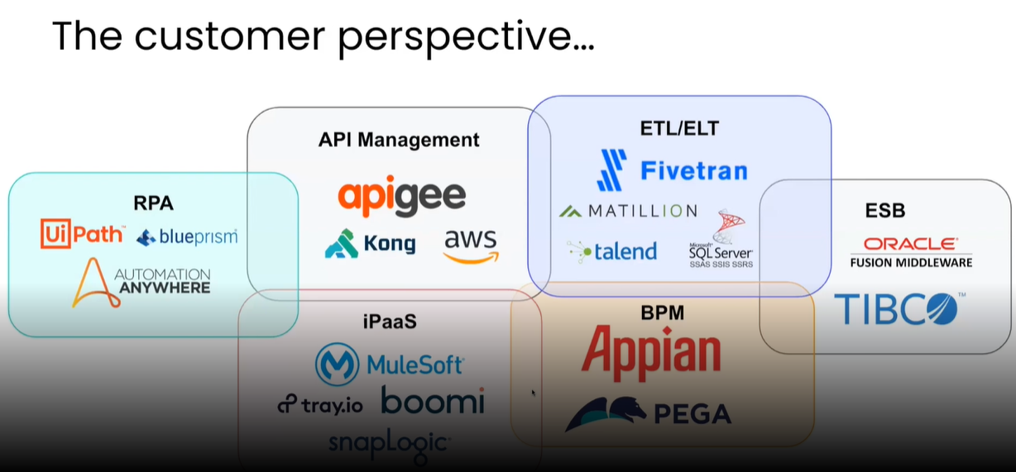

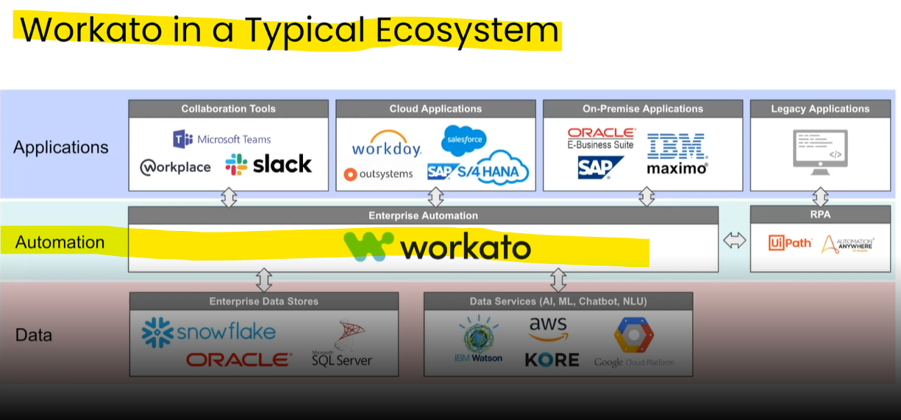

**Module 5 : Automation Pro 2 On Demand**

**Steps Expanded**

* **Conditional Actions?**
* **Conditional actions allow us to control the execution of a recipe flow based on a condition and better define workflow processing logic.**
* There are **three types of conditional actions**: the **IF condition**, the **ELSE IF** condition, and the  **ELSE condition**.
* **IF Condition:** Actions are only carried out if the specified condition is true
* **Else IF Condition:** Different actions are carried out depending on if a specific condition is true or false
* **Else Condition:** Actions can be carried out if no previous conditions are met
* **IF Condition?**



* The IF condition is basically an IF statement where actions are only carried out **if the specified condition is true**.

For example, we can configure our recipe so that an account will only be created in Salesforce if the account ID cannot be found in Salesforce.

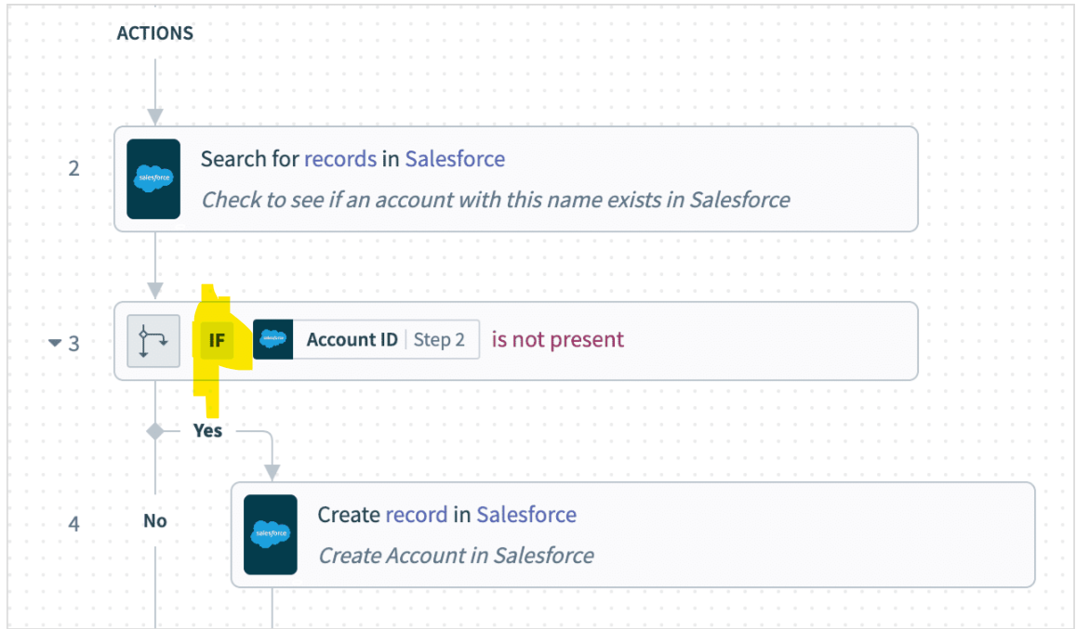

* **ELSE IF Condition?**



* With the ELSE IF we can**configure other actions to do if the specified condition is false** and we can chain multiple ELSE IF conditions.
* **ELSE Condition?**



* we can set tasks to occur if you no previous conditions are met.

Expanding on our Salesforce ID example, we can specify that if the account ID is present, update the account.

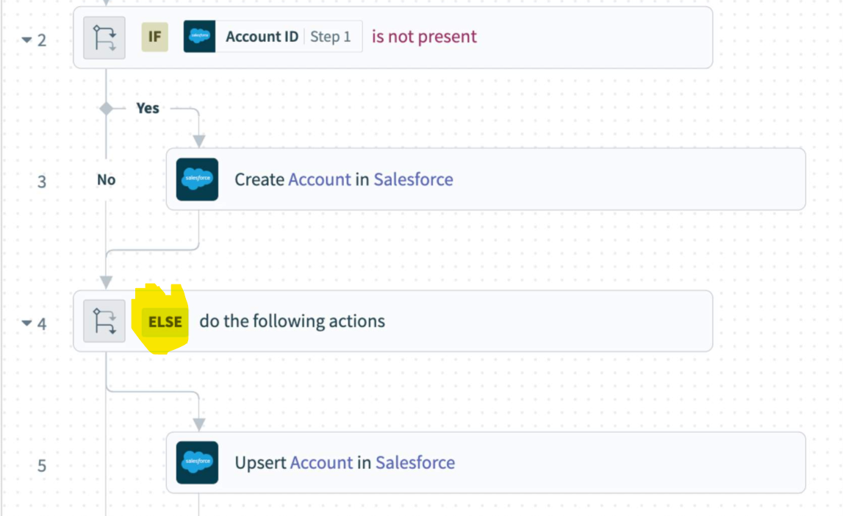

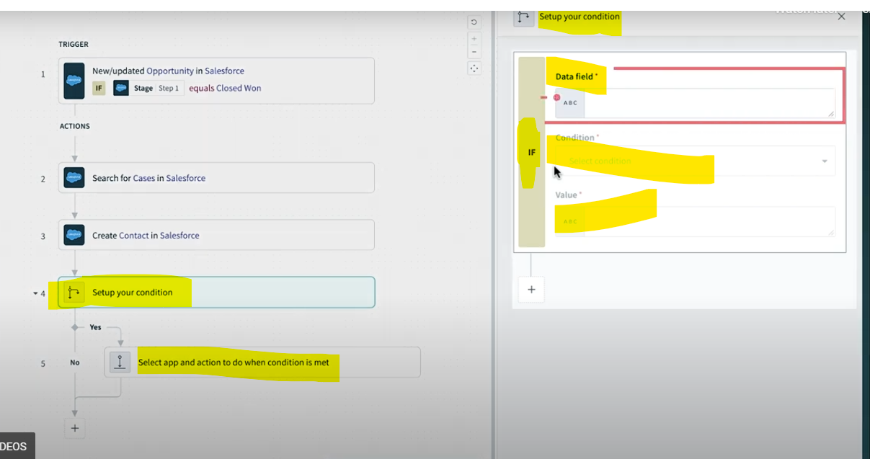

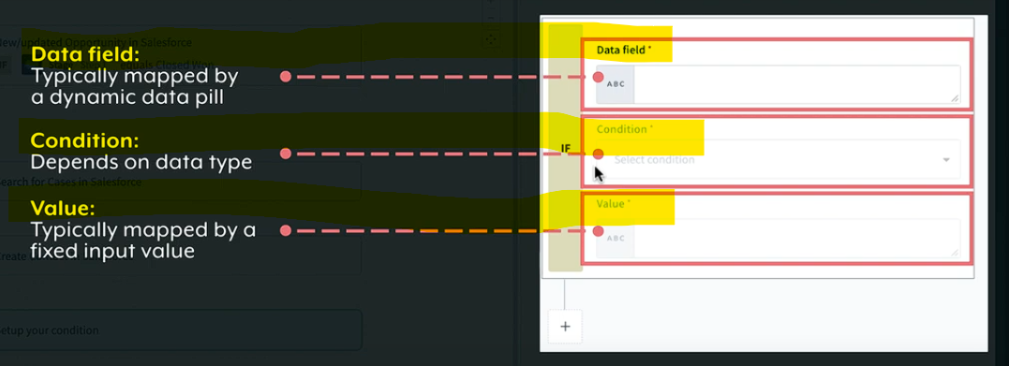

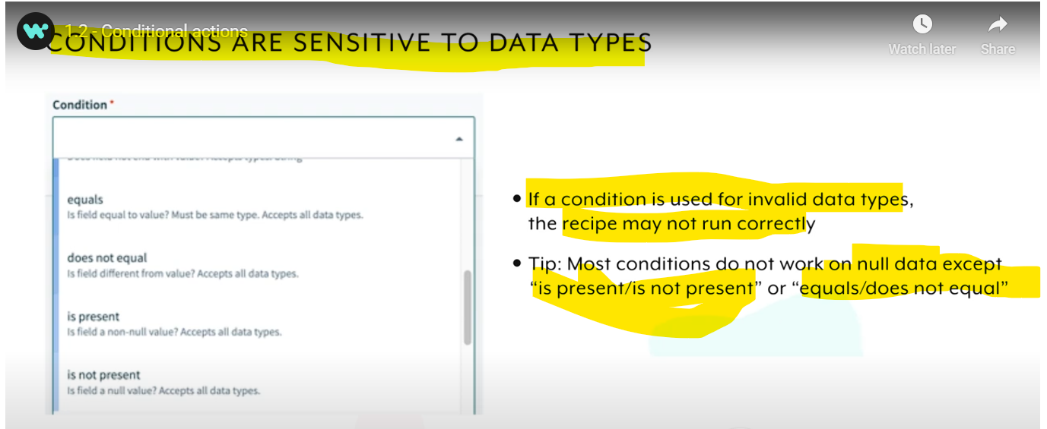

* **Repeat Actions?**
* Integrating business applications often involves working with **batches of records or lists of items**, where you may need to **repeat a set of actions** for every item in a list.

**For Example:** In the Google Sheet that we are using for Lab Exercises, we total have 19 Records which we want to import in Salesforce Contact object based on Industry=Finance Condition …so out of 19 records we will have 3 industry=Finance records which we want to see in salesforce as a outcome.Since if we are using if condition alone we will be able to import only 1st record of 3 this is becoz as we are not using repeat action to perform which will loop thru all 19 records and will then apply IF industry=Finance condition n import the data in salesforce else log the message as industry.

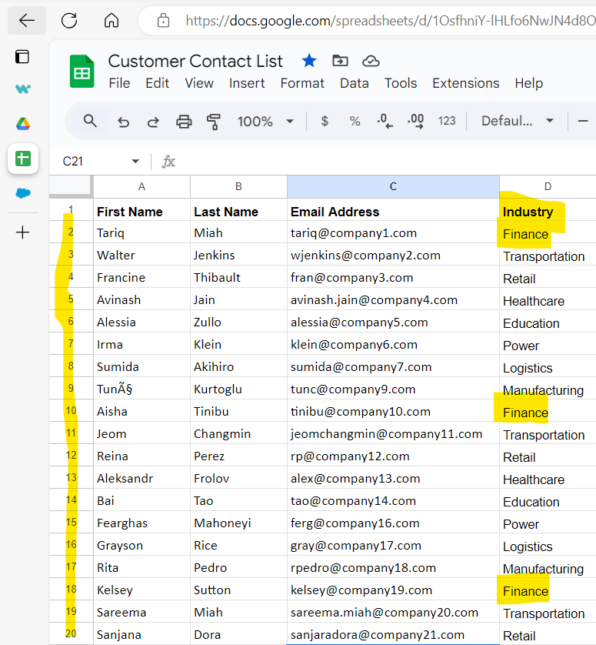

* You can use the **Repeat for each** action to **execute a set of actions through every item in a list**.
* This action functions similarly to the **foreach** loop concept in programming. For example, for each file attachment in Salesforce, you can upload the file to Box.

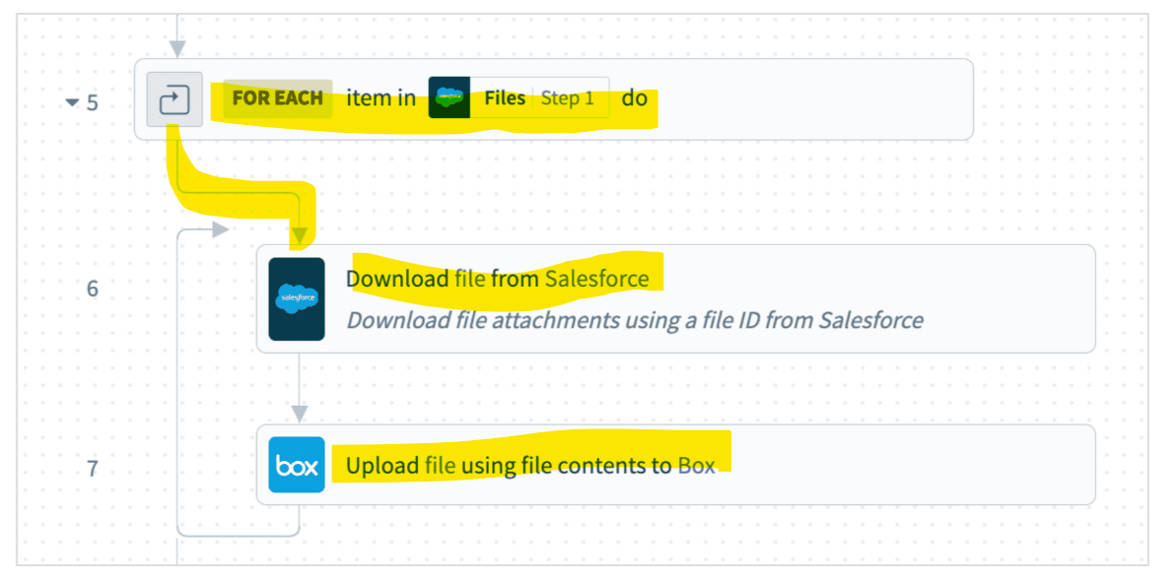

* **To refine your batch task, you can use the Repeat while action to create a loop that executes configured tasks at least once and continues iterating while a condition is met.**

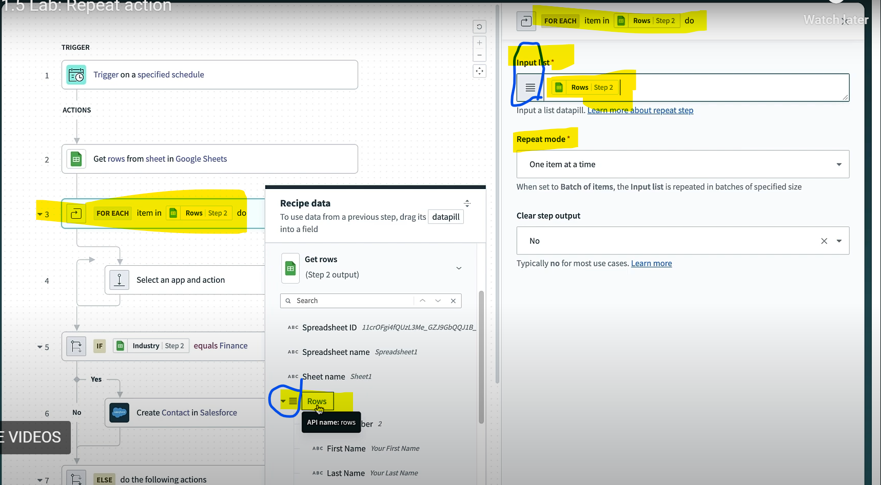

**Input for the ForEach or Repeat action is a list of items which can be indicated in stack iconor which is 3 horizontal lines resembles a hamburger.**

* **Error Monitoring And Handling?**
* When running your recipes, errors can occur and affect the successful execution of your workflows.
* These errors can be **system-generated**such as temporary network issues, or **user-created**. Another error can occur from **bad data input**, where a string number was expected for an invoice amount but a string text was passed instead.
* As such, when building recipes, it is good practice to **monitor for errors and handle** them appropriately. To do so, you can use the Handle Errors action when building your recipes.

-For Error monitoring n error handling we can use **Handle Errors** step which will create 2 blocks Monitor Block & On Error Block

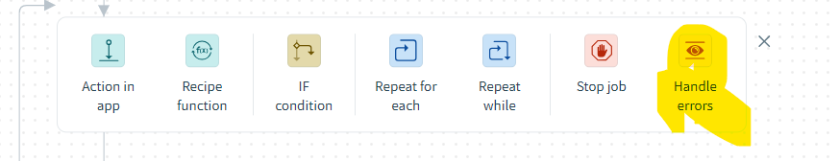

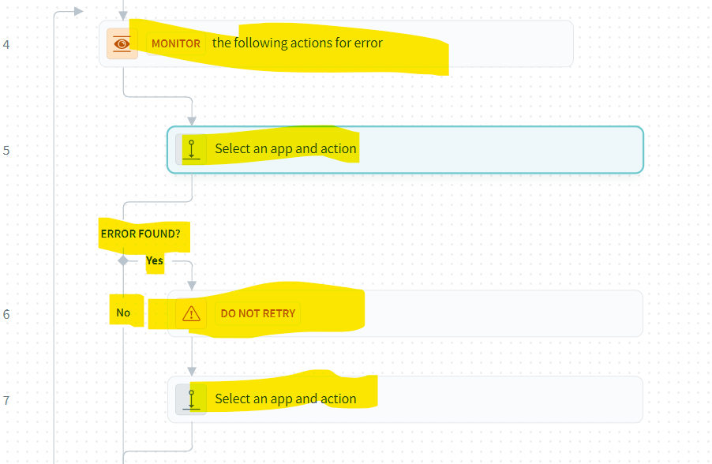

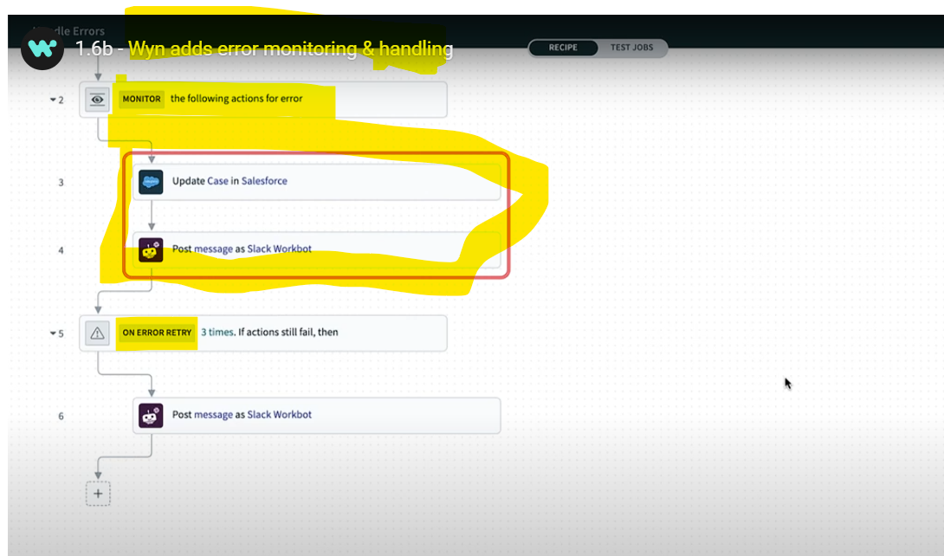

**-**The above **monitor block will monitor for an error in salesforce n slack action listed under the monitor block** if it **encounters an error then it goes to error block where we have specified retry as 3 times so it will retry 3 times after the retry exhausted it will execute the error block’s slack action.**

**Maximum we can configure 3 retry in On Error block n we can define the time interval between retries n the retry If condition**

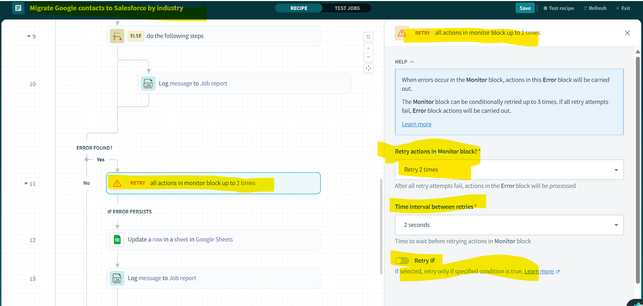

* **Stop Job Action**
* We may also make use of the **Stop Job action** in error handling or for other purposes in a recipe.
* **This action stops the job from executing further actions in the recipe.**
* **It is often used in cases when there is an error in the workflow logic and further processing of the job is not required.**
* **When configuring the Stop Job action, we also have the option to mark the job as Successful or Failed in a job report. If chosen failed it adds one more option to configure the reason of Failure option**

**Data mapping & modifications expanded**

* **Introduction to data transformations**
* **During recipe design, you could find that some data fields from one app may not directly map into a data field for a different app.**

For example: Your sales app stores names in a single field*full name*, but your marketing app uses two fields*first name*and*last name*

Your e-commerce app stores addresses as the individual fields *address line 1, address line 2, city, state*, but your accounting app only accepts a single *billing address* field

The priority levels in your ticketing app are stored as *low, medium, high*, but in your sales system they are *low, normal, urgent*

* In such cases, you can take advantage of Workato's data transformation capabilities by using **formulas**.

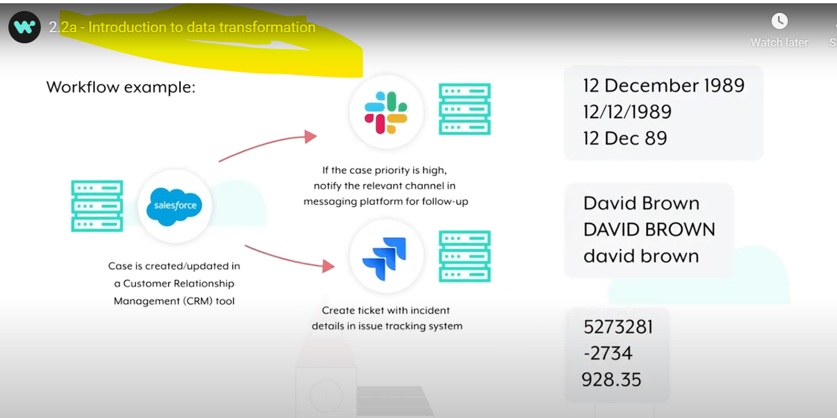

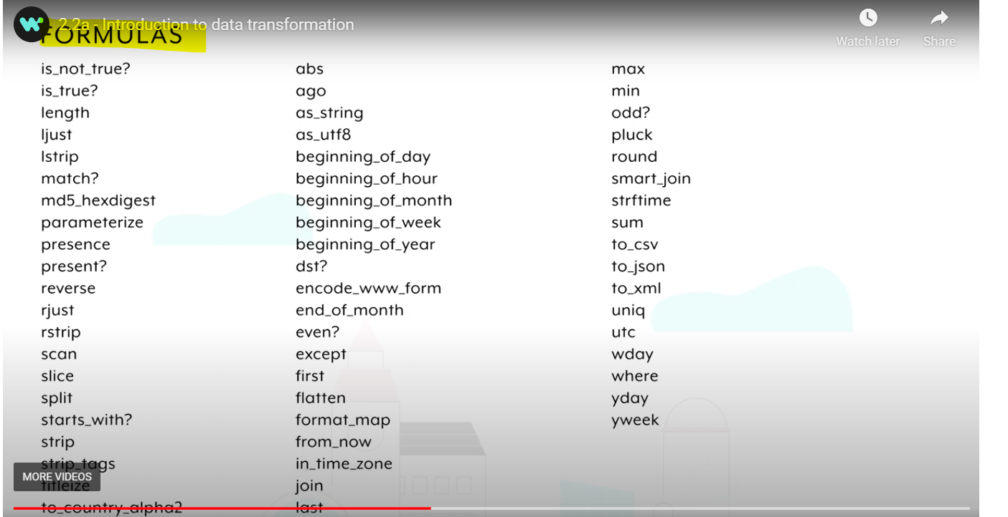

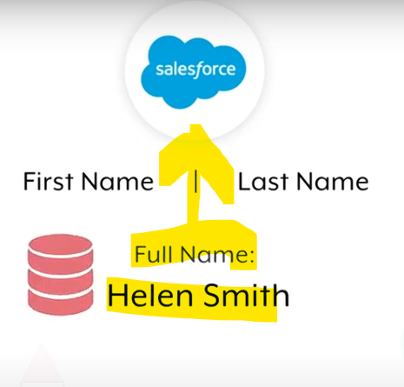

* Here the **source db have column Full Name with data such as Helen Smith** but our **target system salesforce requires data in two separate columns like First Name as Helen & Last Name as Smith so to transform the data we can use Formulas in Workato**

**While mapping to Salesforce upsert or create action we can have below configured**

**First Name: Full Name.split.first**

**Last Name: Full Name.split.last**

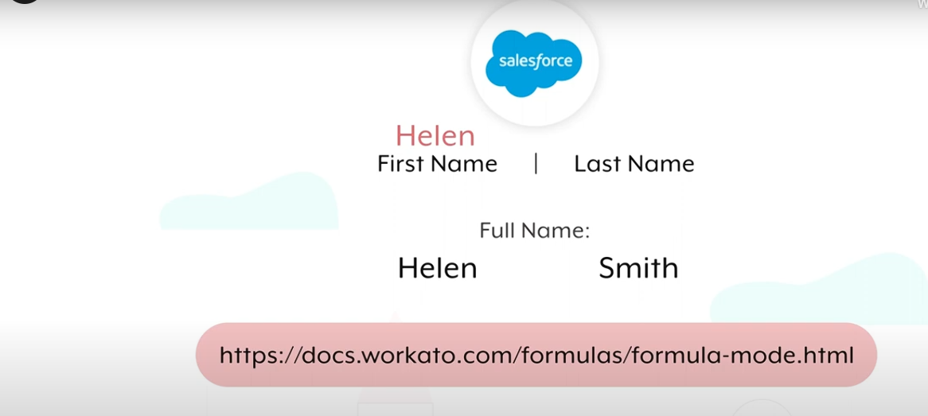

* **Formulas?**
* When you're first learning formulas, it's best to start with simpler scenarios before working up to more complex use-cases. However, even seemingly simple formulas can be powerful in meeting the needs of your workflow automation.
* Formulas in Workato are**Ruby methods** we have added to an allowlist and therefore not all Ruby methods are supported. You can also **combine multiple formulas** to achieve your desired outcome.

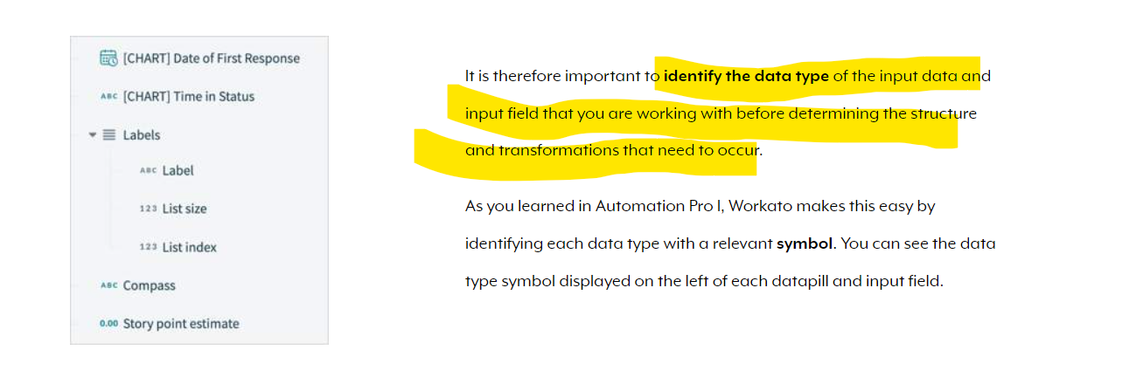

* There are four main types of formulas based on the data types.
* **String formulas**
* **Number formulas for integer and float**
* **Date and datetime formulas**
* **List formulas**
* **String Formulas**
* When automating workflows, you may need to modify letters, numbers, and symbols. In **Ruby**, these sequences of text and characters are called **strings**.
* Formulas in Workato are Ruby methods we've added to an allowlist, and therefore not all Ruby methods are supported. You can always reach out to us to add additional formulas to the allowlist. Syntax and functionality for these formulas are generally unchanged.

Note: **Most formulas will return an error and stop the job if it tries to operate on nulls (expressed as nil in Ruby), except for present?, presence, and blank?.**

* Common string formula types are:
* **Manipulate text**
* **Manipulate text case**
* **Apply conditions**
* **Convert strings to other data types, vice versa**
* **Manipulate Text**
* Often, you will need to add or remove specific characters to a string, or change numbers into a certain format for display. The following formulas are helpful in such situations.

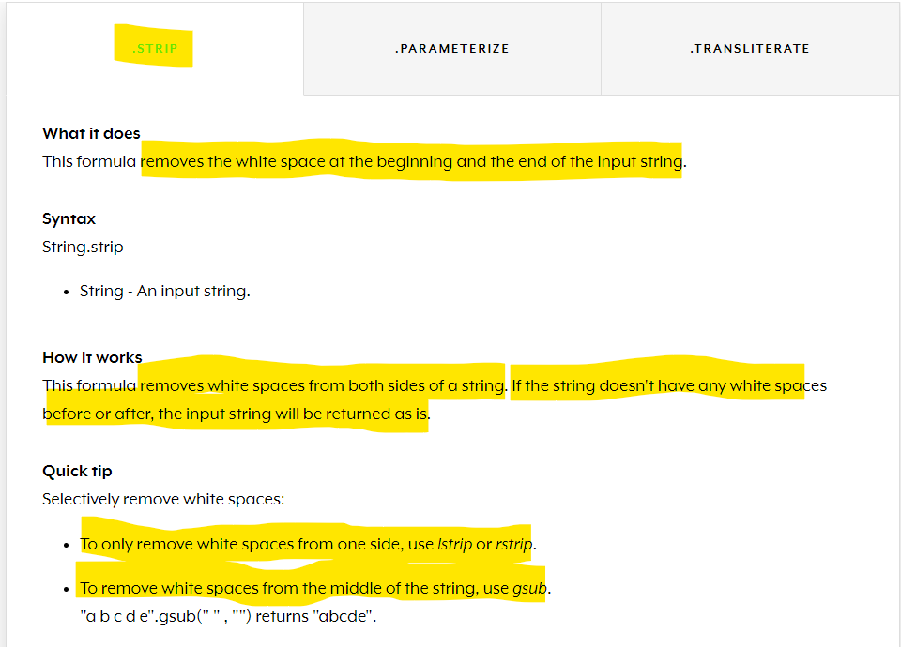

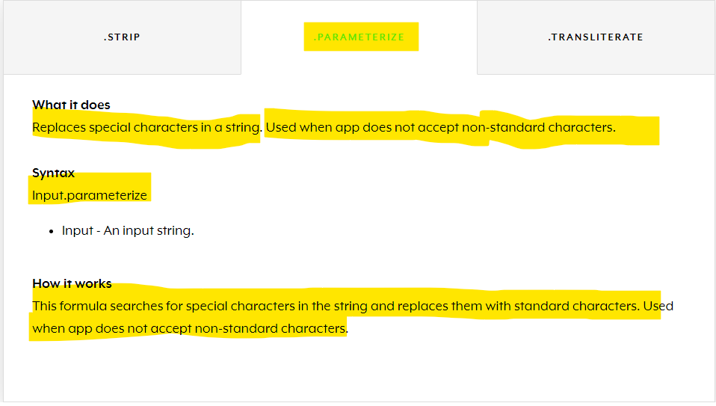 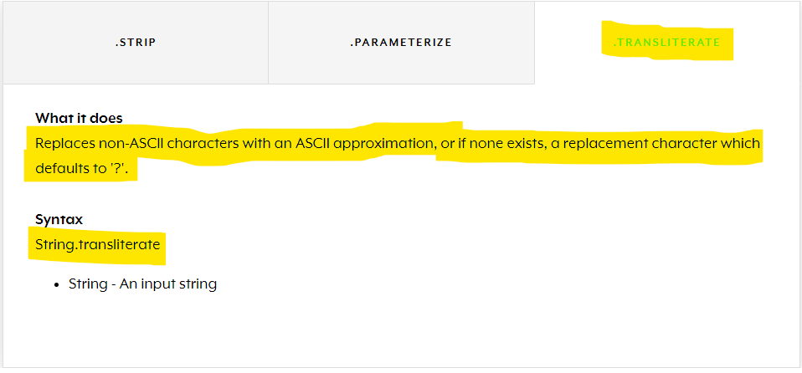

* **Manipulate Text Case?**
* In addition to formatting characters, you can also change the case of text or certain parts of text. For example, you might want to capitalize words in a sentence.

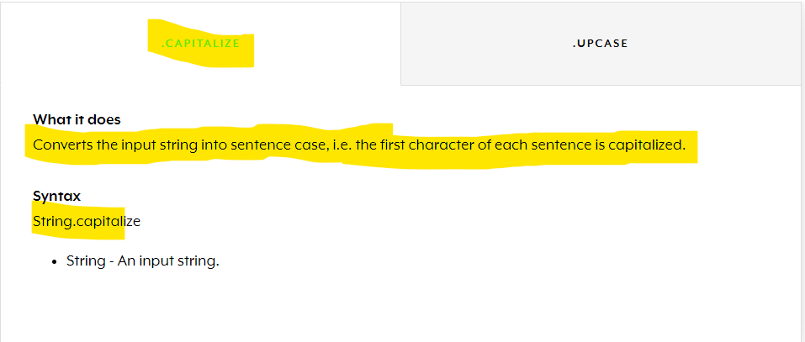

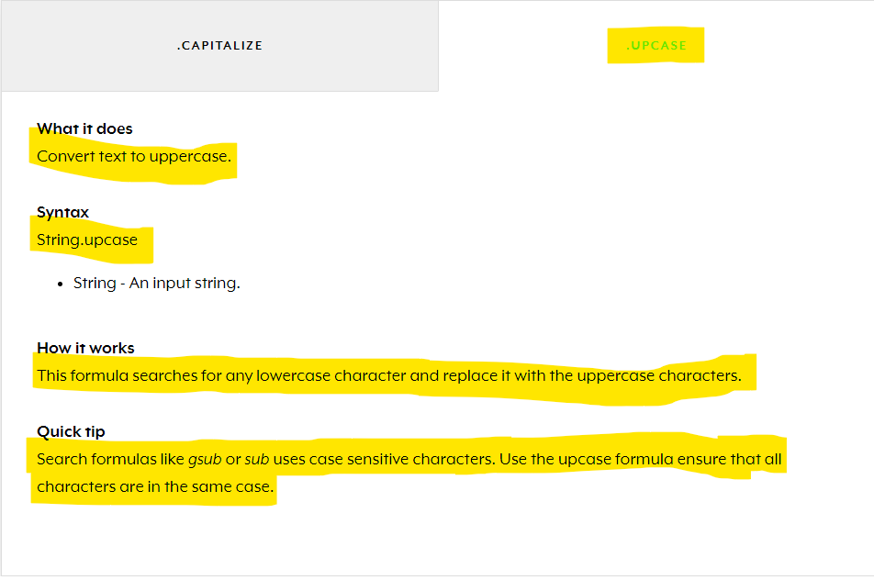

* **Apply Conditions?**
* When working with strings, you may want to apply conditions to check for important information, such as whether the input data contains any value, or if it includes a certain text.
* You can conditionally execute formulas using Ruby's ternary syntax (popular shortcut for if-else statements).

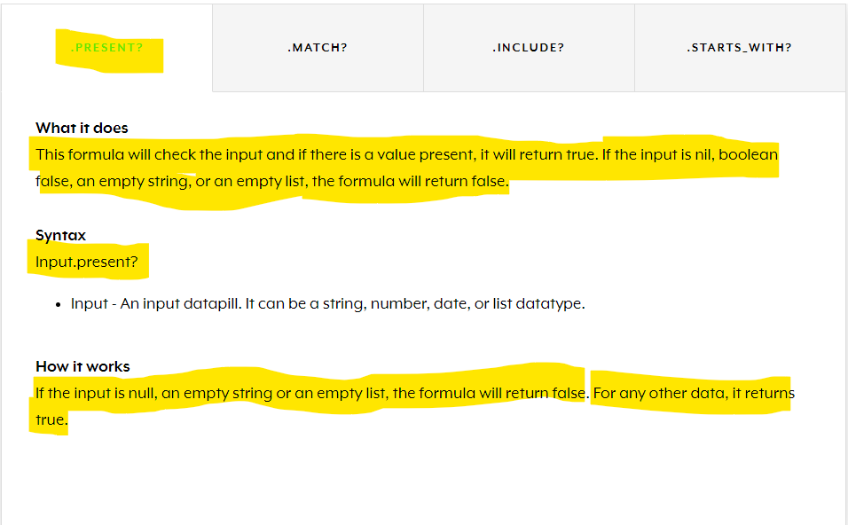

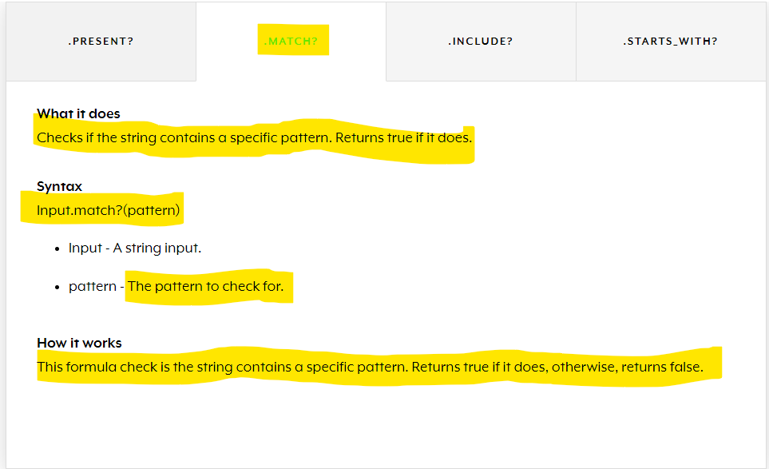 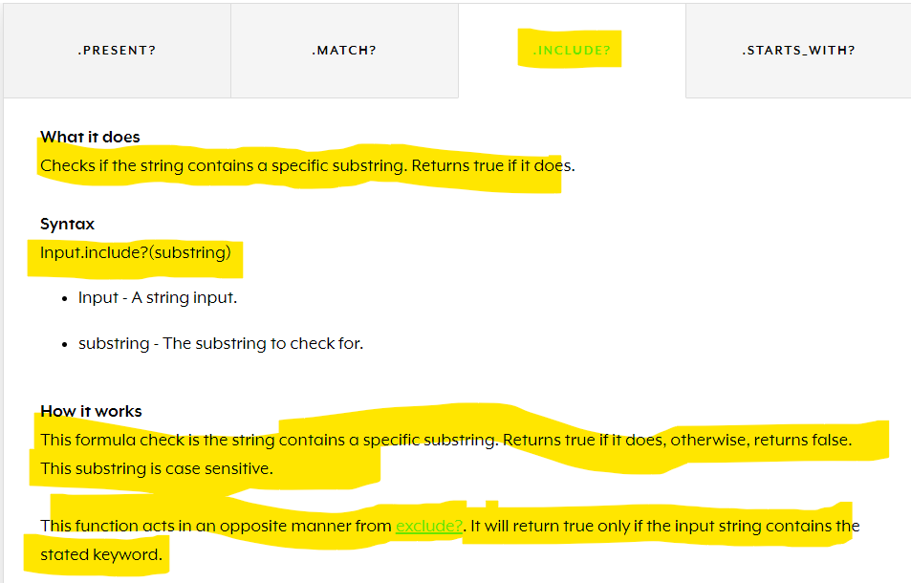 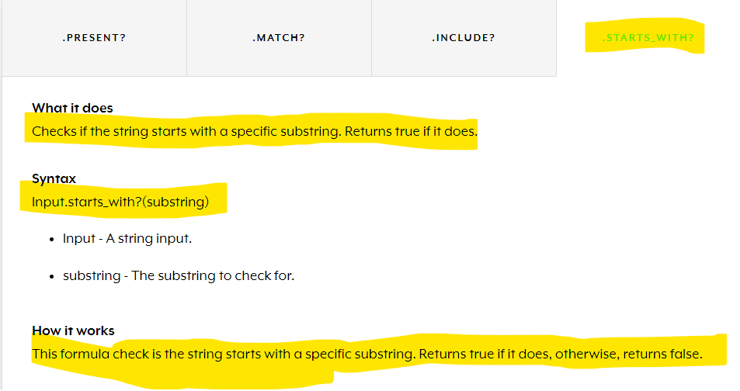

* **Convert strings to other data types?**
* You can also use formulas to convert strings into other data types required for your workflows, such as lists.

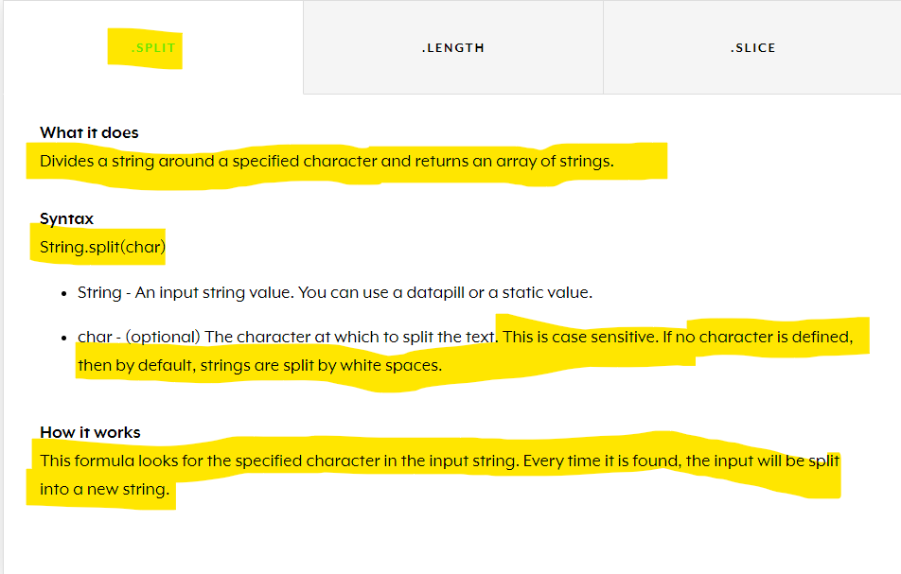

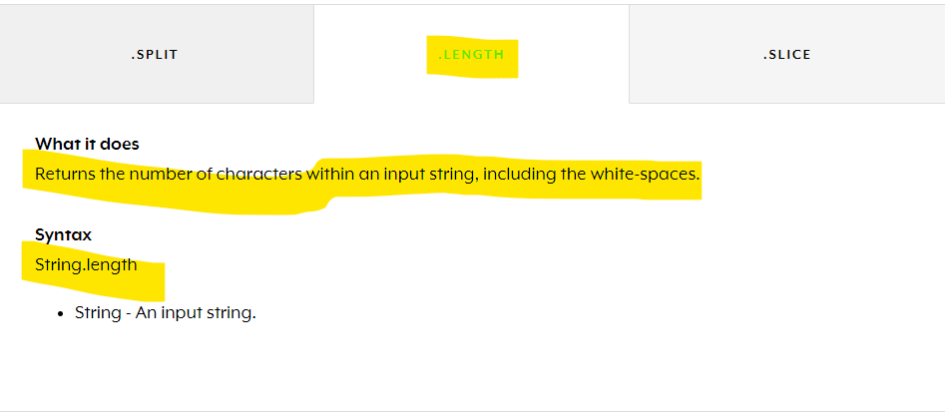 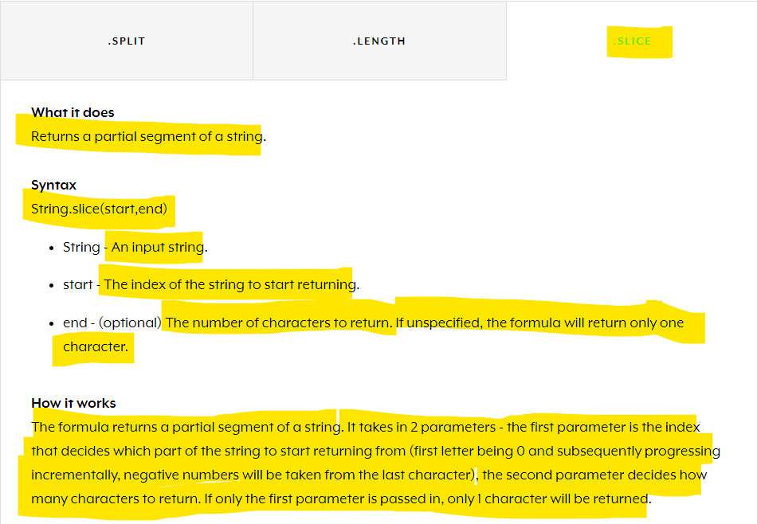

* **Number Formulas?**
* When building recipes, you will often have to process large amounts of data involving numbers, such as payroll, sales records, postal codes, and currencies.
* Workato offers several formulas for processing numbers as:
* Integers (whole numbers)
* Floating point numbers, or floats (positive or negative whole number with a decimal point)

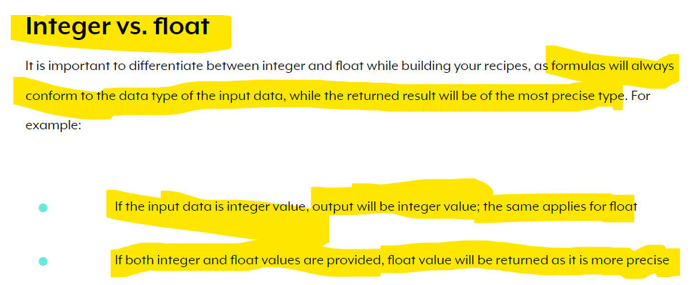

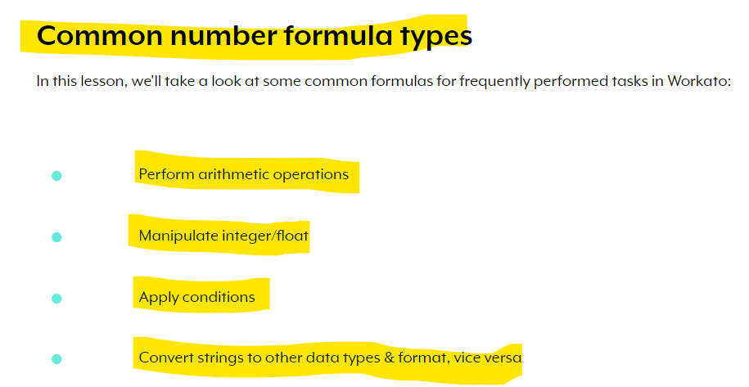

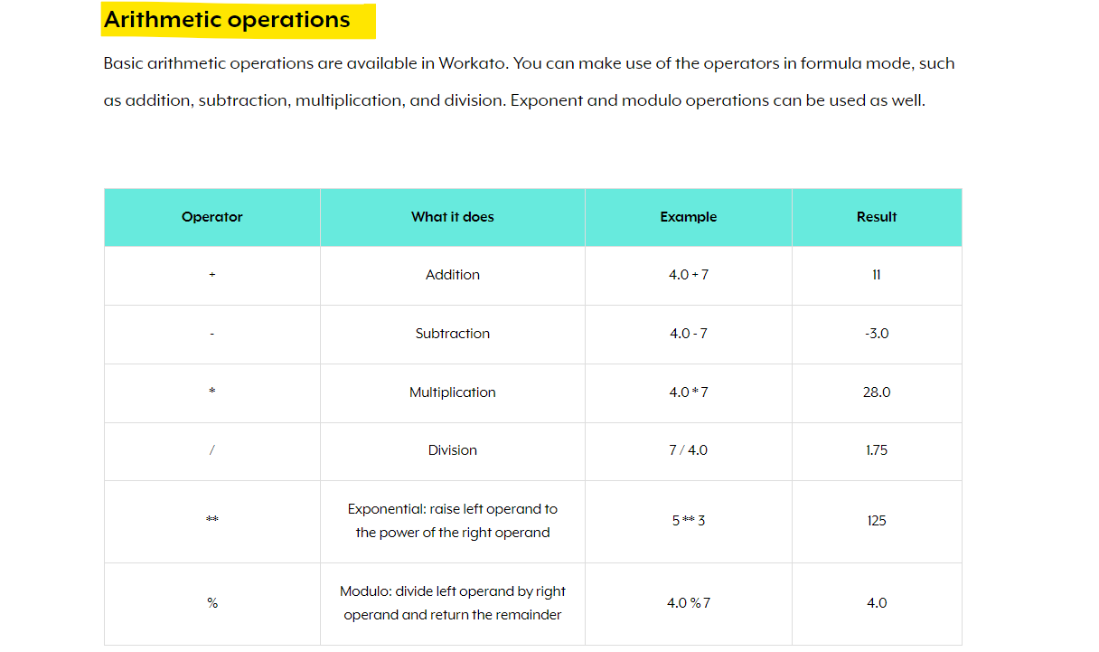

Note: **Remember that when working with numbers, formulas will always stick to the data type of the input data, while the returned result will be the most precise.**

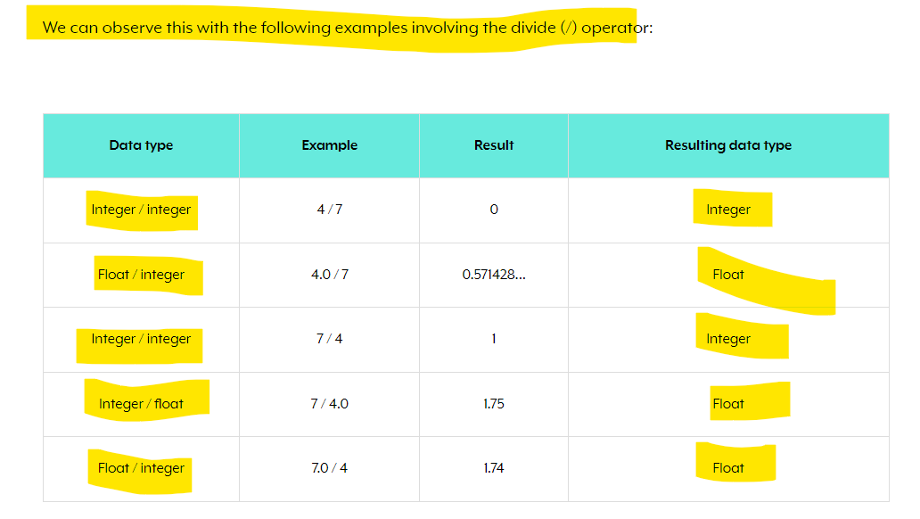

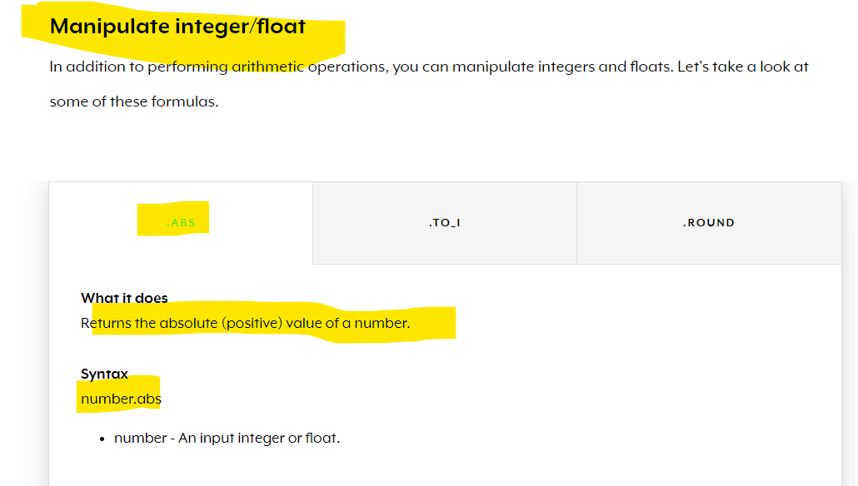

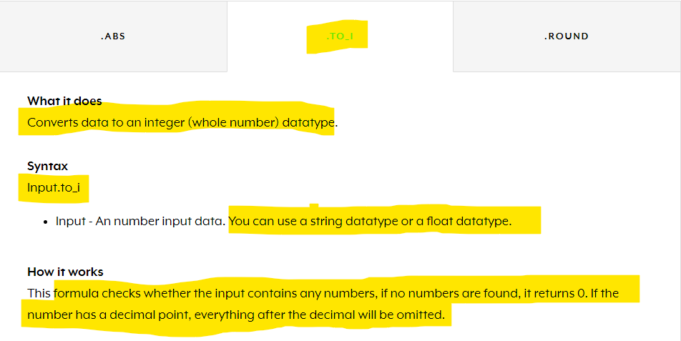

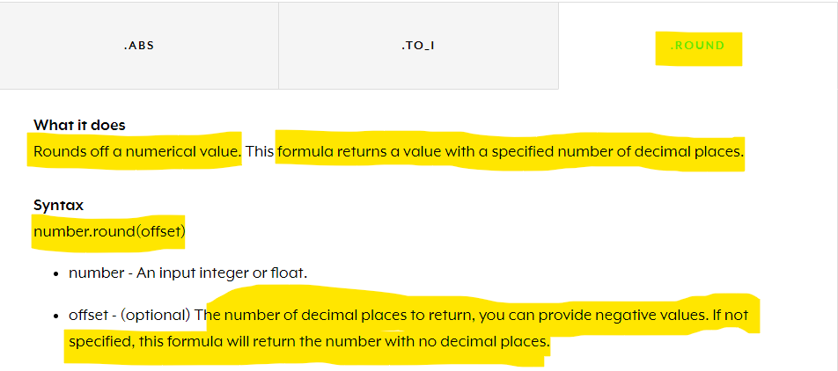 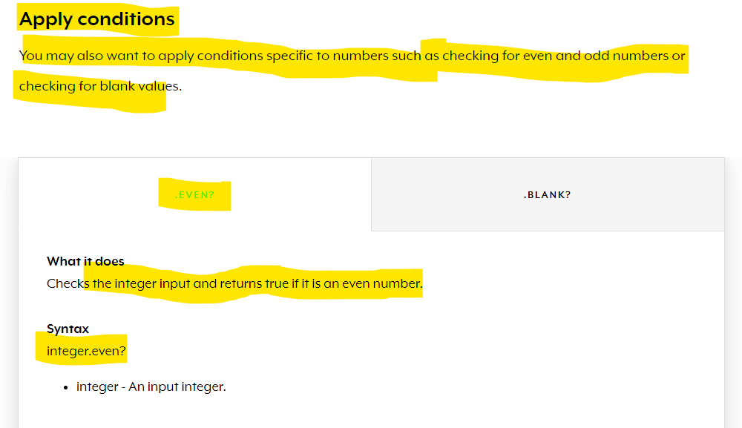 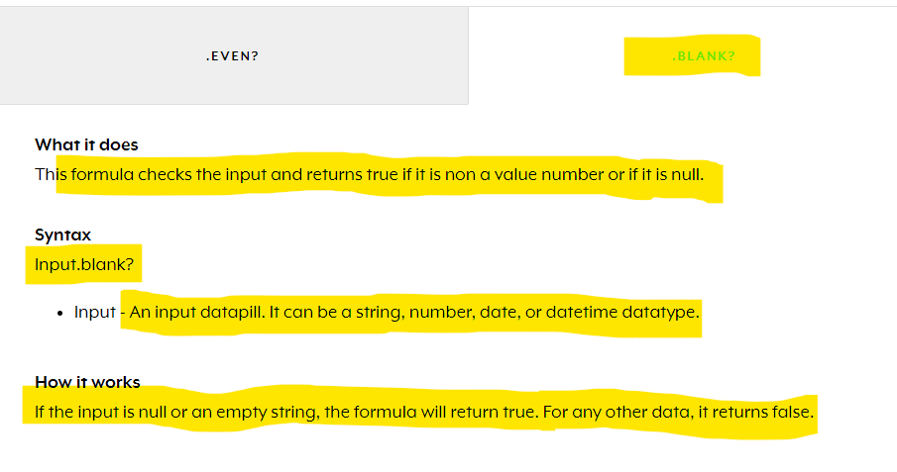

* **Date & Datetime Formulas?**
* Another data type that you will commonly come across involves date and time, such as transaction dates, deal creation date, and timestamps.
* When automating workflows, you will might need to transform such data into other formats, or derive certain useful information for processing.
* Date and datetime formulas allow you to work with date and time datapills.

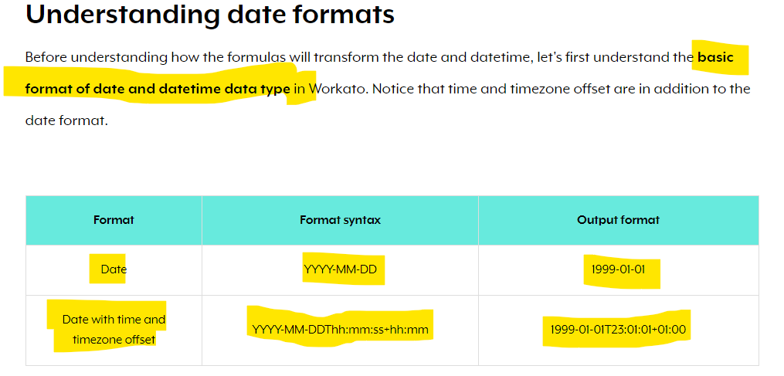

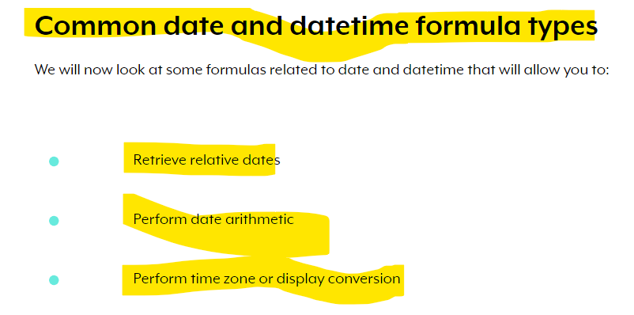

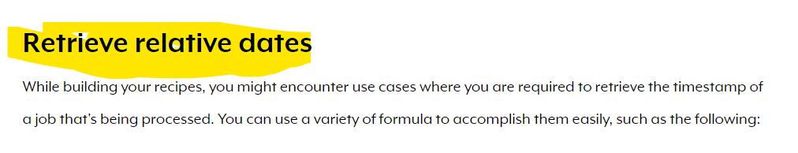

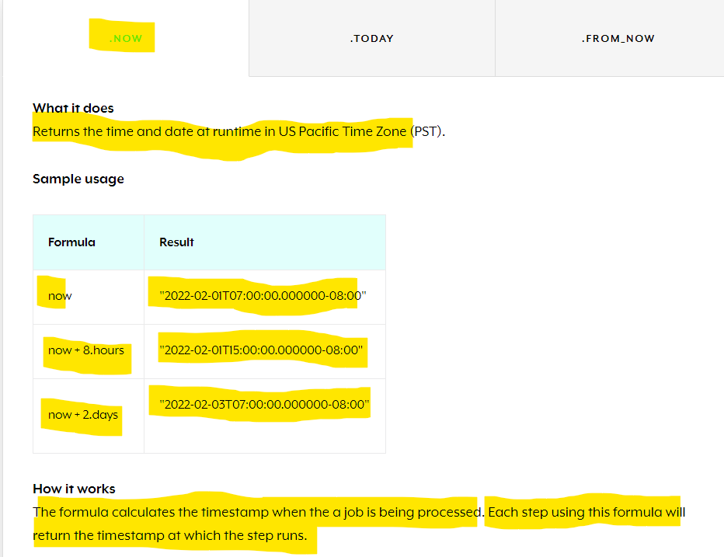

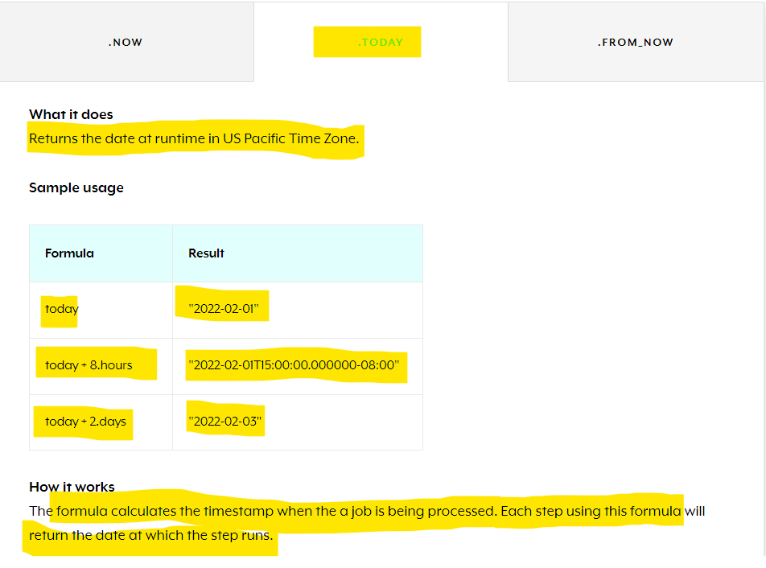

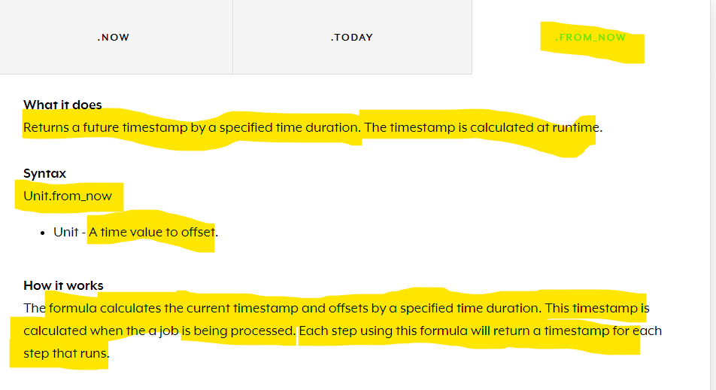

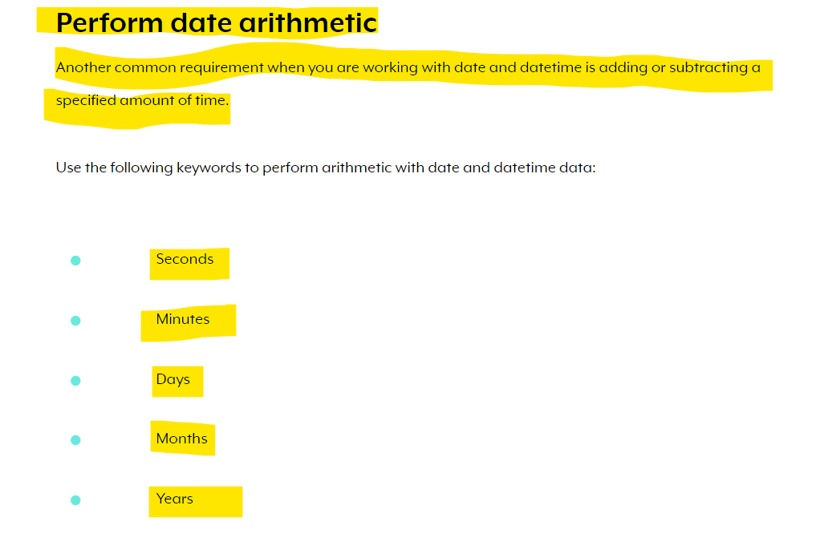

* 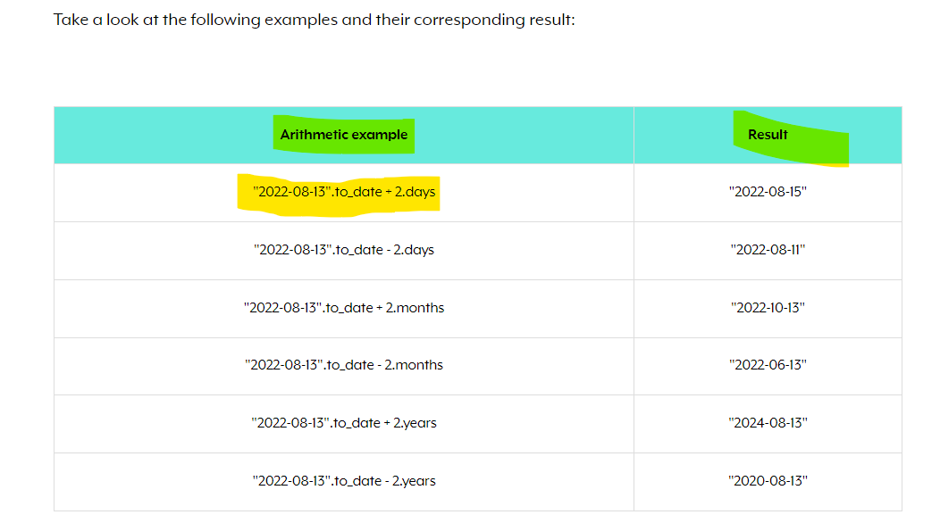 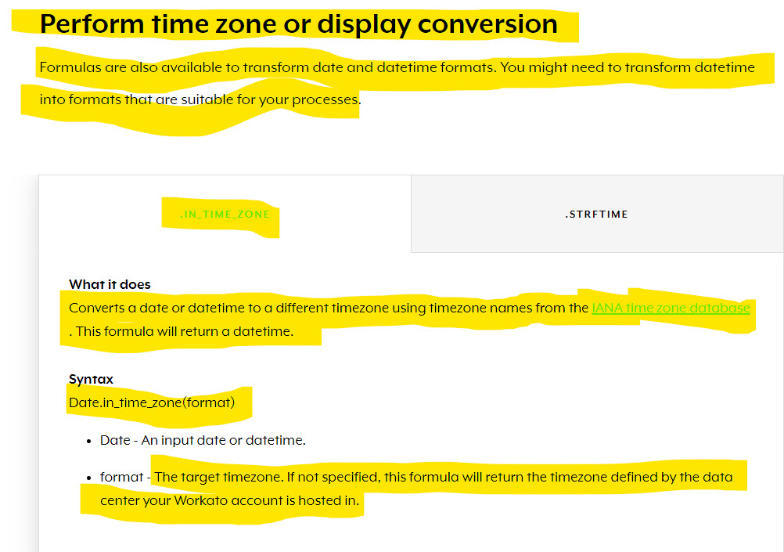 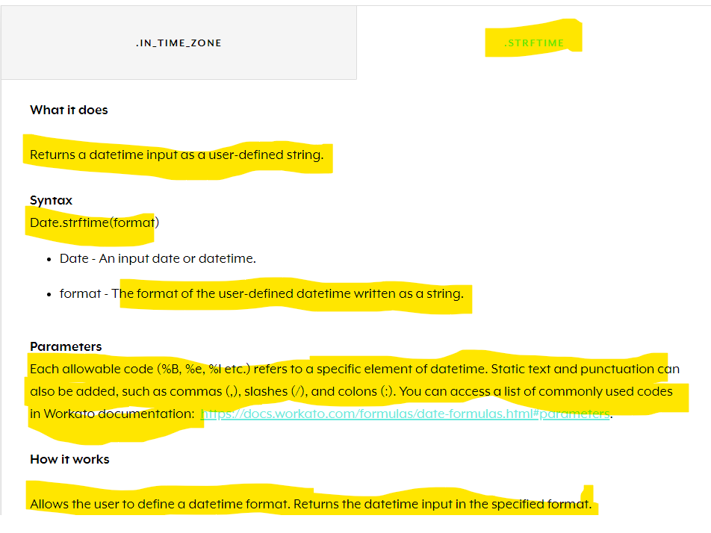
* **Introduction to lists**
* Lists are **powerful data structures**that allow you to **simplify operations and actions** in work processes.
* **In Workato, lists, which are also knows as arrays in Ruby, are data structures consisting of ordered, integer-indexed collections of objects containing values or variables.**
* **Basic and Nested Lists**
* Lists can be broadly classified into two types, basic lists and nested lists.

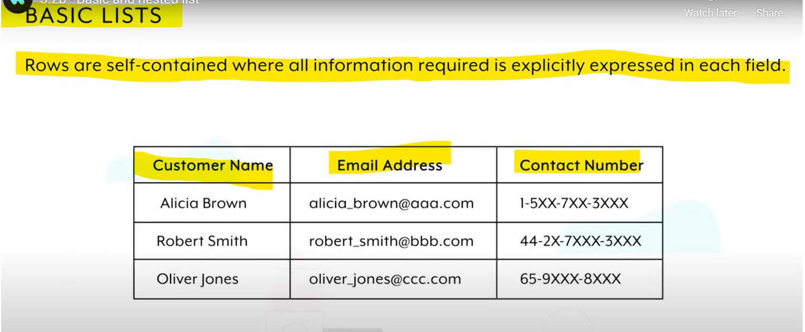

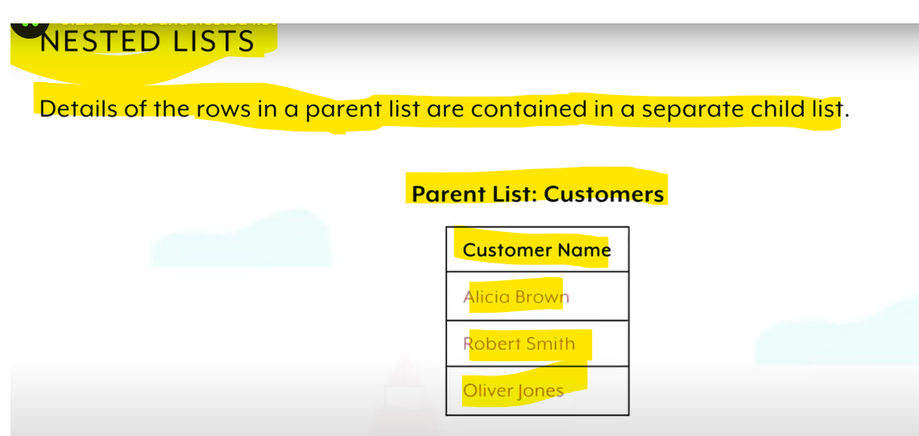

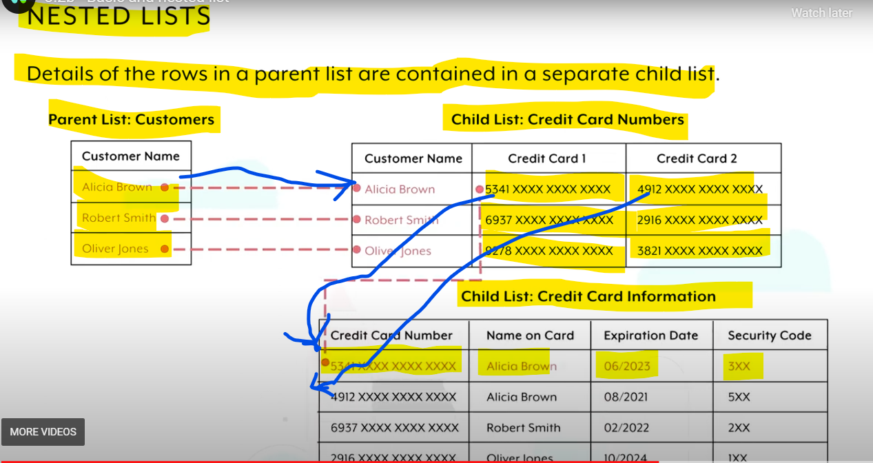

# **Data mapping with lists**

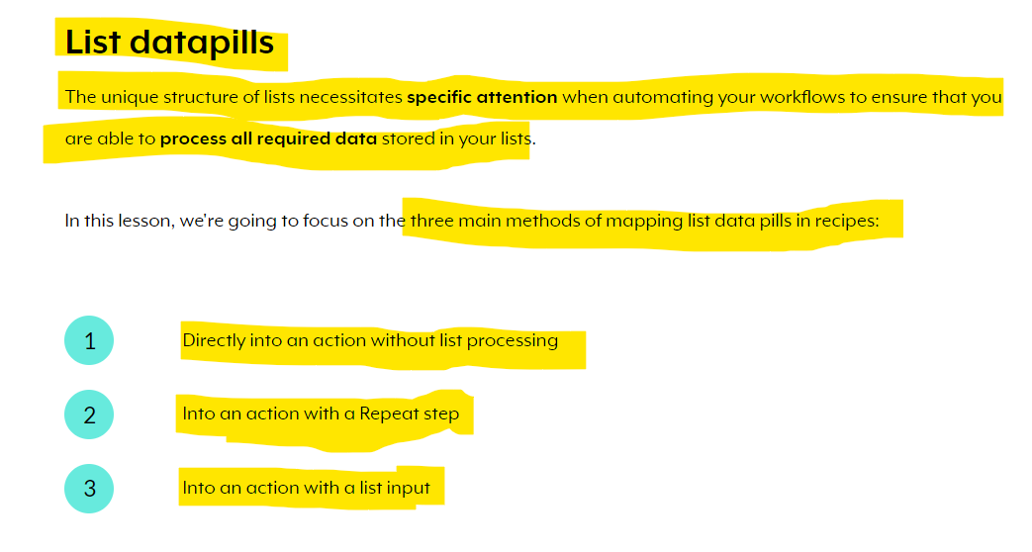

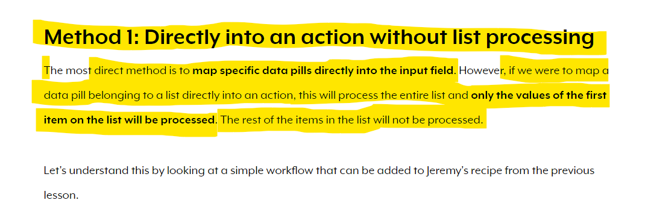

For example:

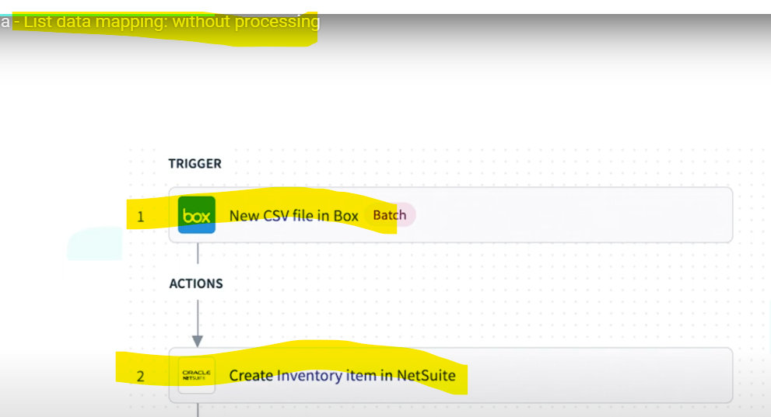

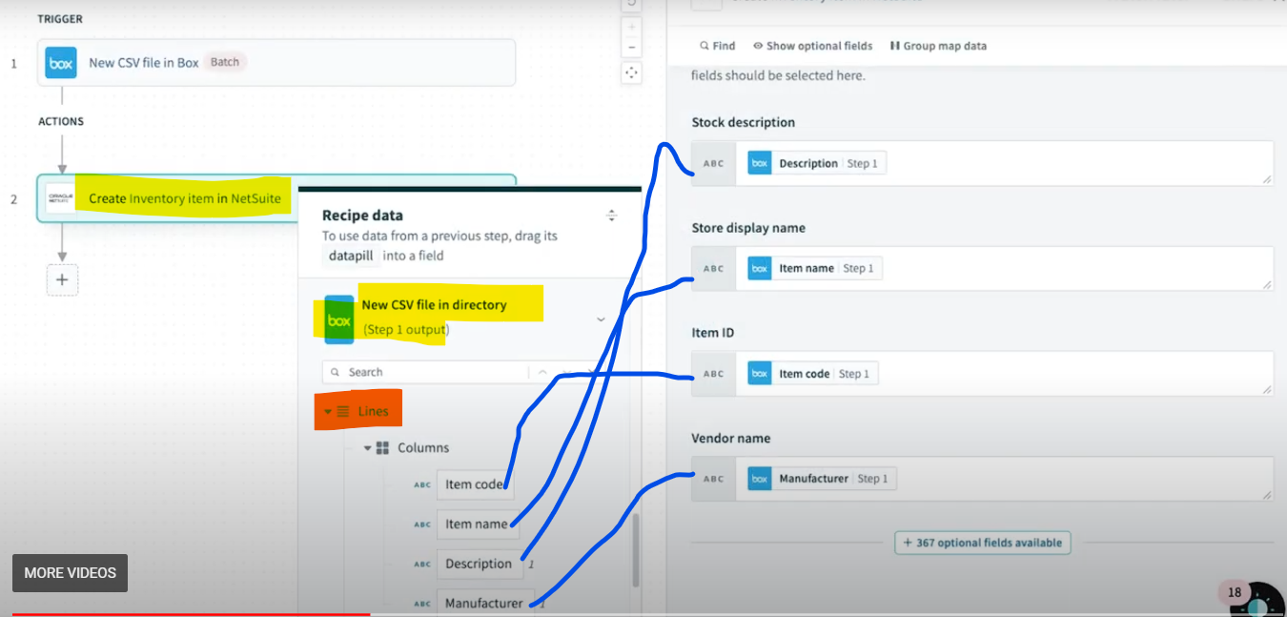

* **If you notice the mapping above ,we have mapped all fields like manufacturer,item name,item code,description of Lines list that we are receiving from CSV File Trigger directly to the input fields of Netsuite’s create connector, but from the above csv file we are receiving a list of of Lines that is List of Items so what will happen if we run the recipe ,the job will take only 1st occurrence of the Lines List object n will ignore all other.**

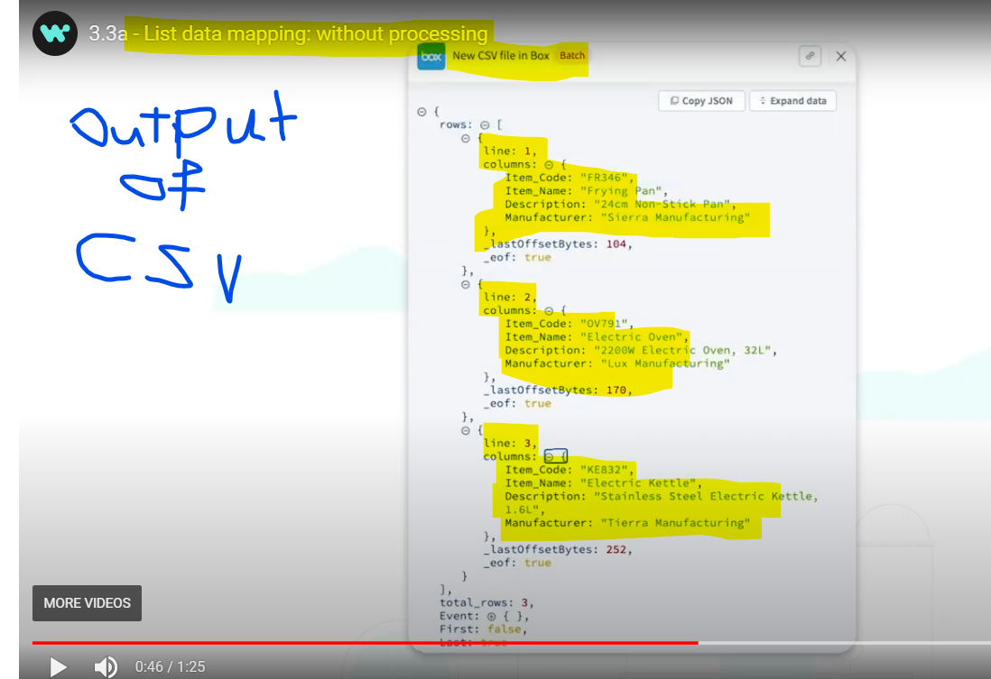

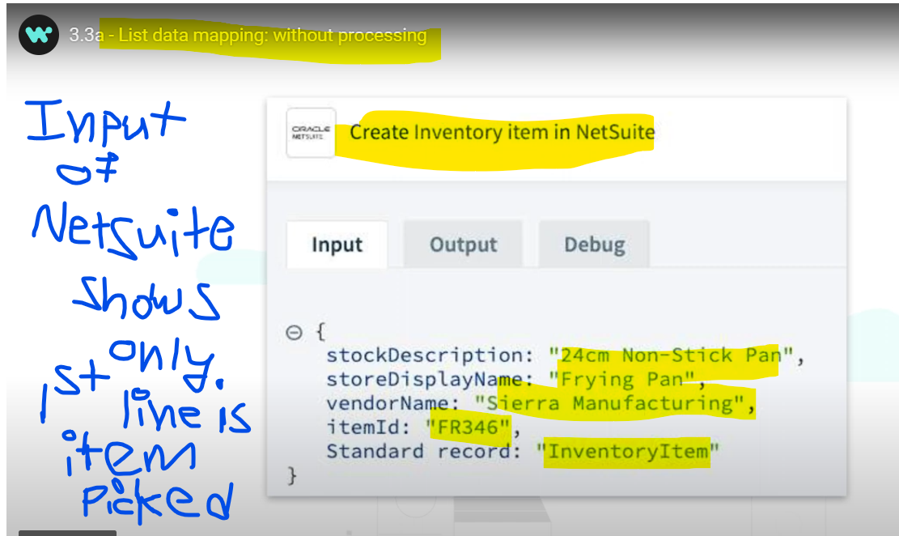

**To process all the Lines List records we can use Repeat Action**

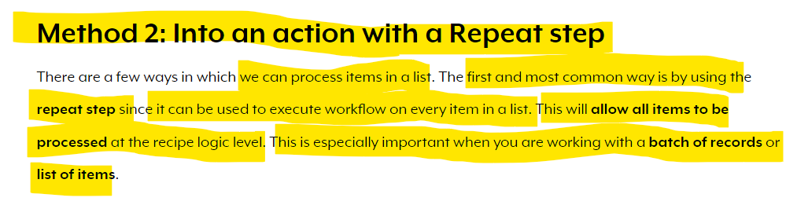

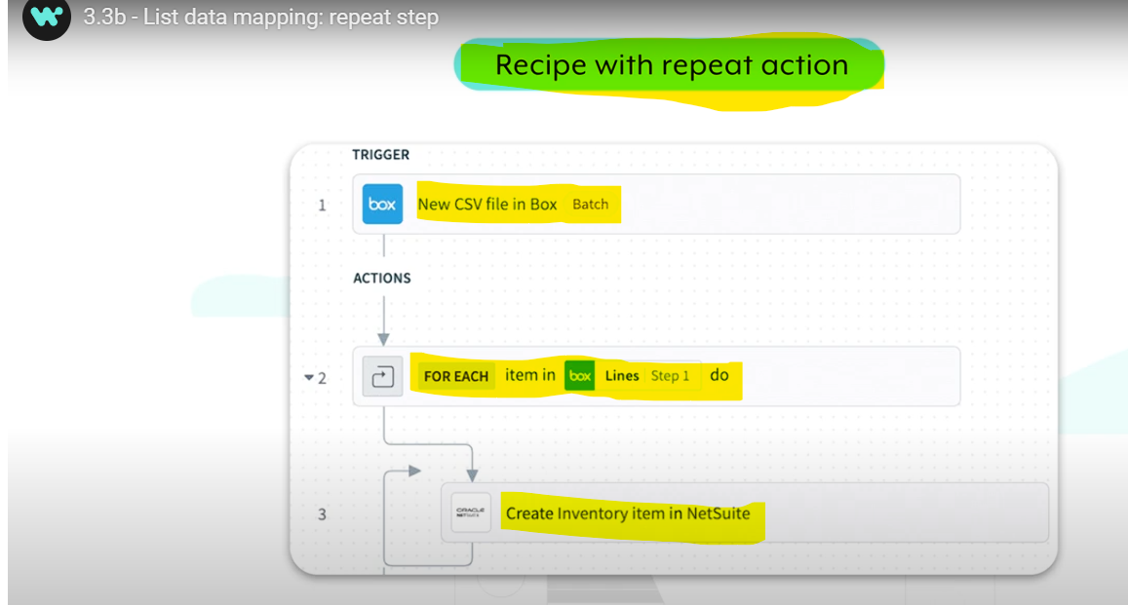 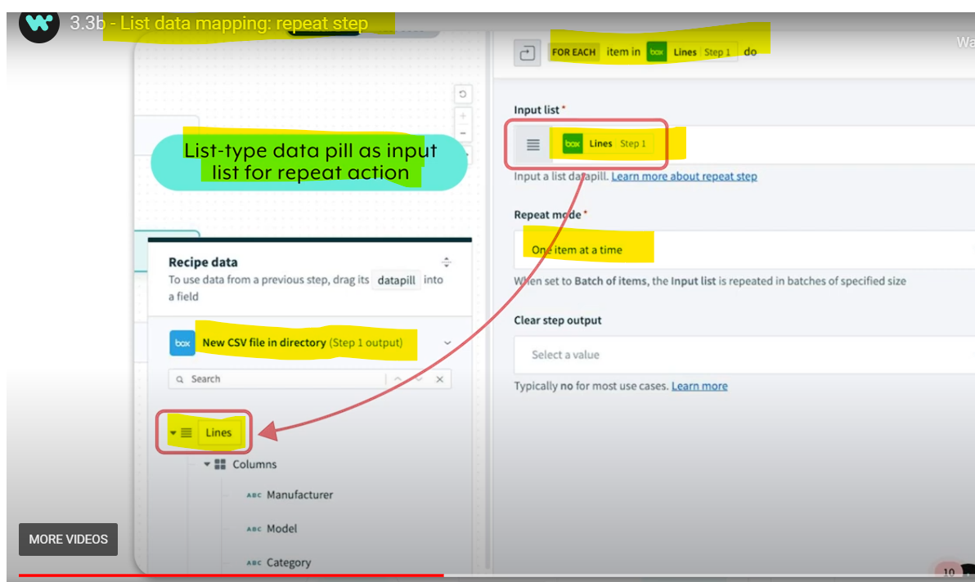 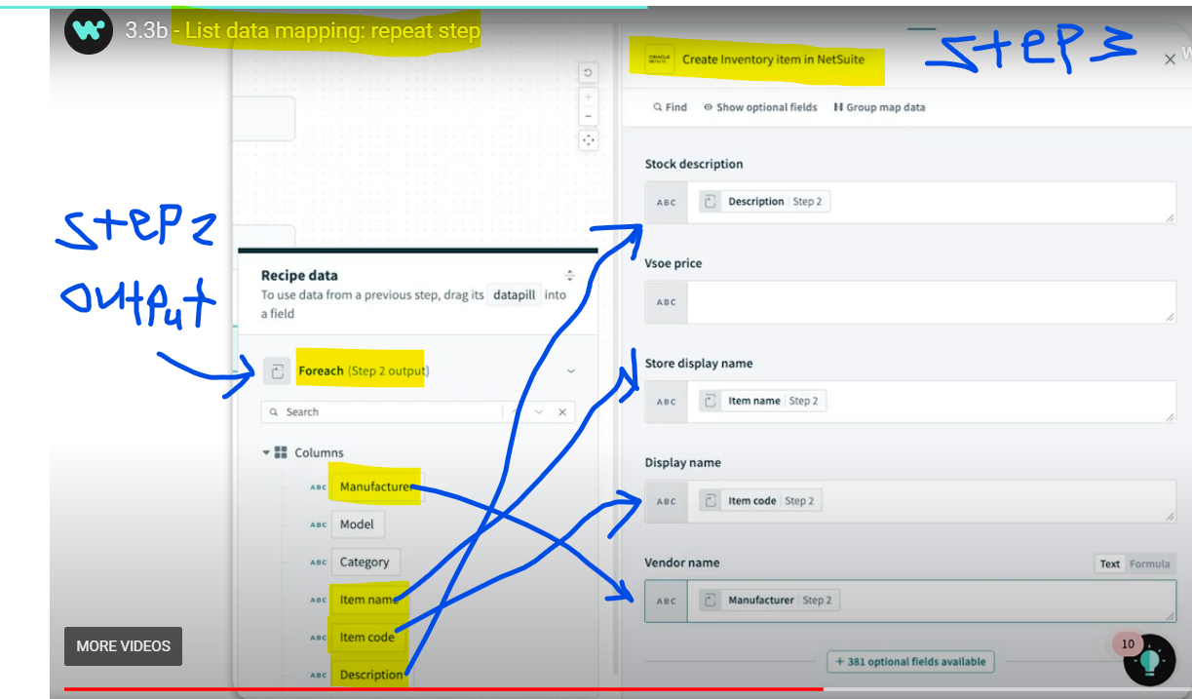

* **Above screenshot depicts that whatever actions we perform in Repeat Action we should use or map the output from the Repeat Step only if we map the output from the trigger or any out of the action step(trigger in this case) we see that only 1st record of the List is getting processed.**

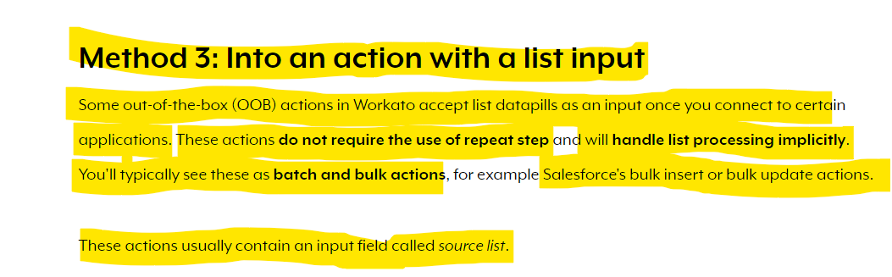

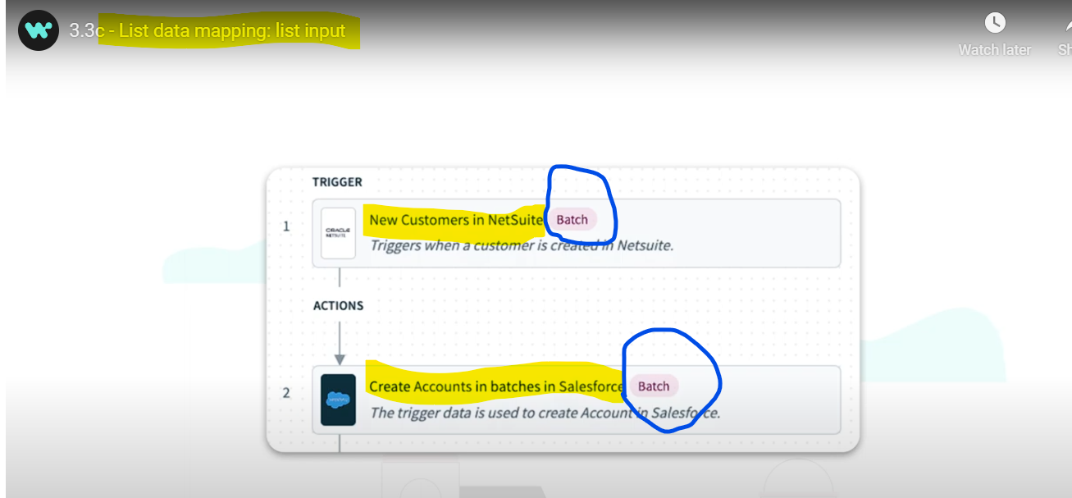

* **Without using repeat action we can perform list mapping by using the actions/steps that are configured with batch option here in above example we use both netsuite n saleforce batch supported operations so all new customers created in netsuite in Batch will be directly mapped to salesforce create account batch operation**

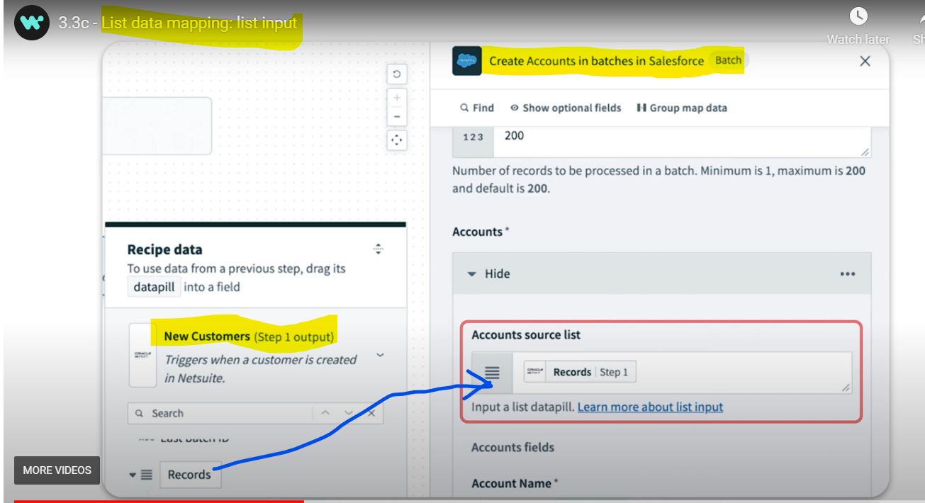

**IN salesforce create account batch operation we just need to specify the account source list input field with the output of netsuite batch Records list n then map the columns as it is required so here we are not using repeat action instead we are using supported batch operationsof both the systems.**

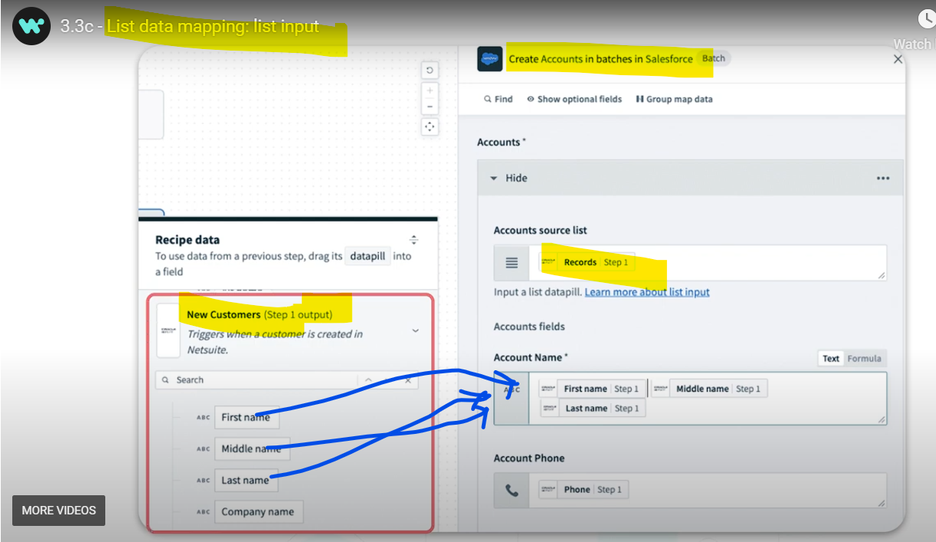 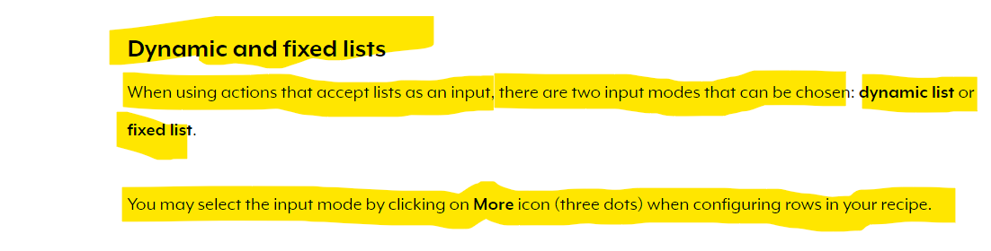

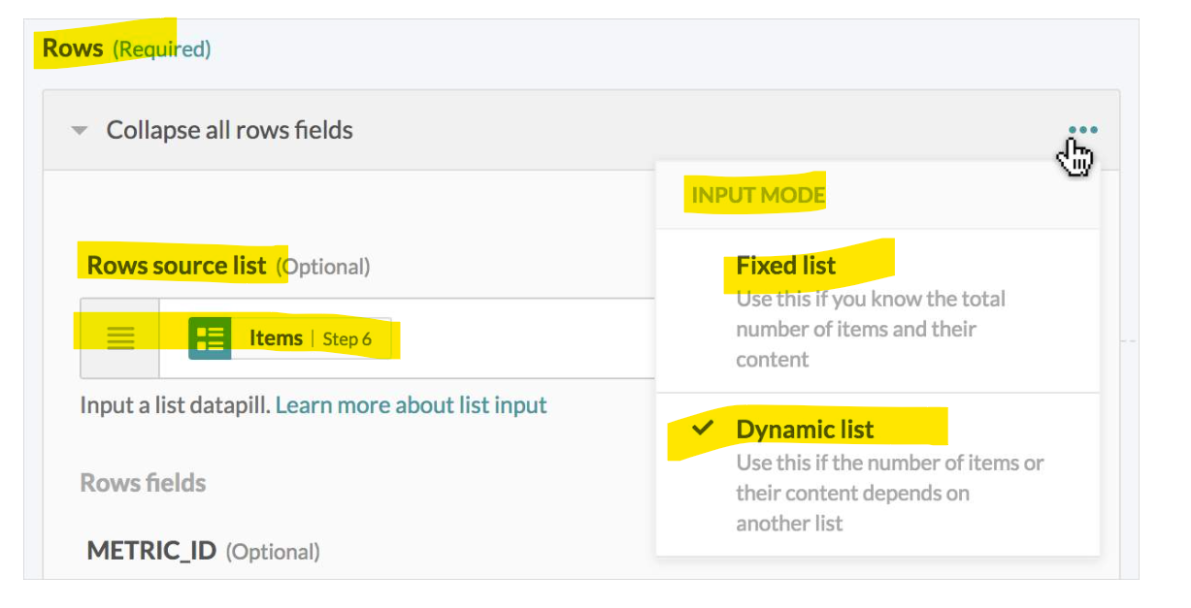



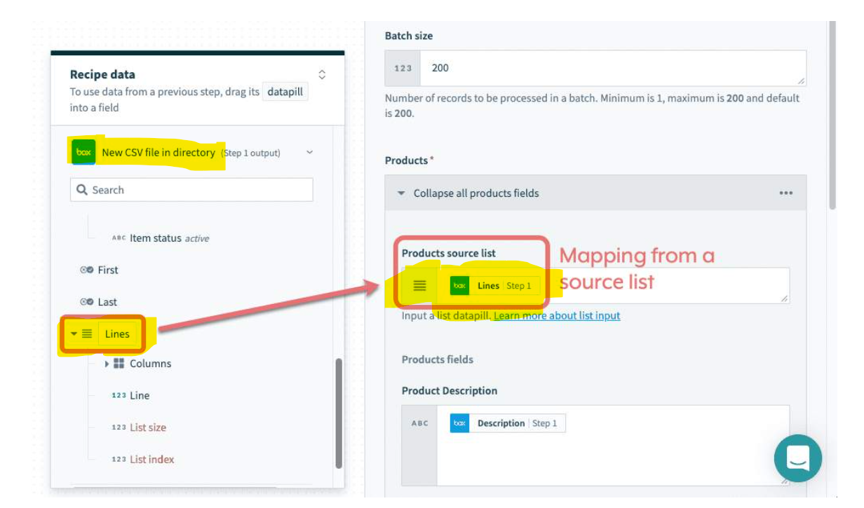

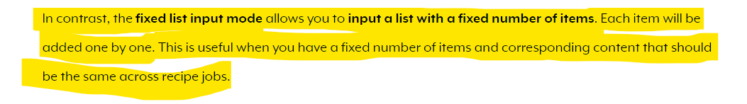 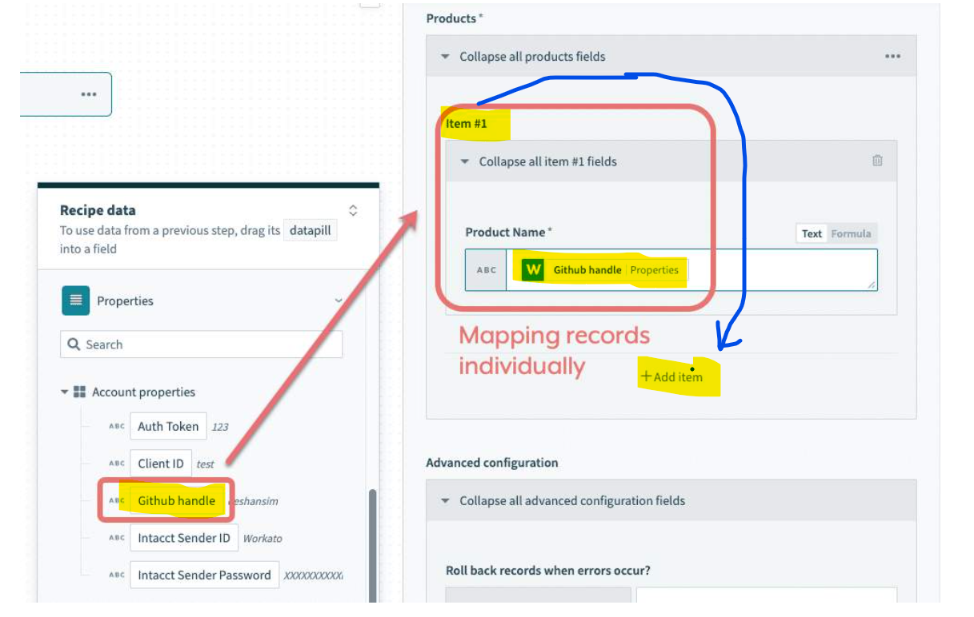 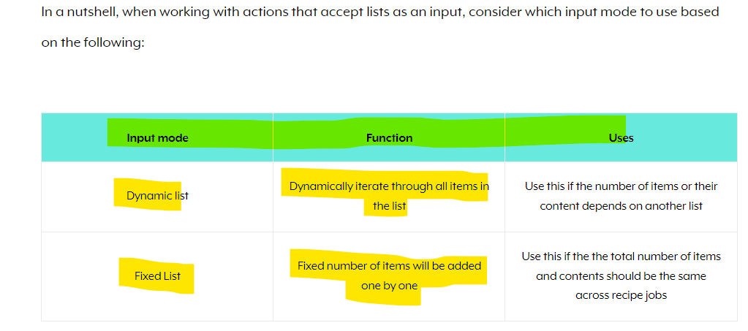

* **Processing lists in recipes**

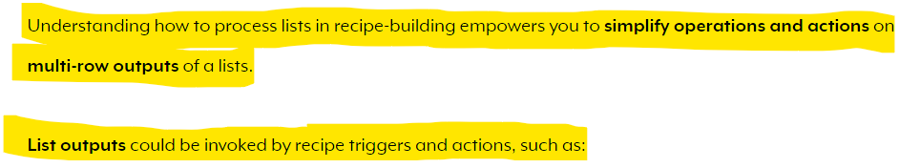

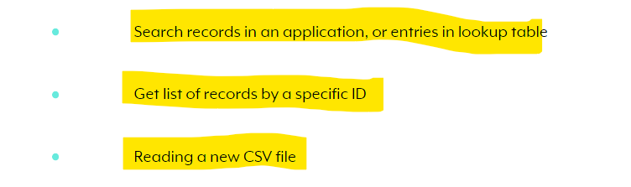**Search-related actions**

* One such common action is search-related actions, which often **retrieve a list of entries based on search criteria** specified.

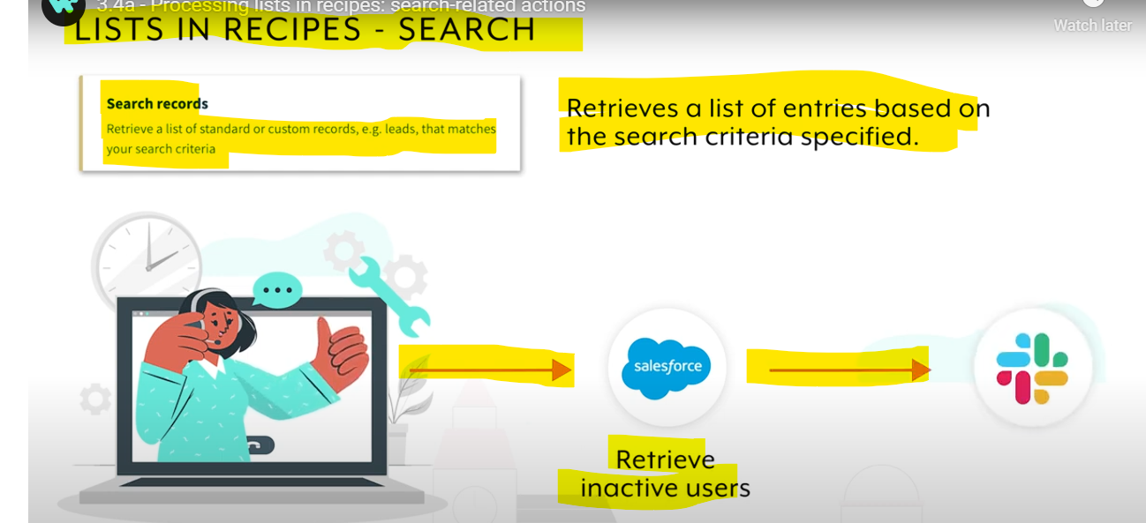

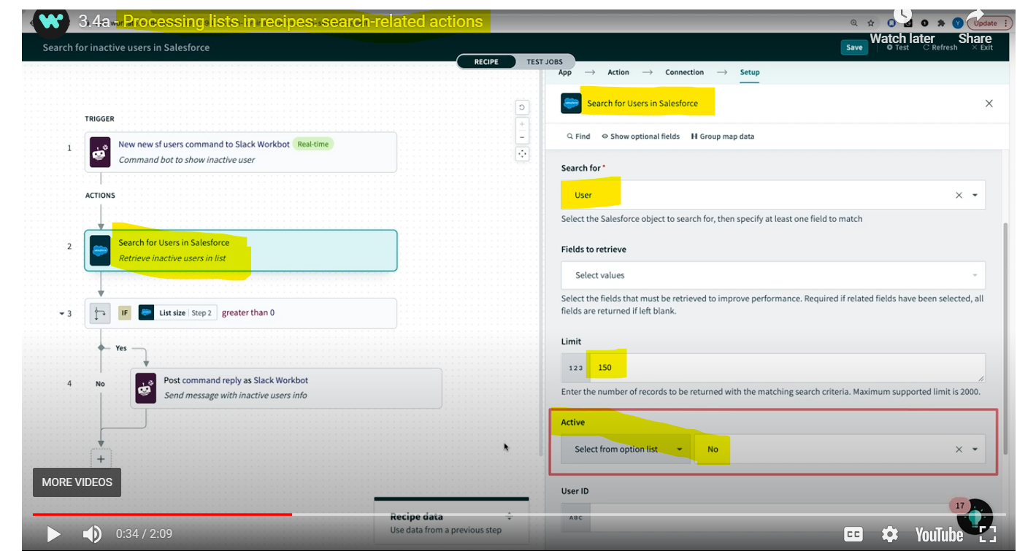

**When you search u may get a list so if you want to know whether the list contains anything or not or apply some conditions like if list size is greater than 0 then post msg to slack else don’t post you can use List size parameter under the list**

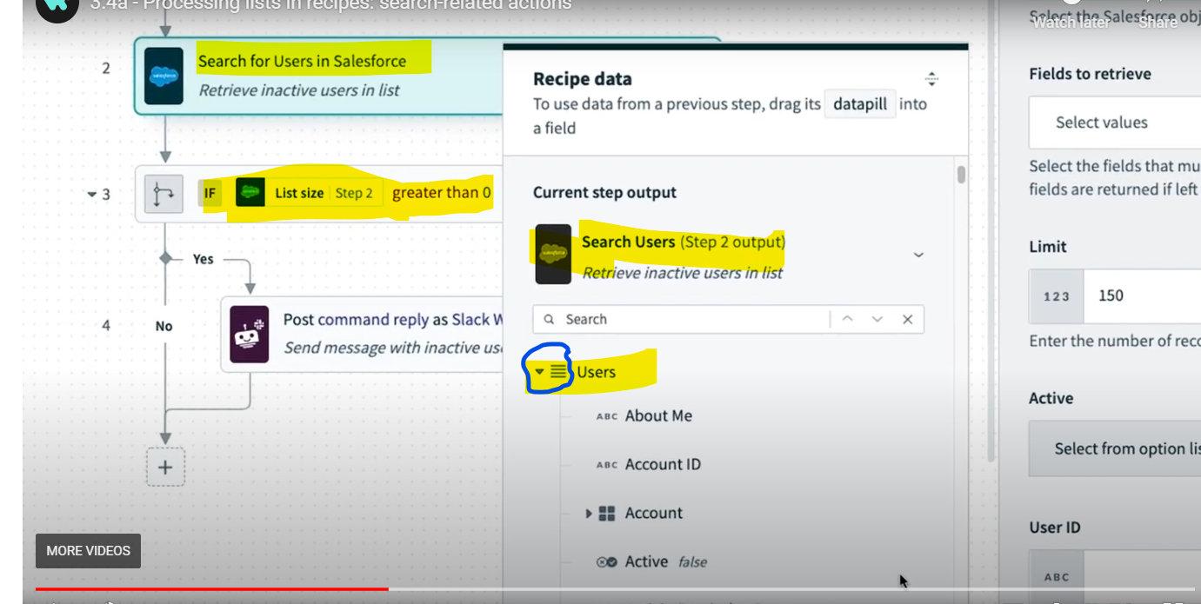

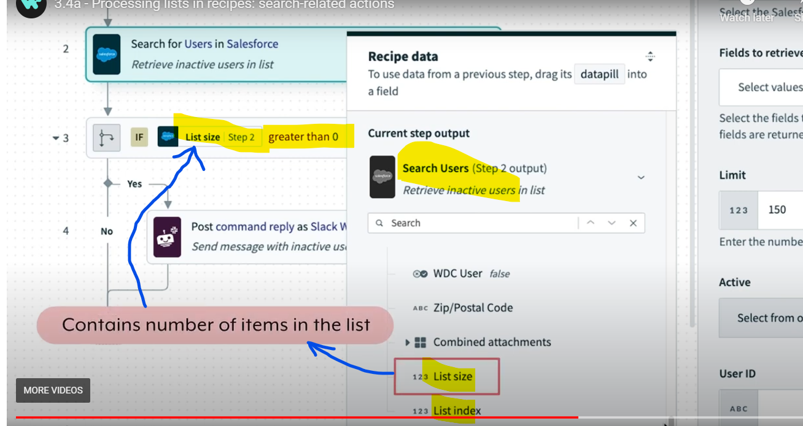

* **As lists are ordered, we can use formulas to retrieve specific objects by specifying the index.** **The list index contains the position of the item in the list. Indexes start from zero and the index of the first item will thus be zero. This is useful when referencing specific items in a list.**

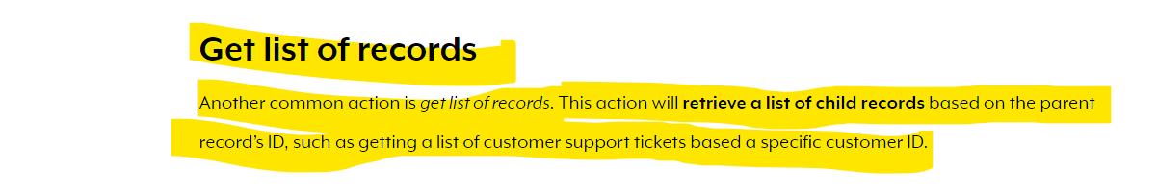

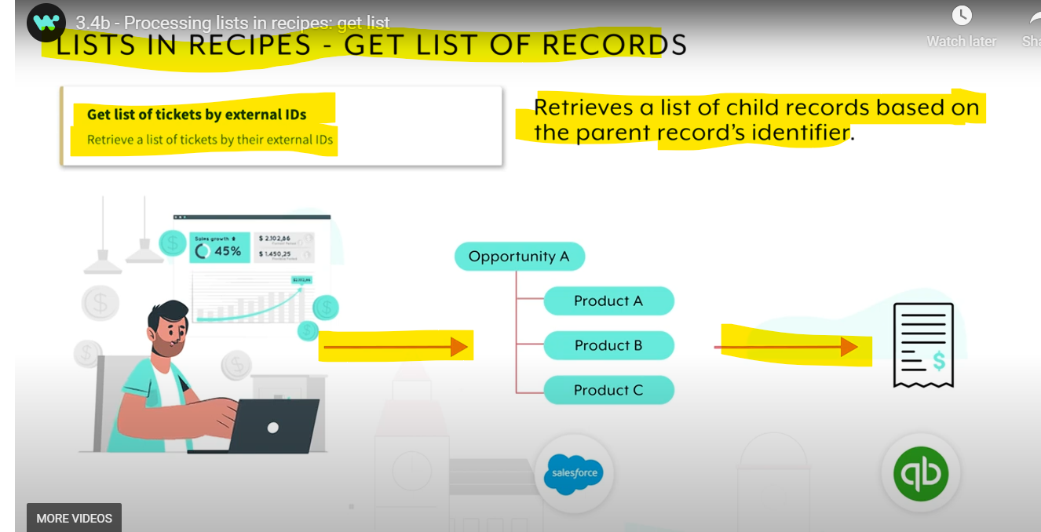 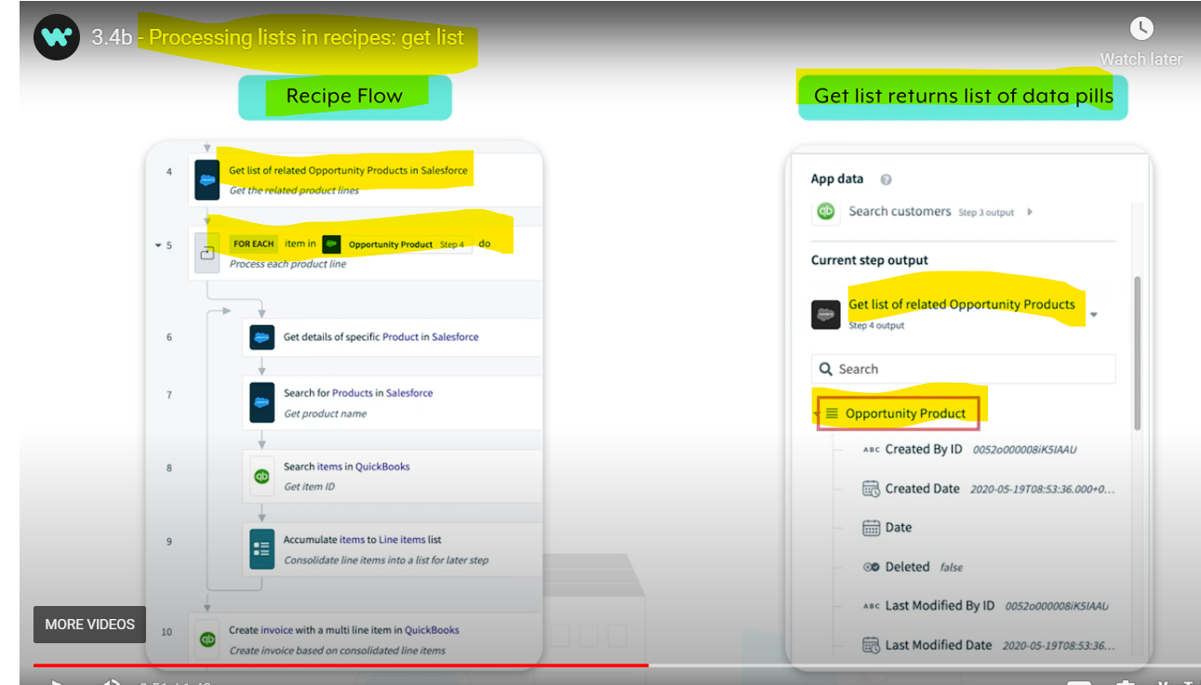 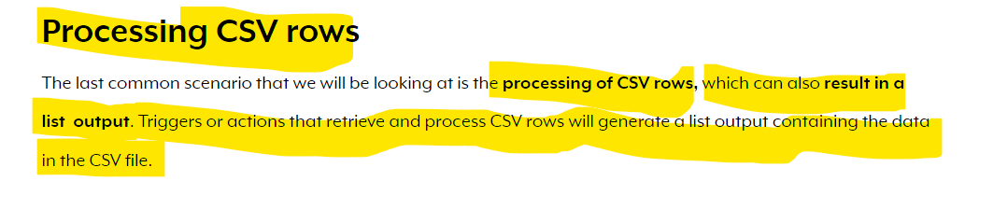

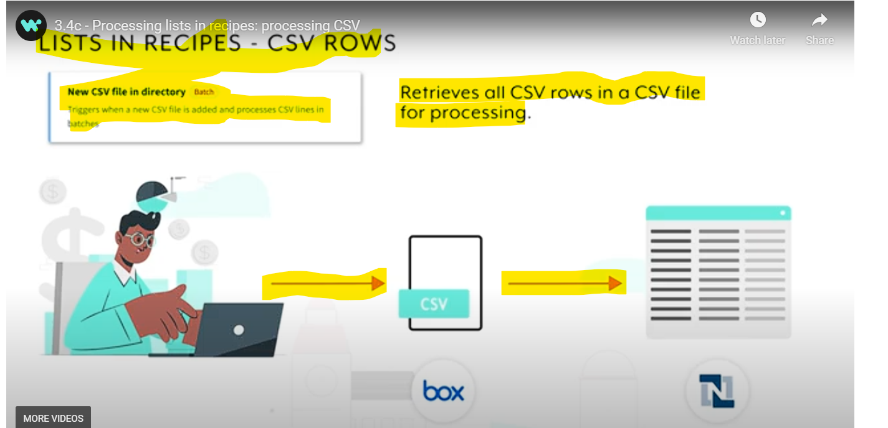

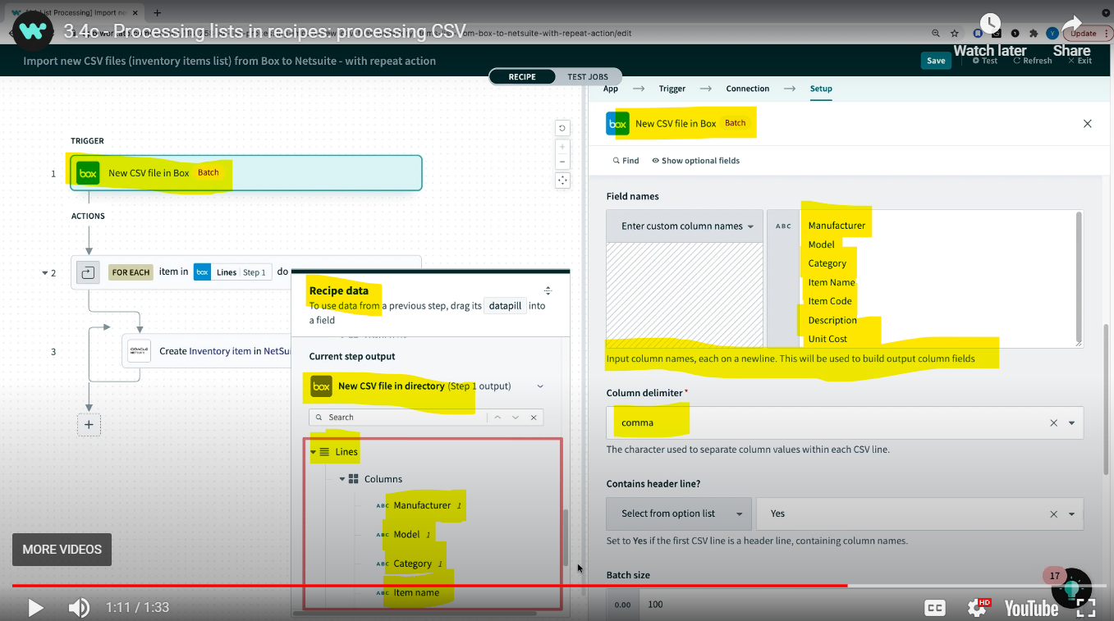

* **List formulas**

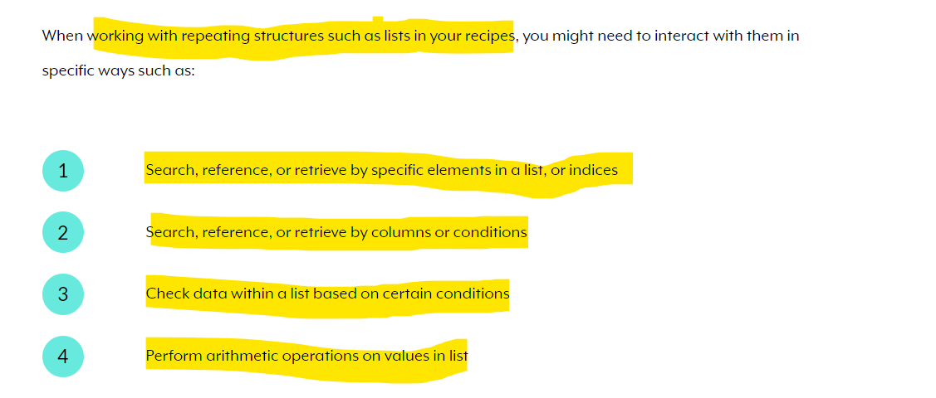

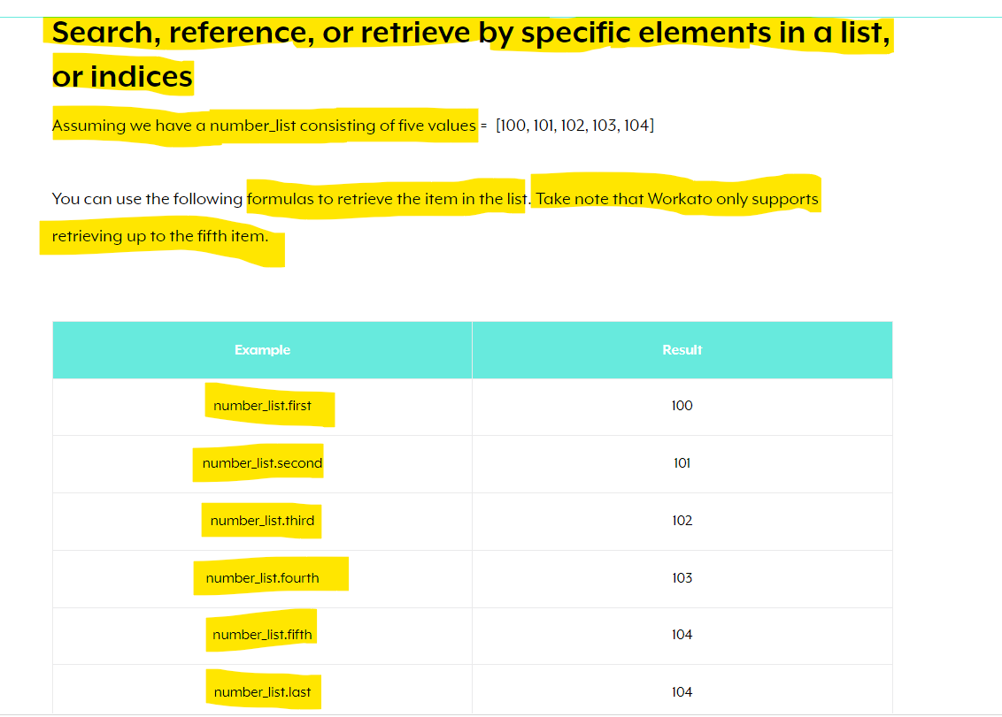

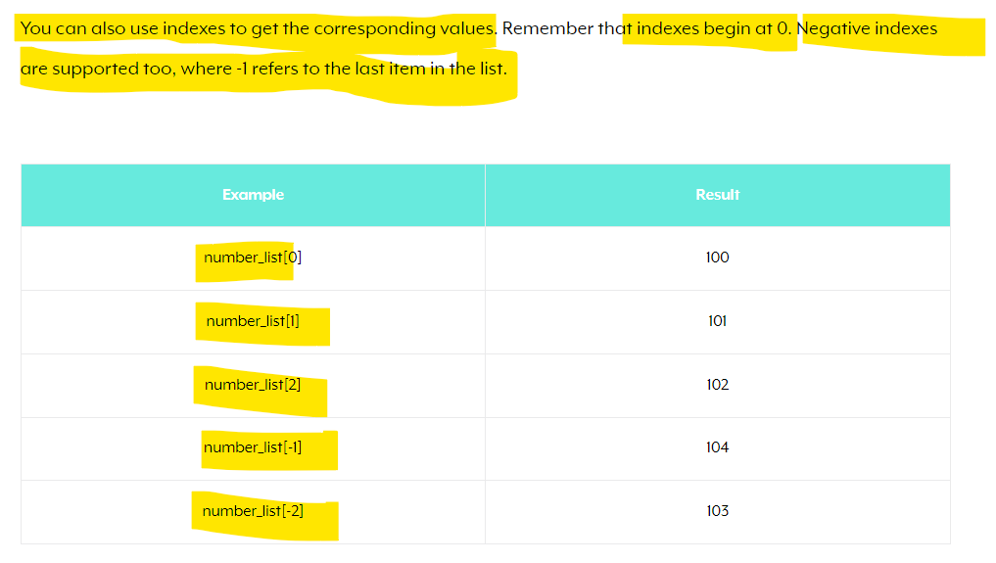

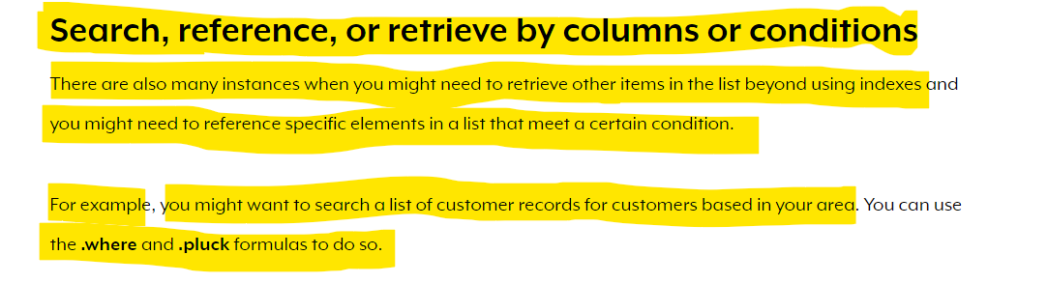

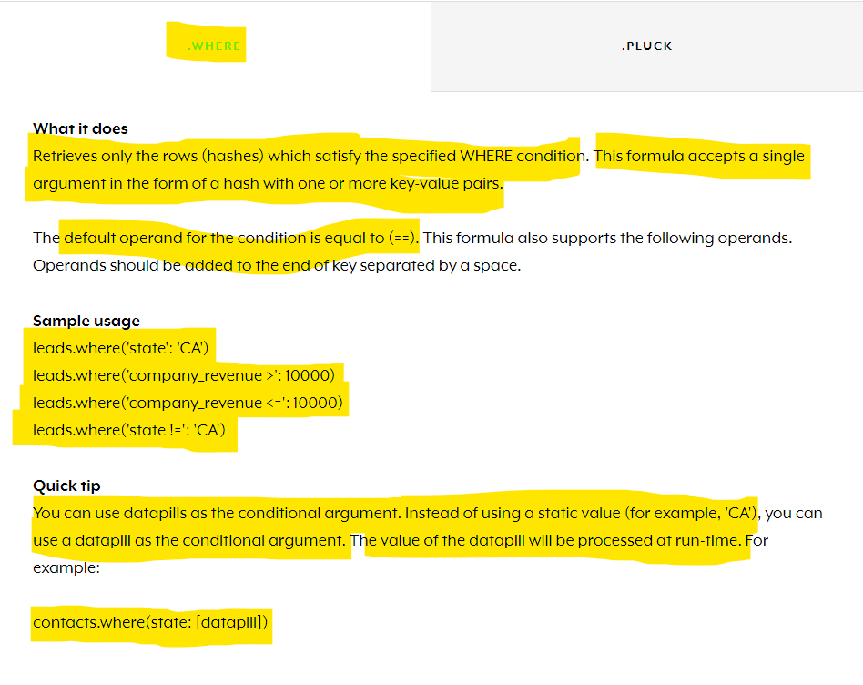

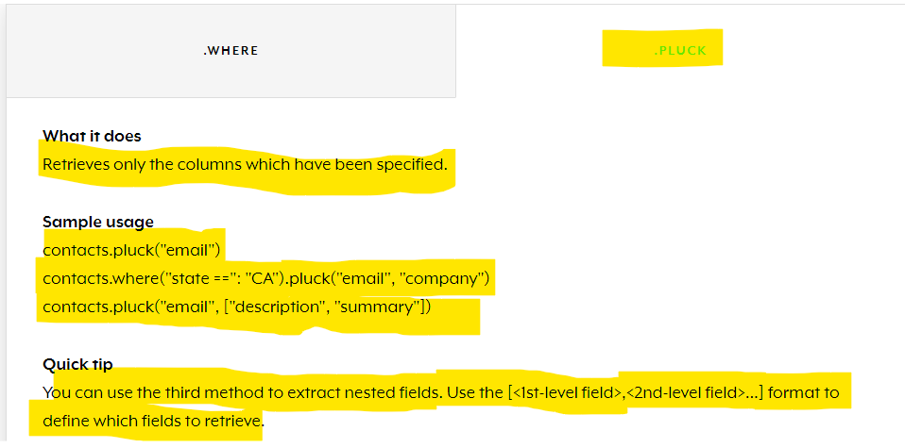 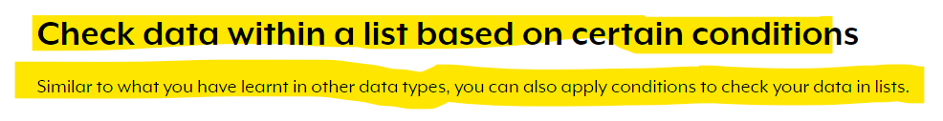

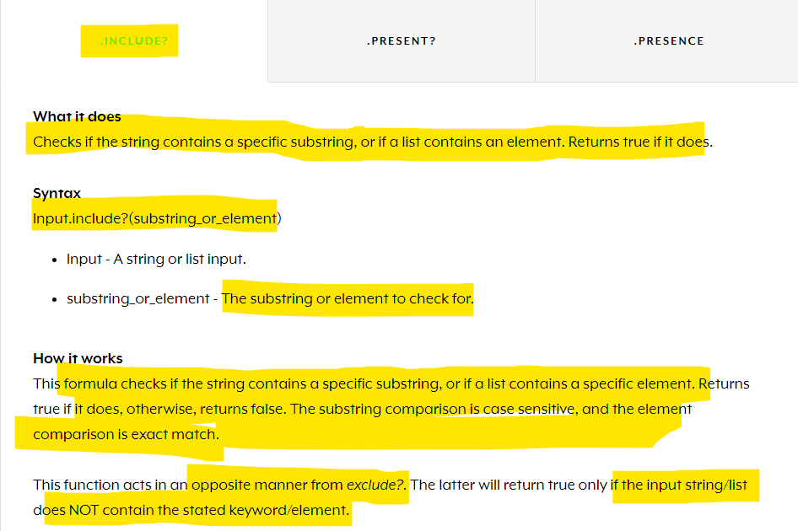

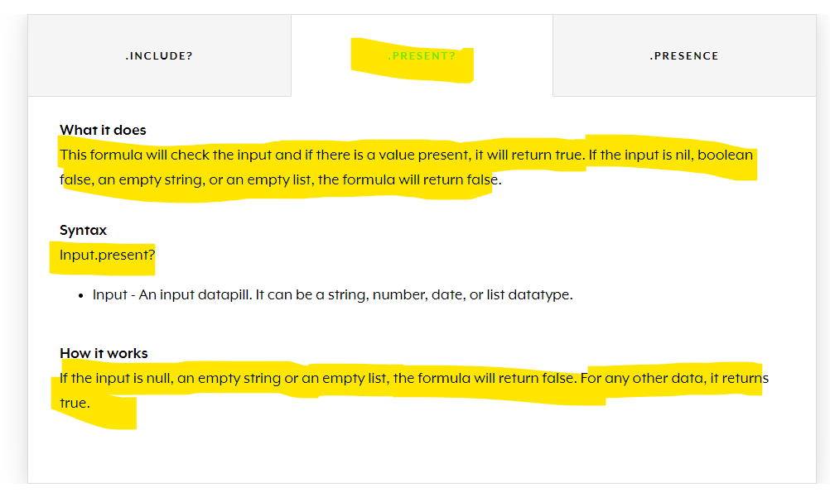

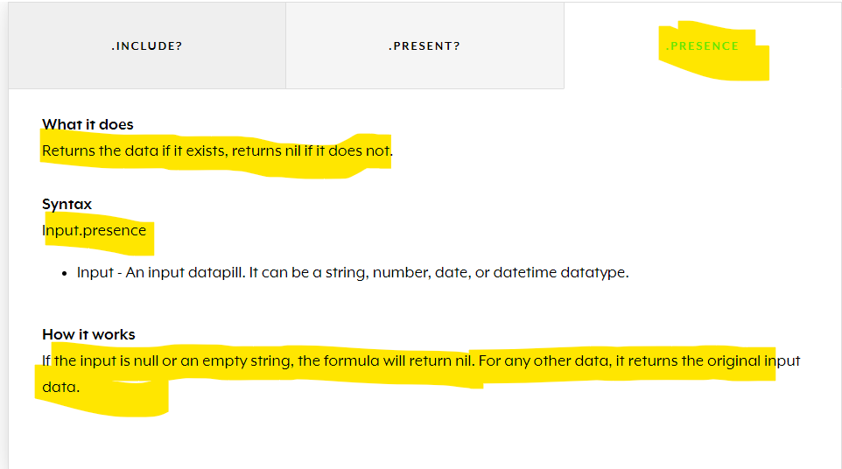

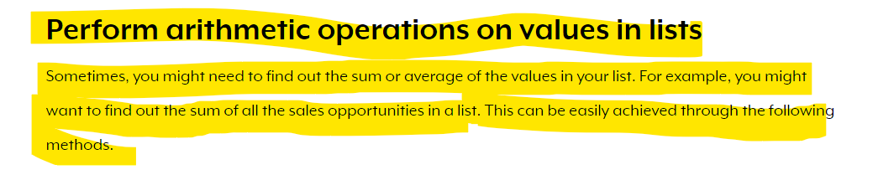

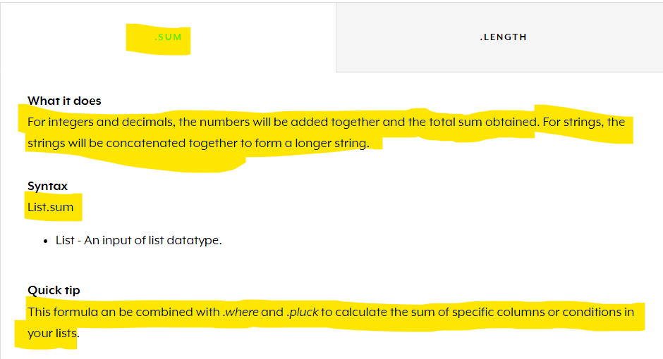

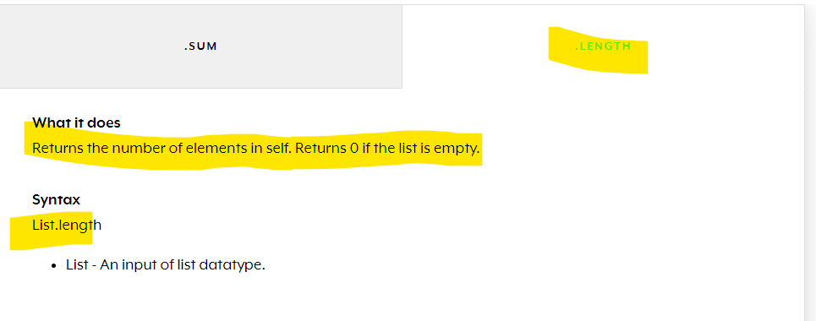**Introduction to Workato tools and built-in apps**

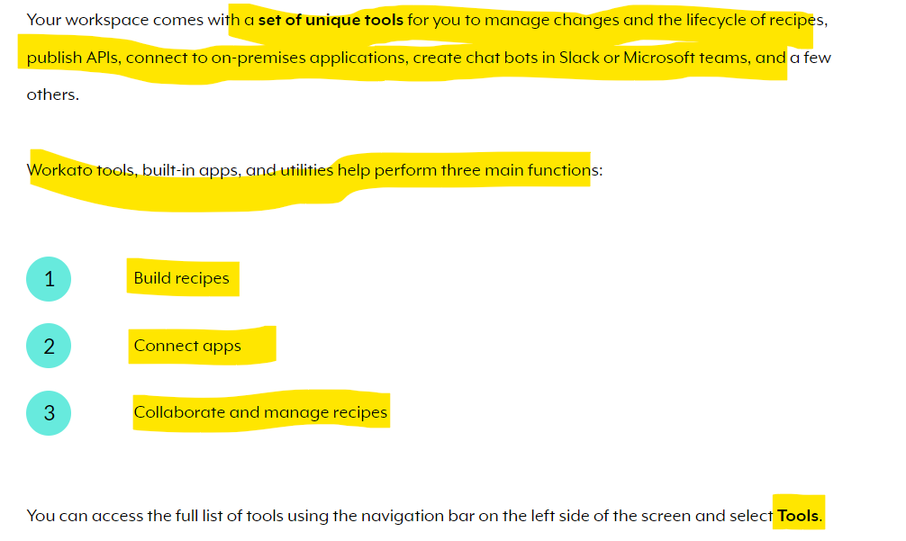

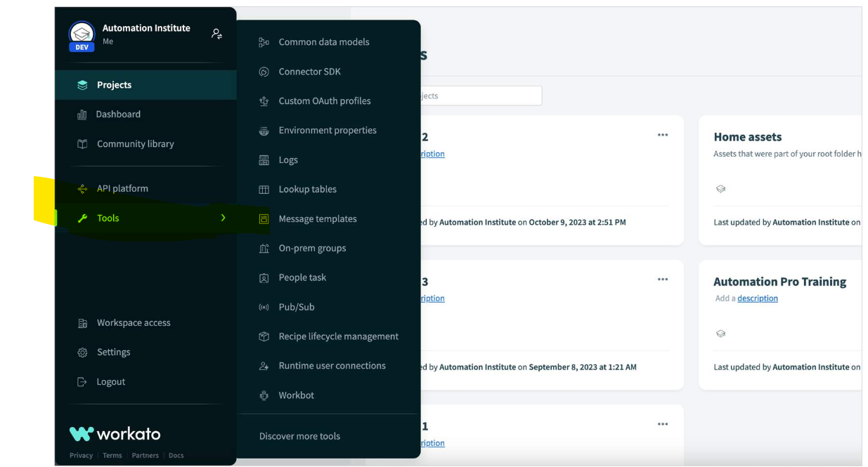

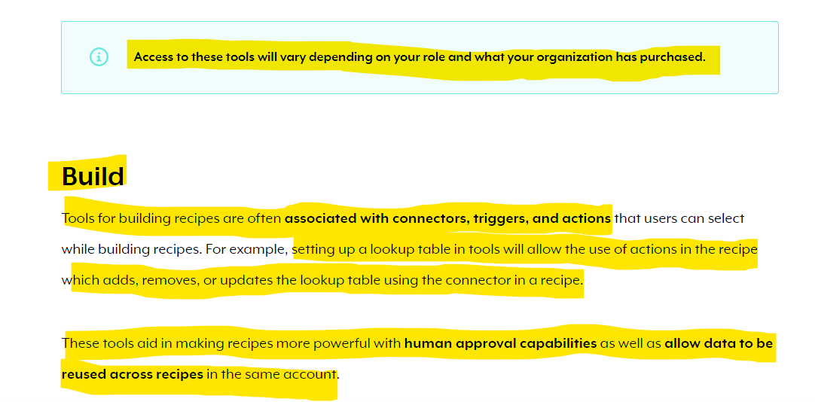 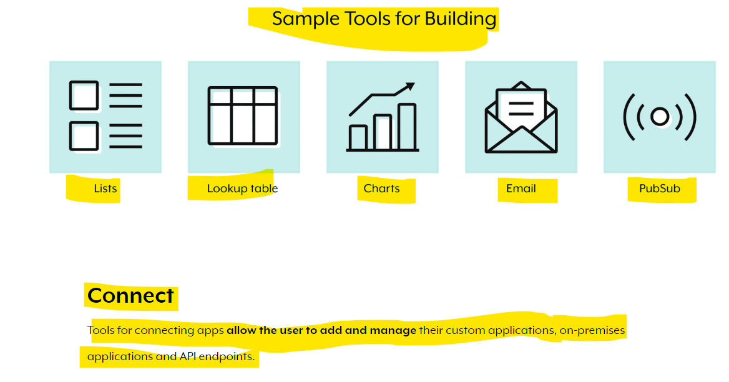

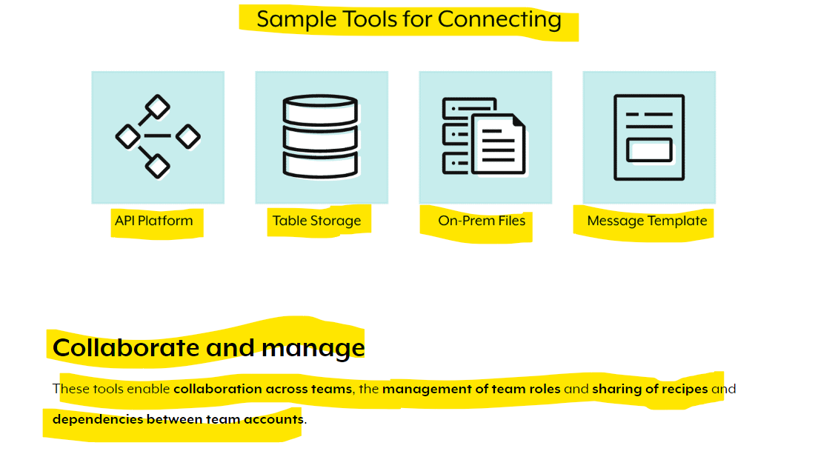

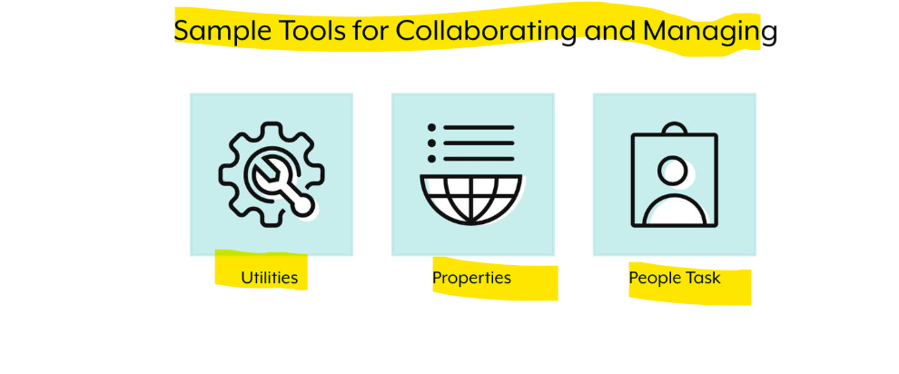 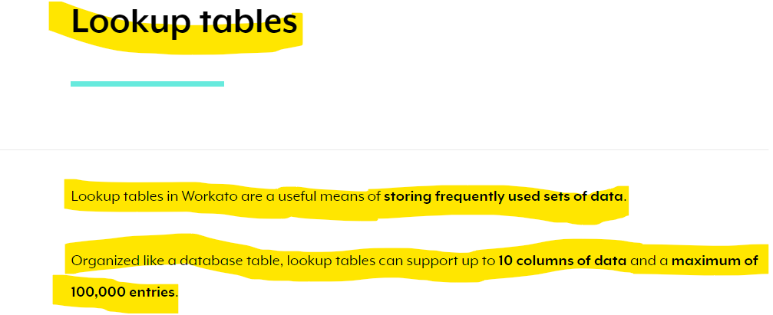 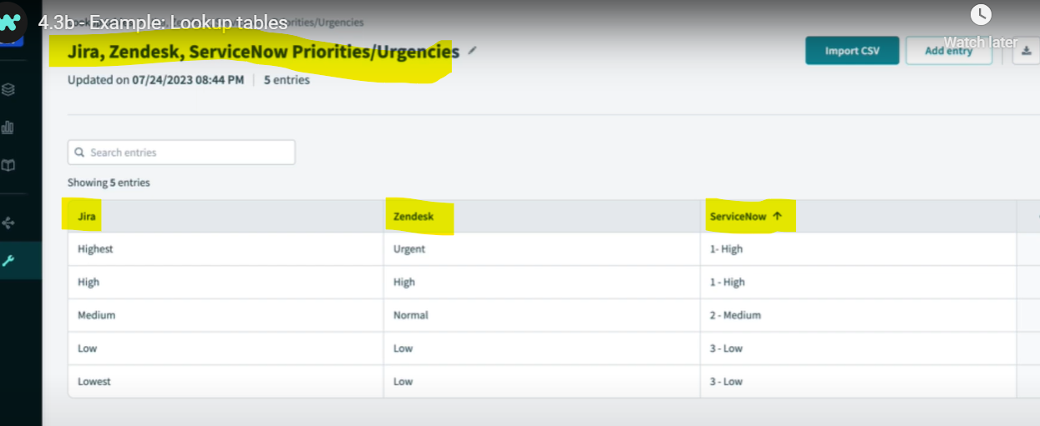

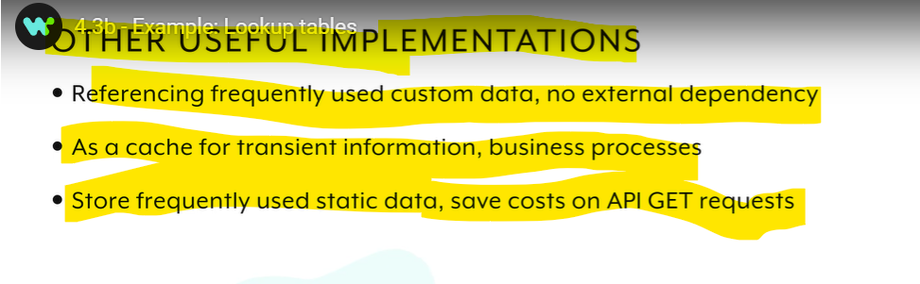 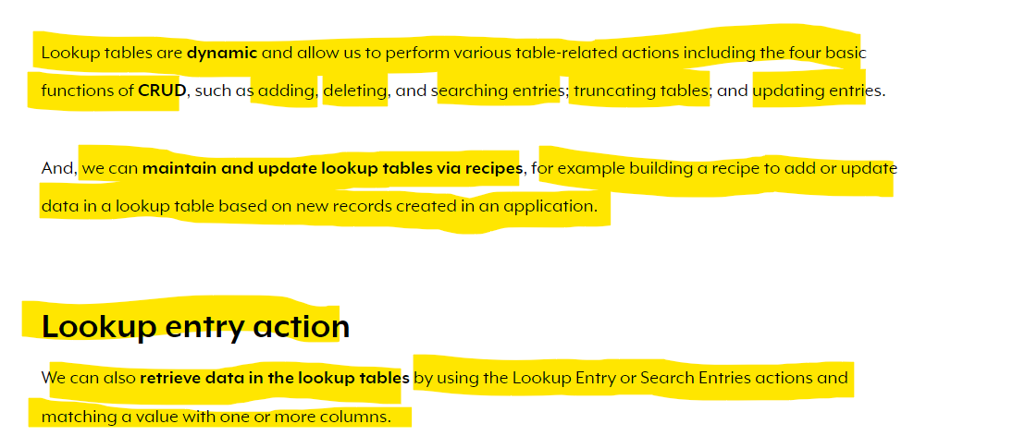

**If no data is found in lookup table then it errors out.**

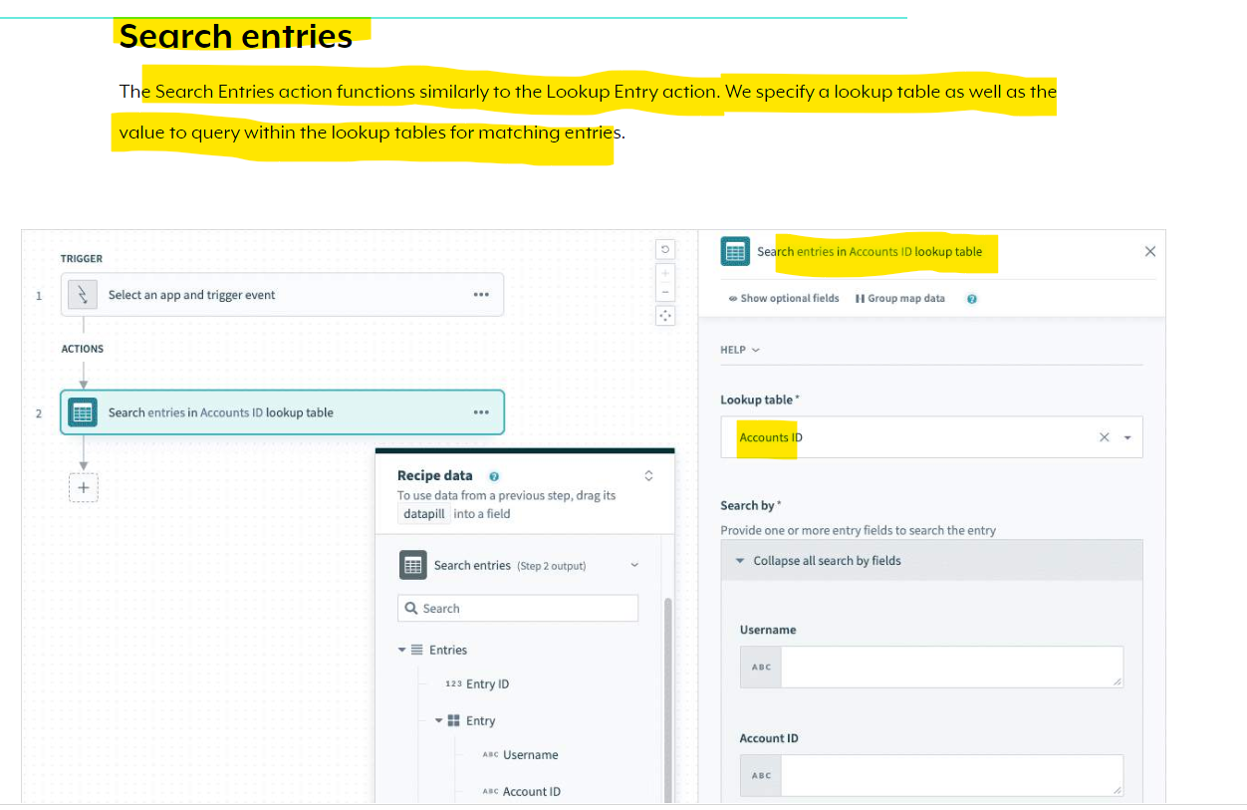 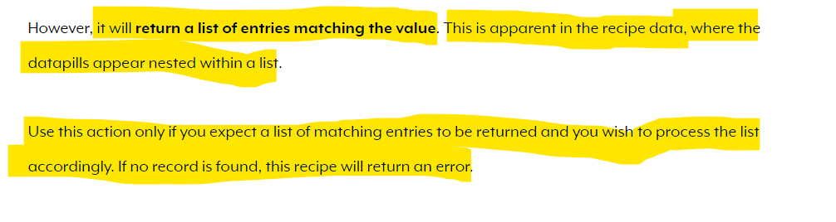 **You can find out more information on how to use each of these actions in Workato documentation at**[**https://docs.workato.com/features/lookup-tables.html(opens in a new tab)**](https://docs.workato.com/features/lookup-tables.html)**.**

* **Variables By Workato**

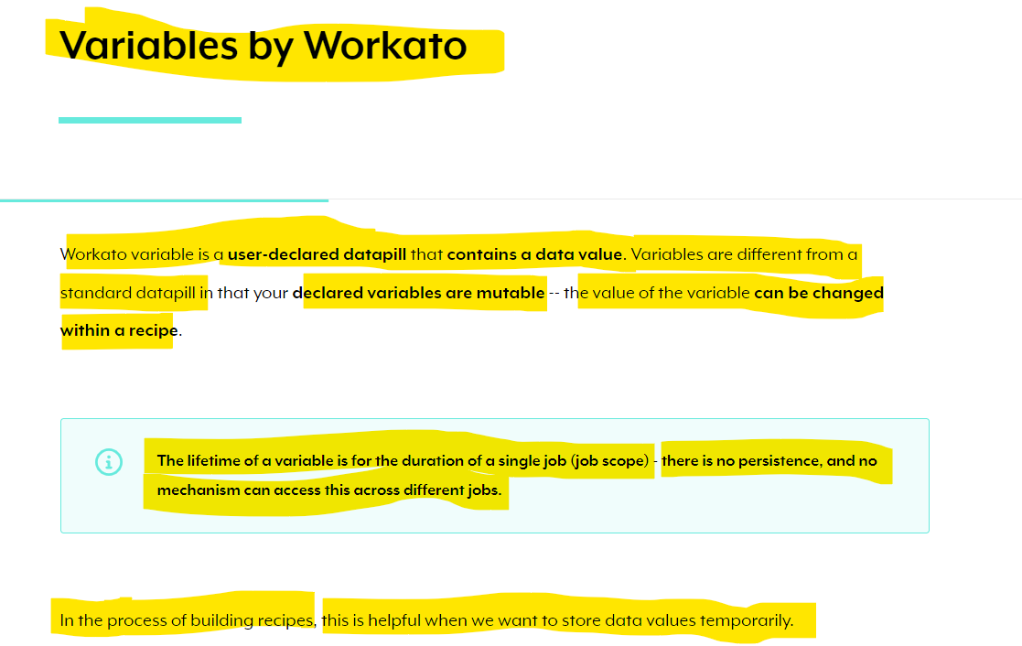

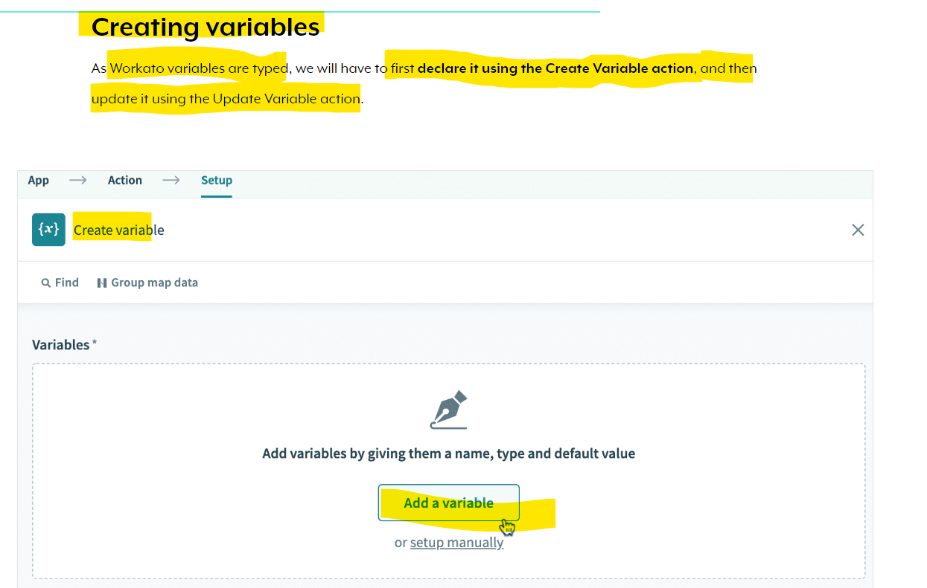 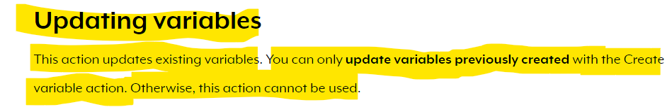 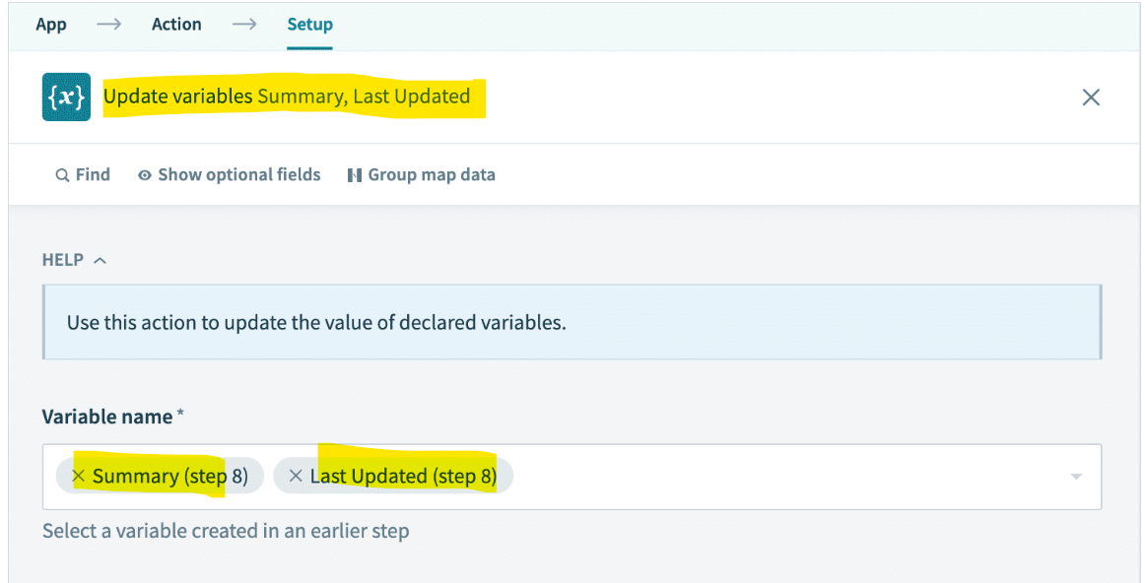

**Module 6 : Enterprise Workbot for Slack**

* **Enterprise Workbot for Slack**